Name:_________________________

Doctor DeSoto Activity Sheet
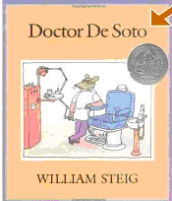

FACT – TRUE

- Write a sentence about something that could be true in the story.

- Draw a picture to match your sentence.

Name:_________________________

Doctor DeSoto Activity Sheet

Fiction – NOT TRUE

- Write a sentence about something that could not be true in the story.

2. Draw a picture to match your sentence.

