Sample Learning Log
Below is an example of a learning log for recording data from the Unit Plan, The Great Bean Race in Designing Effective Projects.

Plant Data Log

Name:____________________________ Group Member Names:________________________________________
Date Seeds Planted:_________ Date First Growth Appeared: _________ Final Measurement Date: _________

Week 1  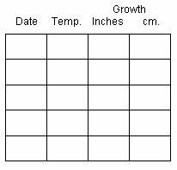 | Week 2 | Week 3

Notes:

Plant Growth Graph

5 cm
4.5 cm
4 cm
3.5 cm
3 cm
2.5 cm
2 cm
1.5 cm
1 cm
0.5 cm
 | Date | Date | Date | Date | Date | Date | Date | Date | Date | Date | Date | Date | Date | Date

