Designing Effective Projects: Sequencing Activities
Timelines

Example of a Timeline Organizer
Events Leading up to the Eureka Rebellion Timeline
This is a sample timeline a student might create.
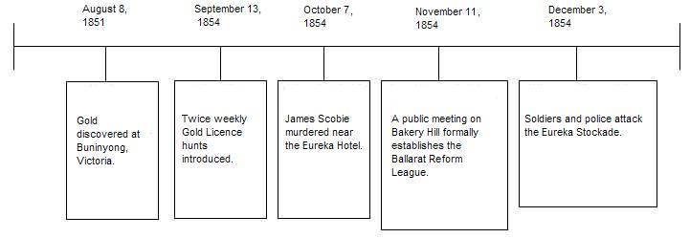
Note: An extension idea is to have students create a slideshow presentation where each student is assigned a date, types out the event, illustrates it using a draw program or clip art and the slides are compiled into one presentation.

