Contents of this Tutorial
INTRODUCTION 2
Setting Up a Blog using Edublogs or GlobalTeacher 2
How to Change Your Password 3
How to Create Your Online Profile 4
How to change the settings on your Dashboard. 5
How to Create a Post 5
How to Manage Posts 5
How to Write a Page 6
How to add an image 6
How to change the look and feel of your blog 6

INTRODUCTION
WELCOME to the Tutorial for Edublogs and Global Teacher/Student Blog Programs! Global Teacher/Student is program offered by the Victorian Department of Education and Early Childhood Development. Whilst teachers from any state can access Global Teacher, ONLY Victorian DEECD teachers can set up a Global Student project for their class.
This document outlines the steps for setting up a blog for education use through the Edublogs (http://edublogs.org) site or Global Teacher (http://globalteacher.org.au). The setup and operating system for Edublogs, Global Teacher, Global Student are the same.

Edublogs and Global Teacher have been specifically designed for the education community to create a safe, secure environment for students.

Setting Up a Blog using Edublogs or GlobalTeacher
- Go to http://edublogs.org/wp-signup.php or http://globalteacher.org.au/wp-signup.php?new= .
- Follow the prompts to sign up.
Note: Choose your Username carefully. Your Username will become your domain name, and therefore part of your web address. If you typed “johnsmith” as your Username, your new web address would be “johnsmith.globalteacher.org.au”. When using blogs, students should use first names or initials only, and avoid giving out too many personal details about themselves (e.g., name of school, name of sports teams.) IMPORTANT: When you are ready to begin signing up students, be sure they already have established email accounts. To sign up students for blog accounts, you must already have your own registered blog.
- To activate your new account, go to your email and click the “activate your blog” link.
- After you have activated your account, you will receive another email that provides your Username and password. Record your Username and password and your new blog address (you will need them later).
- Click on the link to View your site or Login. The login link will take you directly to the dashboard, which is where you can manage your blogging site. If you click on View your site, your home page will display in a default template you can use to get started blogging.
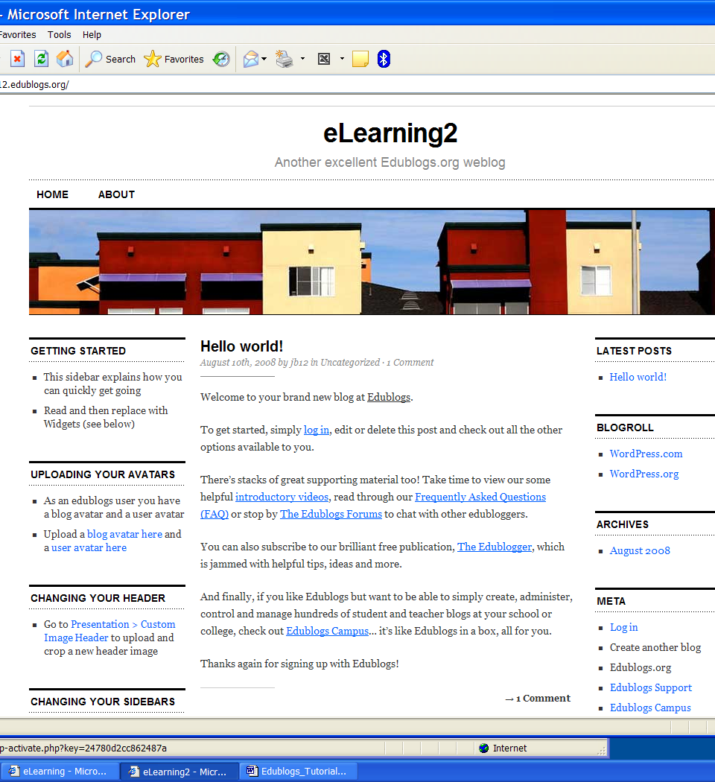
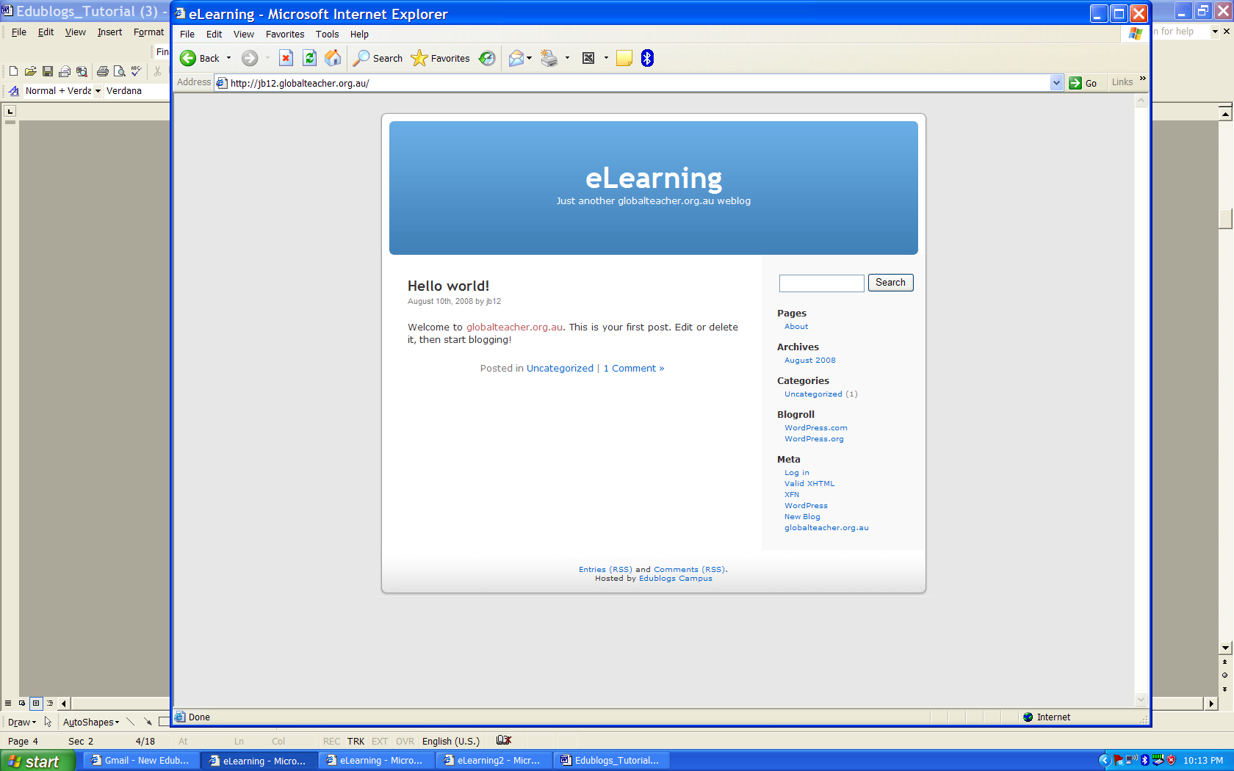
Global Teacher
Edublogs

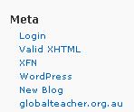
- On the right side, under the word Meta, click Login.
- A Login Page displays. Type in your Username and Password from your activation email to visit the ‘Dashboard’. The dashboard is where you can personalise your blog. Click on some of the links on the top navigation to learn more about writing and managing your blog. You can also manage your blog’s posts, pages, and uploads, format text, use a spell check program, create, save, edit, store, and publish work, import and export material, insert pictures, add categories and apply tags.

How to Change Your Password
You can change your system-generated password for one that is easier for you to remember. Follow these steps:
- On the far right hand side of the blue main navigation bar, click Users.
- From the top navigation sub menu, directly under the light blue menu , click Your Profile.
- Scroll down until you see the Update Your Password section.
- Type the new password you want to use in both of the text boxes. Use upper and lower case letters, numbers, and symbols (!&^).
- Click the Update Profile button to save your changes.
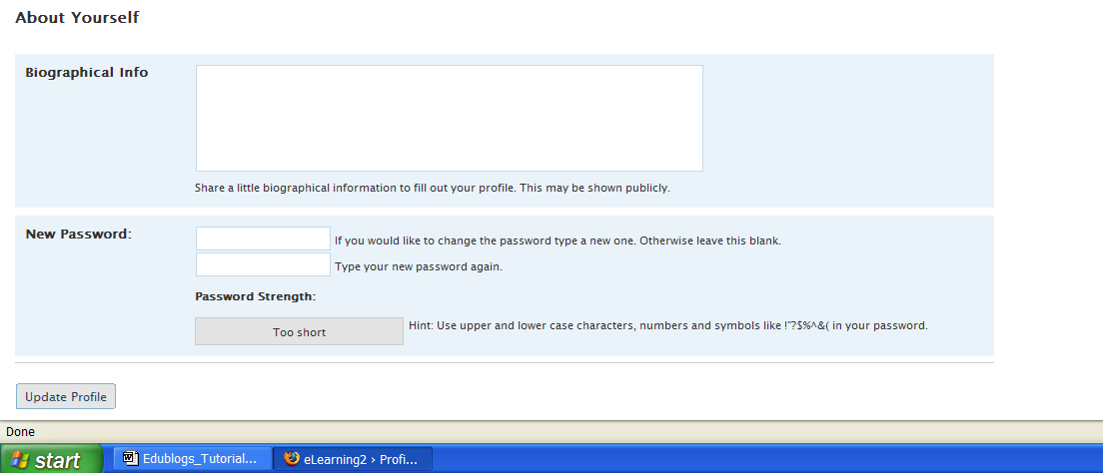

How to Create Your Online Profile
You can create or adjust an online profile to tell readers something about yourself. (But be careful not to share all your personal data.) Follow these steps:
- On the far right hand side of the blue main navigation bar, click Users.
- From the top navigation sub menu, directly under the light blue menu, click Your Profile.
- Fill in as much (or as little) information as you want to share in the Name, Contact Info, and About Yourself text boxes.
- Click the Update Profile button to save your entries.

How to change the settings on your Dashboard.
- On the far right hand side of the blue main navigation bar, click Settings.
- The General Settings page will display.
- Here you can change the blog title, the tagline, your email address, and format the date and time.
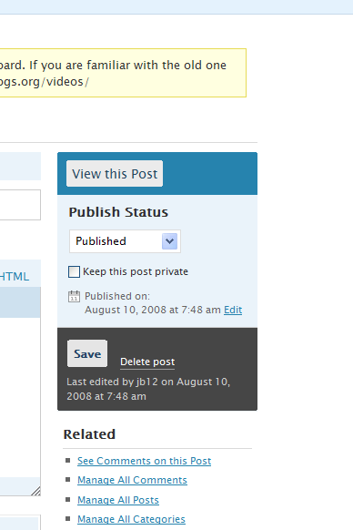

How to Create a Post
- To create a post, go to the dashboard and select Write and then select Post.
- Because posts are archived you can make categories to store them so that you can readily locate them again.
- Save the post by clicking on the ‘Save’ button on the right hand side.

How to Manage Posts

You can write, view, edit, or delete posts and related comments easily. You can assign each post to a category.
- Go to the dashboard, click Manage in the main menu, and then click Posts.
- The newest post will appear at the top of the page. All posts are archived automatically.
The system will provide a default blog titled “Hello world!” You can customise this by clicking on the link and changing the text.

How to Write a Page
- To create pages, go to the dashboard. Click Write and select Page. The main editing window will allow you to edit text using bold and hyperlinks, and also add images.
- There are some templates, which do not enable comments. If you want people to comment on a page then you need to select ‘Comments and Pings’ under ‘Advanced Options’ at the bottom of the page, and check 'Allow Comments'.

How to add an image
When you create a post or page, you can also add an image.
- At the top of the main editing window, click on the icon next to ‘Add media’.
- When the pop up window displays, select ‘Choose files to upload’. A second window will appear that will allow you to browse to the file you wish to upload.

How to change the look and feel of your blog
- Go to your dashboard and click on Display. To change the appearance ofyour blog you can scroll down and select a themed template.
- The Widgets tab allows you to alter the appearance of your side bars. Widgets allow you to place images, permanent text and links to sites like Google and del.cio.us.
Some of the themes do not use widgets. If you wish to use widgets, the Almost Spring 1.0 template is an example of a theme that does.
- To insert your own image as a header for your blog, select ‘Custom Image Header’ in the sub navigation menu.

