Name ____________________
K-W-L Chart
for
________________________
(your animal)

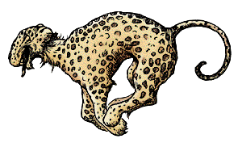

Write about what you know about your African animal. Then write questions about what you want to know. Lastly, when you have finished the unit, write about what you’ve learned.

What I Know: What I Want to Know: What I Learned:
Example  A cheetah eats antelope. | Example  How does a cheetah kill the antelope? Where do antelope live? How many antelope will a cheetah eat in one week? Do antelope ever escape from the cheetah? | Example  Cheetahs can run up to 70 mph to catch an antelope. They find the antelope grazing on the African savannah. The cheetahs have to suffocate the antelope because they have small jaws and can’t kill in one bite.

