Pedal Spreadsheet Help

Step 1: Create a Spreadsheet
Open a worksheet in a spreadsheet application. In cell A1, type the title of your study (for example, type Who Impacts Harder?). To make your title go across several columns, highlight the cells you want it to cover, select the Format menu, choose Cells, and then click the Alignment tab. In the Text control section, click Merge cells, and then click OK. You can now center your title and change your title’s font size and style. You may also want to change the background fill color.

In row 3 beginning in cell A3, type the subjects that you measured (such as Teen, Child, Adult). Enter your data in columns B or B and C.
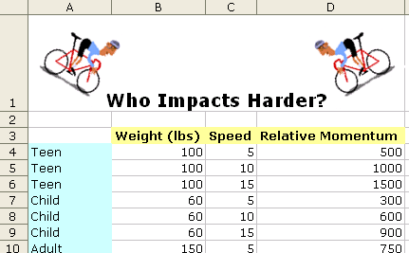

Step 2: Create a Chart or Graph
Highlight the cells that you want to represent graphically. Choose Chart on the Insert menu. Choose the chart type that you think best represents your data, then click the Next button. Follow the specific directions for your type of chart. Add titles for the chart and its axes if appropriate. Click the Gridlines tab and experiment with gridline options if gridlines apply to your type of chart. Choose gridlines that makes understanding your data easier. Click the Legend tab, choose a location for the legend, and then click Next. Place your chart as an object on the original worksheet so you can see the worksheet entries as you examine the chart, or place the chart in a separate sheet of your worksheet and label it (see the example below, which represents the spreadsheet data used in the preceding sample).

Explore several options of charts to see which one best represents your data!

Step 3: Create a Formula Using the Formula Bar
To create a formula for automatic calculation, click the cell that you want to contain the calculation (such as cell D4 under the Relative Momentum heading). Click in the Formula Bar, type an equal sign (=) to begin your formula. Determine the operation or formula you need to calculate and then enter it in the Formula Bar. For example, to obtain the average relative momentum of a teen traveling 5 mph, you need to multiply weight times speed, or B4*C4 in the example. To obtain the relative momentum of each person, copy the formula into each cell in column D.

Step 4: Create a Formula Using the Function Dialog Box
To add a formula using the Function dialog box, click the cell that you want to contain the formula. From the Insert menu, click Function. The Insert Function dialog box opens. Choose a function (many functions are available—click each function to see a short description). Click OK. In the Number 1 text box, enter the cells you want the function to include. For instance, in this example, type B4:C4. Click OK. Your data should now be calculated and shown in the cell you selected.
