IIE Web Site Script: Assessing Projects (Script 2 of 4 + 8 assessment plan scripts)
Try It

Rev 1
March 26, 2008

Information Design
Tab Hierarchy
Level 1
Level 2
Level 3
1. Try It
- Demo
- Tutorial (Left hand Navigation)
        - Browsing Assessments
        - Searching Assessments
        - Modifying Assessments
        - Copying Traits or Items
        - Creating Assessments
        - Managing Personal Library
        - Exporting Assessments

Type of Page | Level 1 Content Page
Headline Title | Try It
URL | http://educate.intel.com/en/AssessingProjects/TryIt/

[TITLE HIGHLIGHT BOX 1 ON RIGHT]
Animated Overview

[highlight Box TEXT]
View a short animation that shows key features of the tool.
View animation >

[body text]

Learn about the features of the Intel® Education Assessing Projects application—a place to create new assessments by searching, selecting, and modifying examples from a library of assessments of 21st century skills. You can build and save your own from scratch or modify assessments that address skills such as problem solving, self-direction, collaboration, and critical thinking.

Demo > Use the demo to explore the Assessment Library and examine checklists, rubrics, and scoring guides on thinking skills, processes, products, and performances.

Tutorial > See how features of the Assessing Projects application work:

- Browse and search the library to find assessments
- Modify checklists, rubrics, and scoring guides from the Assessment Library to meet your needs
- Copy traits or items from other assessments
- Create an assessment from scratch
- Manage the Personal Library
- Export an assessment to a colleague or to your personal computer

[PRORAMMING INSTRUCTIONS]

Text link | Link to Page
Demo | Demo
Tutorial | Tutorial
View Animation | http://download.intel.com/education/common/en/resources/AP/demos/AP_overview_demo/AP_overview_demo.htm

Type of Page | Level 2 Content Page
Headline Title | Demo
URL | http://educate.intel.com/assessing-demo/PersonalLibraryPage.aspx?channel=en-US&tid=ap

Type of Page | Level 2 Content Page
Headline Title | Tutorial
URL | http://educate.intel.com/en/AssessingProjects/TryIt/Tutorial/

[left-hand nav TEXT]
Browsing Assessments
Searching Assessments
Modifying Assessments
Copying Traits or Items
Creating Assessments
Managing Personal Library
Exporting Assessments

Using the Assessing Projects Application
Ms. Sohn, a third-grade teacher, is planning a unit on simple machines. She wants her students to collaborate with a partner classroom in another state to investigate simple machines in their environments and share simple machines they have designed. They plan to create a wiki for pubishing student work on the Internet. During this unit, she is going to focus on the 21st century skills of self-direction and collaboration. Ms. Sohn uses the Assessing Projects Application to create her assessments as follows:

- While brainstorming ideas for her unit, she browses the Assessment Library to see what kinds of assessments are available that relate to what she wants students to learn in the unit.

- She then searches the Assessment Library for assessments on self-direction, collaboration, and simple machines.

- She finds a self-direction rubric and a collaboration checklist that she would like to use in her unit, but first she needs to modify them to fit the specific project.

- In the past, Ms. Sohn has had success with a rubric she uses to assess student publishing using wikis. She would like to save it to her Teacher Workspace, so she uses the application to create this assessment from scratch.

- Ms. Sohn wants her assessment to address 21st century skills. She uses the Quick Search feature to copy traits from other assessments and add them to her wiki rubric.

After Ms. Sohn creates a few assessments, she organizes them by managing her Personal Library.

To add graphics and other design features, and to share her assessments with her colleague in the partner classroom, Ms. Sohn exports her assessments to her desktop and uses the e-mail feature to share her resources.

Page 1 of 8 | Next >

[PRORAMMING INSTRUCTIONS]

Text Link | Link to Page
Browsing Assessments/Next | http://educate.intel.com/en/AssessingProjects/TryIt/Tutorial/AP_Browse_Assess.htm
Searching Assessents | http://educate.intel.com/en/AssessingProjects/TryIt/Tutorial/AP_Search_Assess.htm
Modifying Assessments | http://educate.intel.com/en/AssessingProjects/TryIt/Tutorial/AP_Modify_Assess.htm
Copying Traits or Items | http://educate.intel.com/en/AssessingProjects/TryIt/Tutorial/AP_Copy.htm
Creating Assessments | http://educate.intel.com/en/AssessingProjects/TryIt/Tutorial/AP_Creating.htm
Managing Personal Library | http://educate.intel.com/en/AssessingProjects/TryIt/Tutorial/AP_Managing_Per_Library.htm
Exporting Assessments | http://educate.intel.com/en/AssessingProjects/TryIt/Tutorial/AP_Exporting_Assess.htm

Type of Page | Level 3 Content Page
Headline Title | Browsing Assessments
URL | http://educate.intel.com/en/AssessingProjects/TryIt/Tutorial/AP_Browse_Assess.htm

[left-hand nav TEXT]
Browsing Assessments
Searching Assessments
Modifying Assessments
Copying Traits or Items
Creating Assessments
Managing Personal Library
Exporting Assessments

Browsing the Assessment Library
After Ms. Sohn logs on to the Teacher Workspace using her logon ID and password, she browses through the Assessment Library to see what is available.

She clicks on the plus signs (+) in front of each category in the Assessment Library to see its subcategories. When she clicks on a subcategory, the titles of all the assessments in that subcategory appear, and short descriptions of the assessments appear in the right pane. When she selects a specific assessment, a more detailed description of that assessment appears in the right pane.

View the animation >

[Insert browse.jpg]

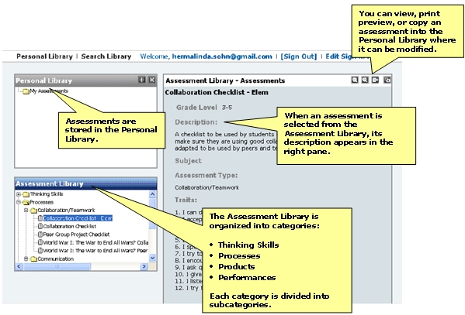

< Back | Page 2 of 8 | Next >

[PRORAMMING INSTRUCTIONS]

Text Link | Link to Page
Back | http://educate.intel.com/en/AssessingProjects/TryIt/Tutorial/
Next | http://educate.intel.com/en/AssessingProjects/TryIt/Tutorial/AP_Search_Assess.htm
View Animation | http://download.intel.com/education/common/en/resources/AP/demos/browsing/browsing.htm

Type of Page | Level 3 Content Page
Headline Title | Searching Assessments
URL | http://educate.intel.com/en/AssessingProjects/TryIt/Tutorial/AP_Search_Assess.htm

[left-hand nav TEXT]
Browsing Assessments
Searching Assessments
Modifying Assessments
Copying Traits or Items
Creating Assessments
Managing Personal Library
Exporting Assessments

Searching the Assessment Library
Since Ms. Sohn wants to focus on collaboration and self-direction during this unit, she wants to find out what assessments are in the Assessment Library on those 21st century skills. She uses the search feature to look for assessments on self-direction.

View the animation >

[Insert search.jpg]
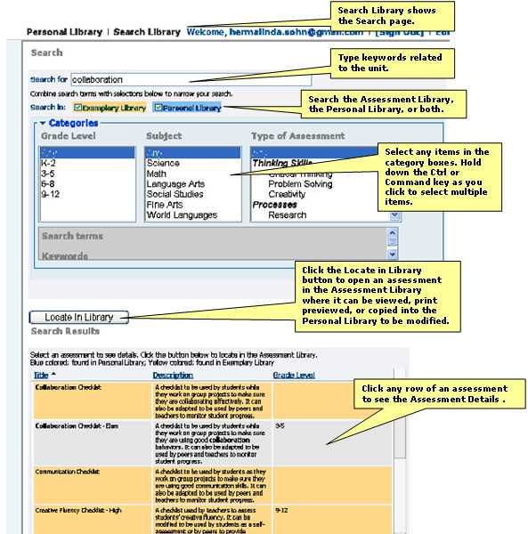

After browsing and searching the Assessment Library, Ms. Sohn saves those that will work her unit to her Personal Library, Ms. Sohn saves three kinds of assessments—checklists, rubrics, and scoring guides.

In her search for self-direction, she located a checklist to help students think about their work during projects. Students will complete this checklist as they work, and Ms. Sohn will use it as a basis for student conferences.

[Insert checklist.jpg]

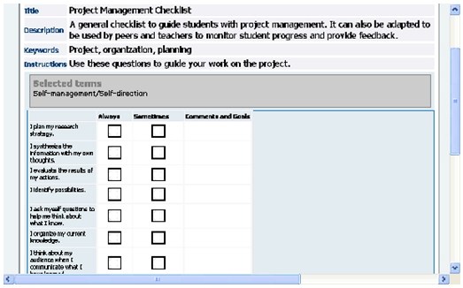

In her search for assessments on self-direction, Ms. Sohn also finds a rubric for middle school students that she can modify to use with her students.

[Insert rubric.jpg]

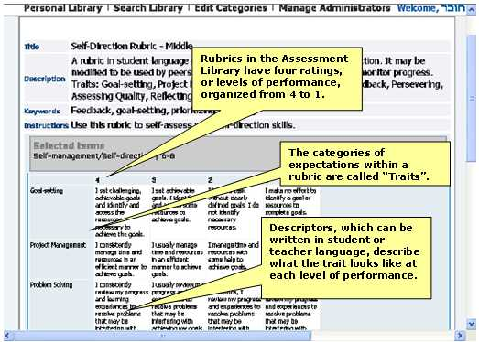

Ms. Sohn searches for “science” assessments in the Assessment Library and finds a scoring guide for a journal that is part of a unit on insects. Her students will keep a journal for their simple machines project, and she would like to modify this assessment to fit her unit.

[Insert Scoring_Guide.jpg]

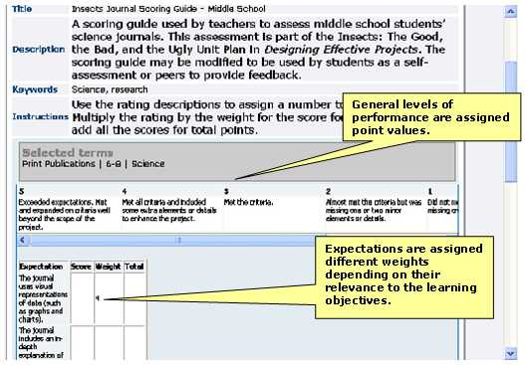

< Back | Page 3 of 8 | Next >

[PRORAMMING INSTRUCTIONS]

Text Link | Link to Page
Back | http://educate.intel.com/en/AssessingProjects/TryIt/Tutorial/AP_Browse_Assess.htm
Next | http://educate.intel.com/en/AssessingProjects/TryIt/Tutorial/AP_Modify_Assess.htm
View Animation | http://download.intel.com/education/common/en/resources/AP/demos/searching/searching.htm

Type of Page | Level 3 Content Page
Headline Title | Modifying Assessments
URL | http://educate.intel.com/en/AssessingProjects/TryIt/Tutorial/AP_Modify_Assess.htm

[left-hand nav TEXT]
Browsing Assessments
Searching Assessments
Modifying Assessments
Copying Traits or Items
Creating Assessments
Managing Personal Library
Exporting Assessments

Customizing an Assessment
Ms. Sohn wants to use a middle school self-direction rubric that she found in her search. She needs to adapt it for her elementary students as well as include specific references to the project students are working on in this unit.

View the animation >

[Insert Customize_Assessment.jpg]

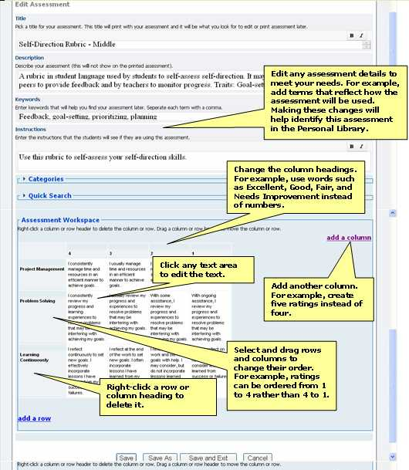

Ms. Sohn can make many changes to assessments in her Personal Library within the application. For example, she can:
- Delete ratings to describe only two or three levels of performance
- Add ratings to describe more than four levels of performance
- Reorder ratings to go from low to high
- Change rating levels from numbers to words such as Excellent, Good, Satisfactory, Developing, and so forth
- Change rating levels to points possible (create a scoring guide)
- Add or delete traits or items
- Modify descriptors to make them specific to a particular unit or project
- Change the language to make the assessment appropriate for a different age group
- Reorder traits (rows) or ratings (columns)

< Back | Page 4 of 8 | Next >

[PRORAMMING INSTRUCTIONS]

Text Link | Link to Page
Back | http://educate.intel.com/en/AssessingProjects/TryIt/Tutorial/AP_Search_Assess.htm
Next | http://educate.intel.com/en/AssessingProjects/TryIt/Tutorial/AP_Copy.htm
View Animation | http://download.intel.com/education/common/en/resources/AP/demos/modify_assessments/modify_assessments.htm

Type of Page | Level 3 Content Page
Headline Title | Copying Traits or Items
URL | http://educate.intel.com/en/AssessingProjects/TryIt/Tutorial/AP_Copy.htm

[left-hand nav TEXT]
Browsing Assessments
Searching Assessments
Modifying Assessments
Copying Traits or Items
Creating Assessments
Managing Personal Library
Exporting Assessments

Adding Traits or Items from Other Assessments
Ms. Sohn has modified the rubric on self-direction to suit her students. Now she wants to add traits to it from other assessments.

View the animation >

[Insert Copy_Traits.jpg]

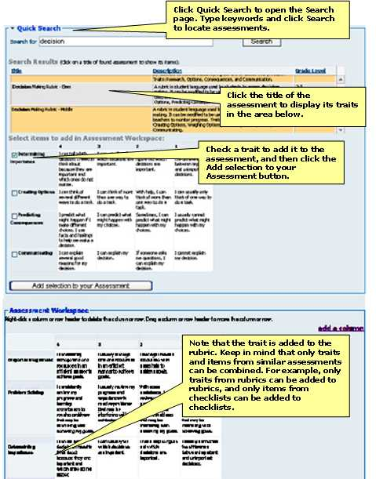

Click Quick Search to open the Search page. Type keywords and click Search to locate assessments.
< Back | Page 5 of 8 | Next >

[PRORAMMING INSTRUCTIONS]

Text Link | Link to Page
Back | http://educate.intel.com/en/AssessingProjects/TryIt/Tutorial/AP_Modify_Assess.htm
Next | http://educate.intel.com/en/AssessingProjects/TryIt/Tutorial/AP_Creating.htm
View Animation | http://download.intel.com/education/common/en/resources/AP/demos/copy_items/copy_items.htm

Type of Page | Level 3 Content Page
Headline Title | Creating Assessments
URL | http://educate.intel.com/en/AssessingProjects/TryIt/Tutorial/AP_Creating.htm

[left-hand nav TEXT]
Finding Assessments
Modifying Assessments
Copying Traits or Items
Creating Assessments
Managing Personal Library
Exporting Assessments

Creating an Assessment from Scratch
In a previous unit, Ms. Sohn created a rubric to help her students self-assess collaborative work using a wiki. She wants to add this rubric to her Personal Library so she can copy traits to it from other assessments in the Assessment Library. To do this, she creates an assessment from scratch by clicking the Create Assessment icon in the right pane of her Teacher Workspace.

View the animation >

[Insert Create_Assessment_1.jpg]

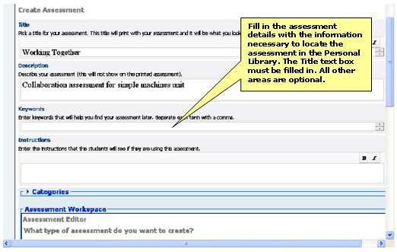

[Insert Create_Assessment_2]

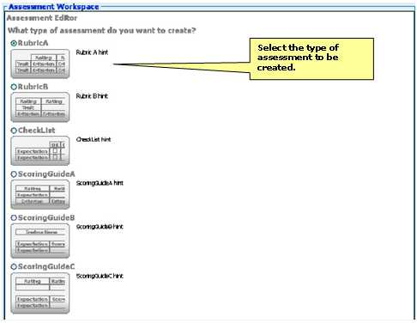
Ms. Sohn types the content of her rubric into the application. Then, she adds rows and columns and drags them to organize them into a different order. She can use the Quick Search feature to copy traits from other rubrics into her assessment.

[Insert Create_Assessment_3.jpg]

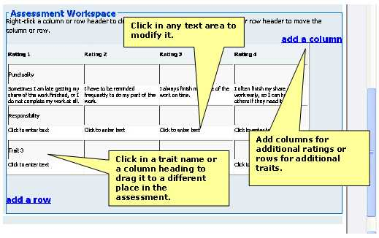

< Back | Page 6 of 8 | Next >
[PRORAMMING INSTRUCTIONS]

Text Link | Link to Page
Back | http://educate.intel.com/en/AssessingProjects/TryIt/Tutorial/AP_Copy.htm
Next | http://educate.intel.com/en/AssessingProjects/TryIt/Tutorial/AP_Managing_Per_Library.htm
View Animation | http://download.intel.com/education/common/en/resources/AP/demos/create_assessments/create_assessments.htm

Type of Page | Level 3 Content Page
Headline Title | Managing Personal Library
URL | http://educate.intel.com/en/AssessingProjects/TryIt/Tutorial/AP_Managing_Per_Library.htm

[left-hand nav TEXT]
Browsing Assessments
Searching Assessments
Modifying Assessments
Copying Traits or Items
Creating Assessments
Managing Personal Library
Exporting Assessments

Organizing the Personal Library
By now, Ms. Sohn has accumulated quite a few assessments in her Personal Library. To organize them, she creates folders and subfolders.

View the animation >

[Insert Personal_Library.jpg]

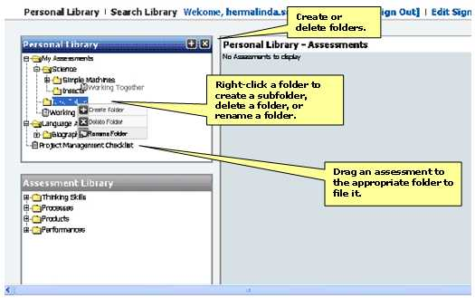

< Back | Page 7 of 8 | Next >

[PRORAMMING INSTRUCTIONS]

Text Link | Link to Page
Back | http://educate.intel.com/en/AssessingProjects/TryIt/Tutorial/AP_Creating.htm
Next | http://educate.intel.com/en/AssessingProjects/TryIt/Tutorial/AP_Exporting_Assess.htm
View Animation | http://download.intel.com/education/common/en/resources/AP/demos/manage_library/manage_library.htm

Type of Page | Level 3 Content Page
Headline Title | Exporting Assessments
URL | http://educate.intel.com/en/AssessingProjects/TryIt/Tutorial/AP_Exporting_Assess.htm

[left-hand nav TEXT]
Browsing Assessments
Searching Assessments
Modifying Assessments
Copying Traits or Items
Creating Assessments
Managing Personal Library
Exporting Assessments

Enhancing Assessments
Ms. Sohn wants to add some features to her assessment that cannot be added in the application. She exports the Simple Machines Wiki Rubric to her personal computer where she can use her word processing or spreadsheet software to make additional changes.

View the animation >

[Insert export_1_jpg]

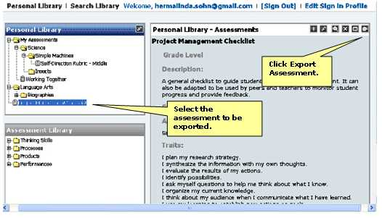

[Insert Export_2]

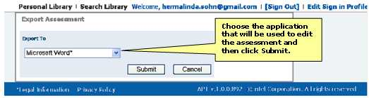

After Ms. Sohn exports her assessment to her computer, she can add features to make it more useful for her students and herself. For instance, she can:

- Add customized headings with spaces for name, date, class, or subject
- Change the text’s color, size, or style
- Change the table’s colors, borders, or other properties
- Add pictures, charts, or diagrams
- Merge cells, rows, or columns to organize information
- Embed useful documents within the assessment, such as guidelines for citations or project tips
- Add spaces for students to set goals, monitor their progress, or reflect on their learning

Sharing Assessments
Ms. Sohn often collaborates with a teacher from another school whom she met during her Intel® Teach Essentials Course training. She wants to share her assessment with the teacher. To do this, she selects the Simple Machines Wiki Rubric and clicks the E-mail button in the right pane of her Personal Library.

[Insert Share_1.jpg]

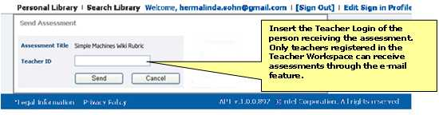

Receiving Exported Assessments
[Insert Share_2.jpg]

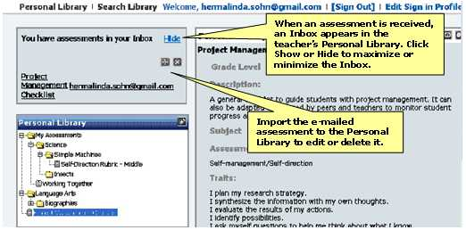

< Back | Page 8 of 8

[PRORAMMING INSTRUCTIONS]

Text Link | Link to Page
Back | http://educate.intel.com/en/AssessingProjects/TryIt/Tutorial/AP_Managing_Per_Library.htm
View Animation | http://download.intel.com/education/common/en/resources/AP/demos/export/export.htm

