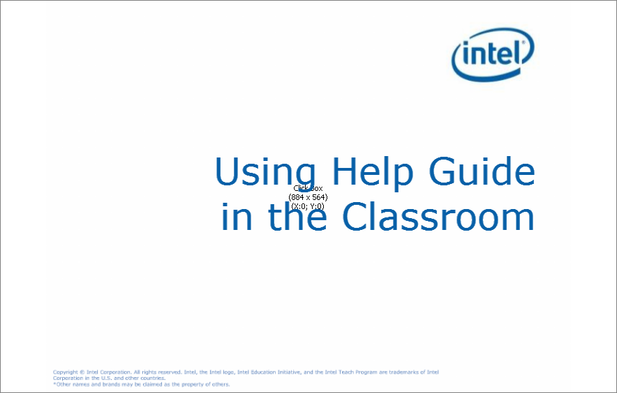
Slide 1
Slide notes:
Text Captions: Using Help Guide in the Classroom


Slide 2
Slide notes: Looking for a tutor who is ready to help your students' complete tasks with
productivity software? The Intel Education Help Guide is the tool that can provide
those step-by-step instructions. Let's take a closer look.

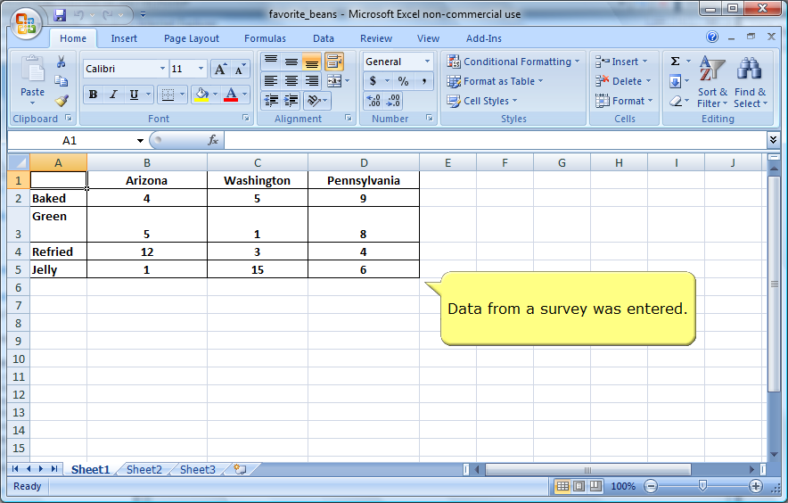
Slide 3
Slide notes: After entering data in a spreadsheet, students need help with creating a chart from
their data.

Text Captions: Data from a survey was entered.

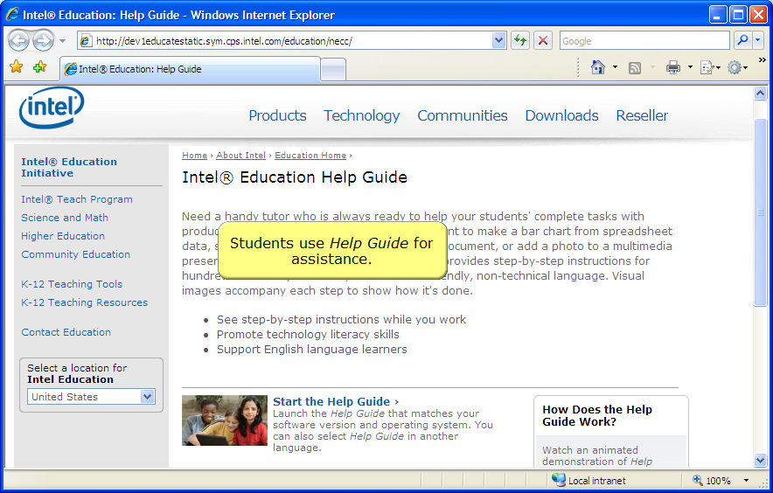
Slide 4
Slide notes: Students go to Help Guide to find instructons on creating charts from spreadsheet
data.

Text Captions: Students use Help Guide for assistance.

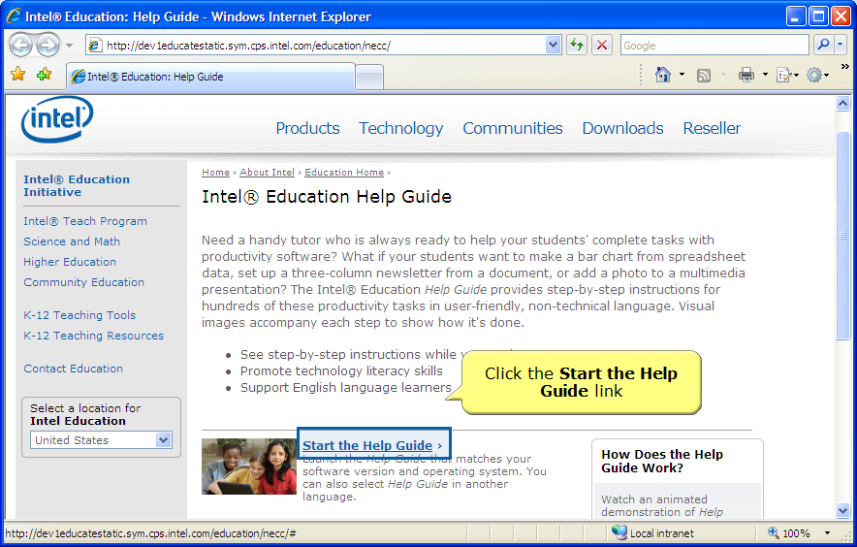
Slide 5
Slide notes:
Text Captions: Click the Start the Help Guide link

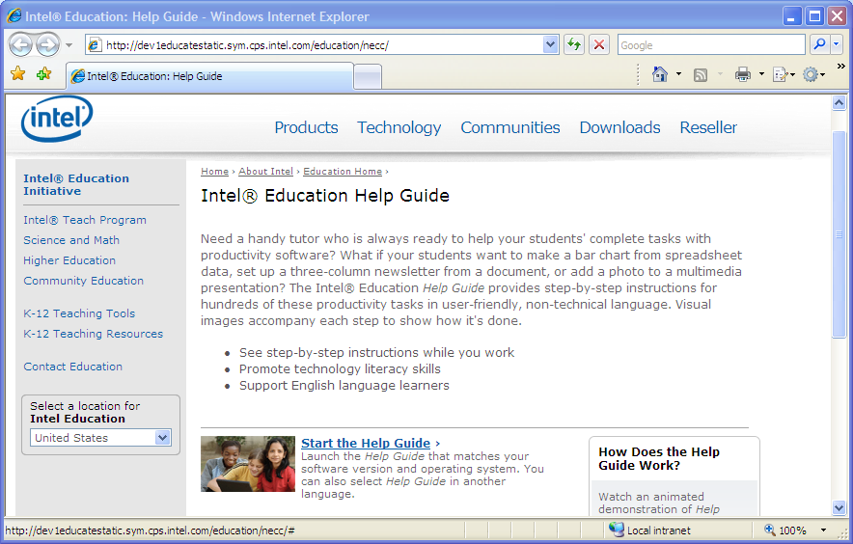
Slide 6
Slide notes:

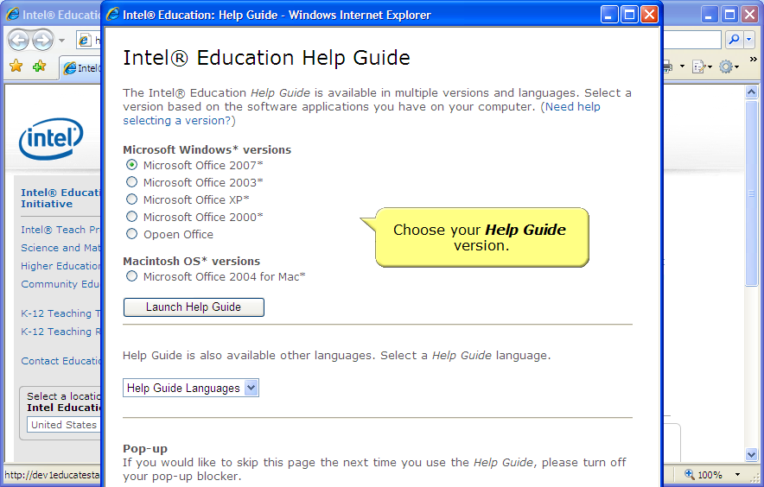
Slide 7
Slide notes: Help Guide can be used with a variety of computers, productivty software and
operating systems.

Text Captions: Choose your Help Guide version.

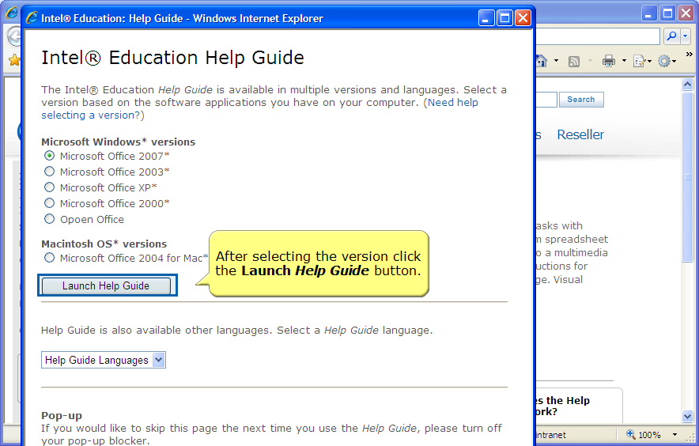
Slide 8
Slide notes:
Text Captions: After selecting the version click the Launch Help Guide button.

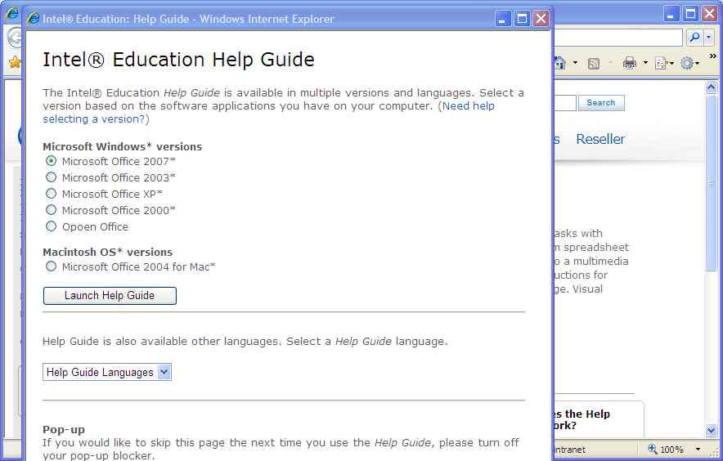
Slide 9
Slide notes:

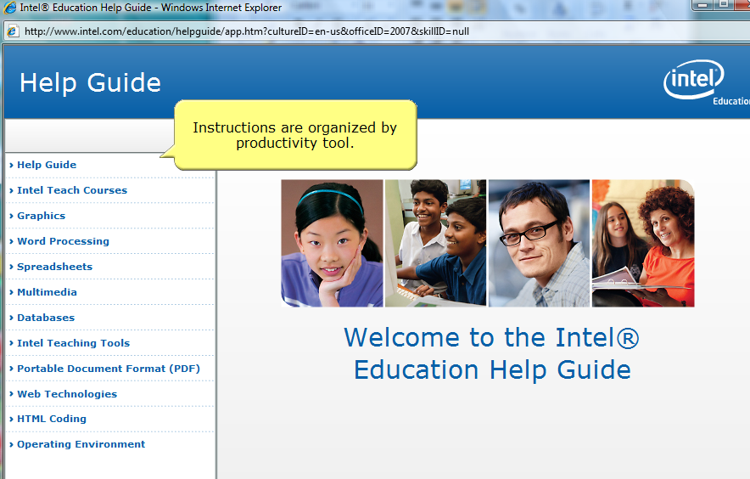
Slide 10
Slide notes: Students use the left-hand navigation to find the skill they need.

Text Captions: Instructions are organized by productivity tool.


Slide 11
Slide notes:
Text Captions: Choose the software

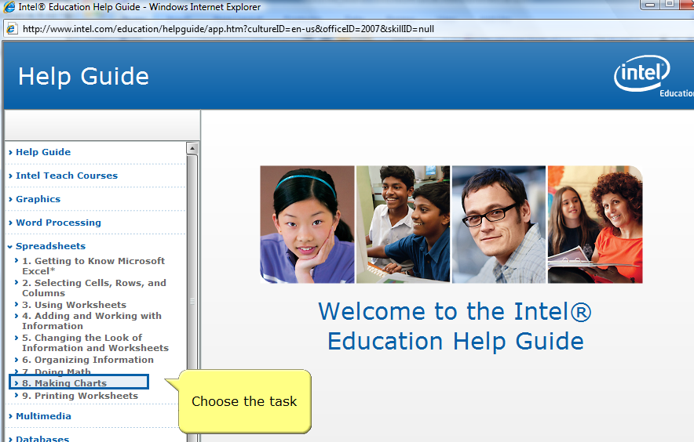
Slide 12
Slide notes:
Text Captions: Choose the task

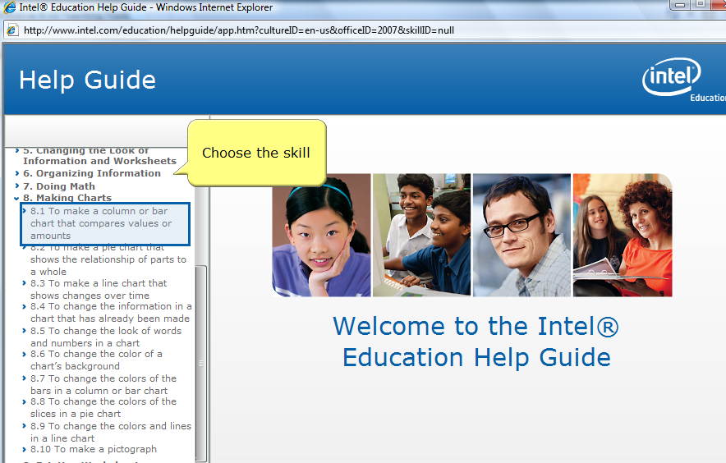
Slide 13
Slide notes:
Text Captions: Choose the skill

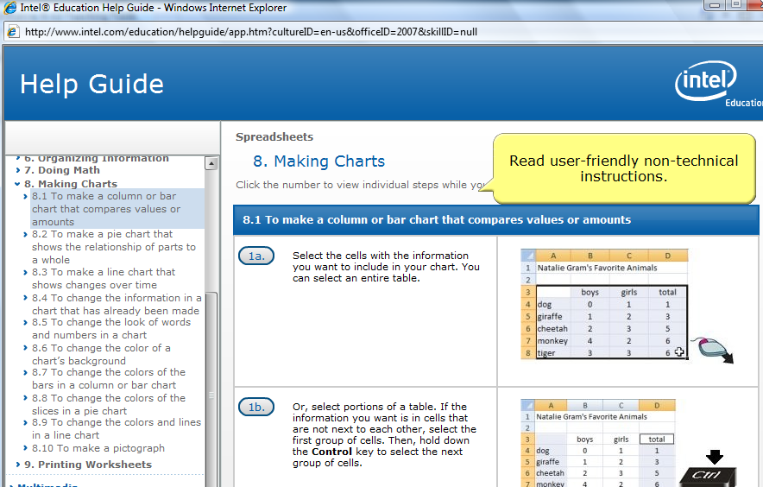
Slide 14
Slide notes: Students select the skill and see step-by-step instructions with images.

Text Captions: Read user-friendly non-technical instructions.

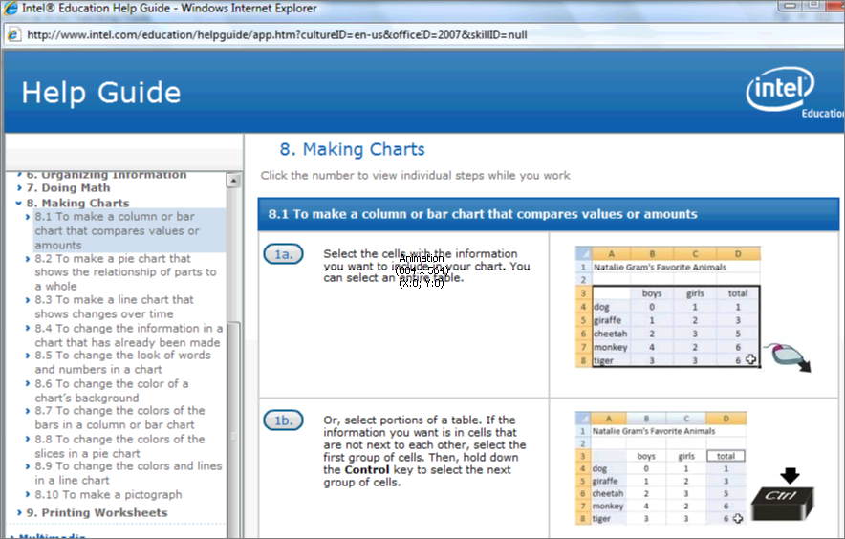
Slide 15
Slide notes: Students can scroll to preview all steps associated with a skill.

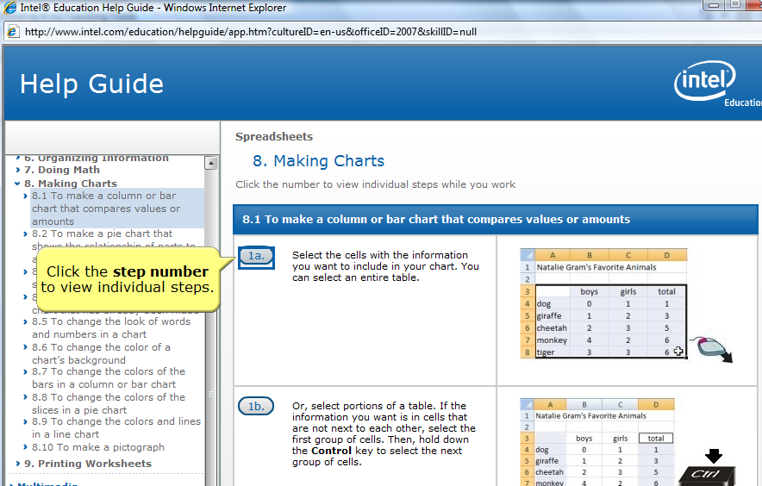
Slide 16
Slide notes: Or students can view the individual steps while they work.

Text Captions: Click the step number to view individual steps.

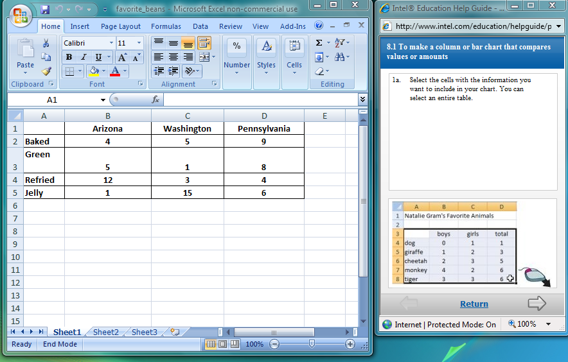
Slide 17
Slide notes: You can view both the software and help guide step.

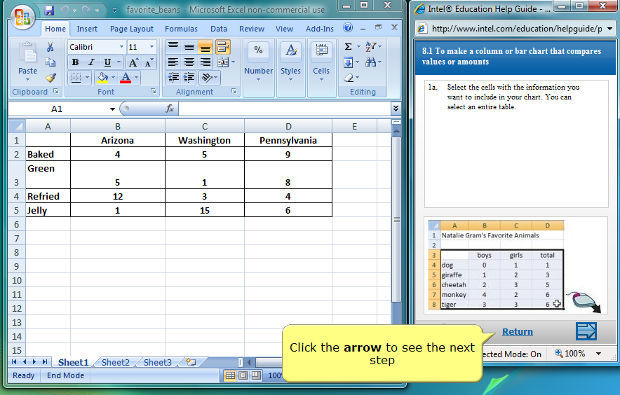
Slide 18
Slide notes: Use the arrow buttons to move between steps

Text Captions: Click the arrow to see the next step

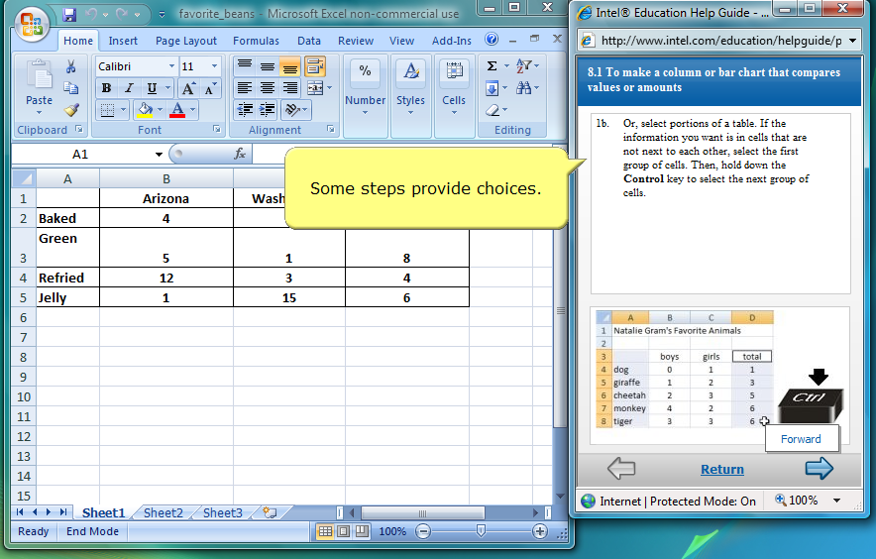
Slide 19
Slide notes:
Text Captions: Some steps provide choices.

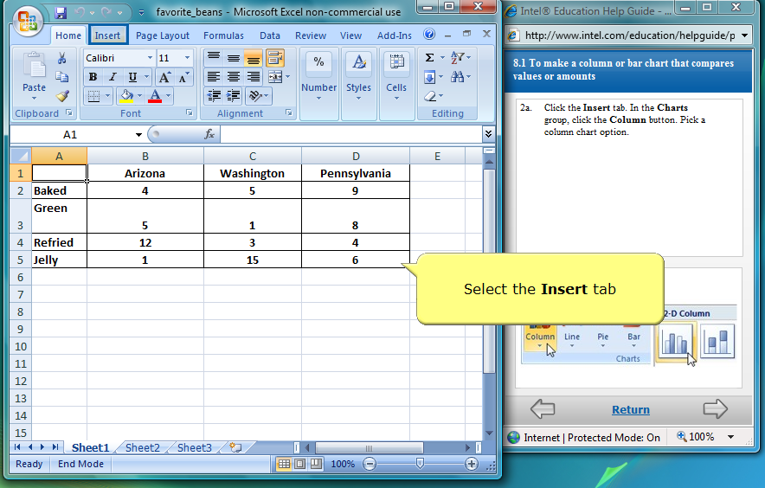
Slide 20
Slide notes:
Text Captions: Select the Insert tab

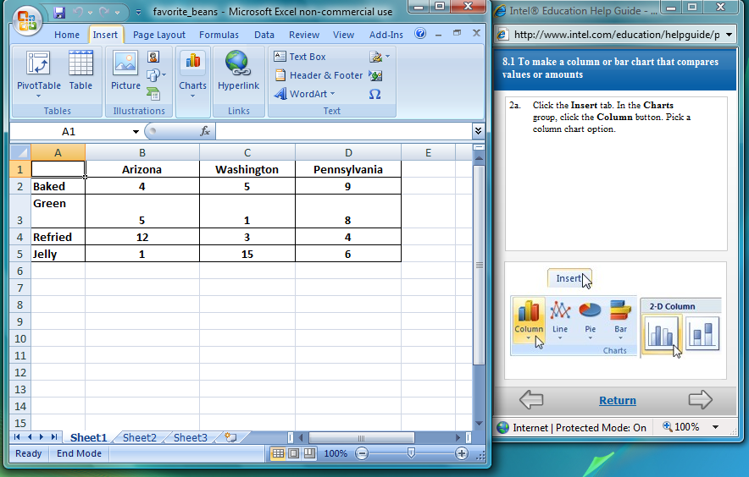
Slide 21
Slide notes:

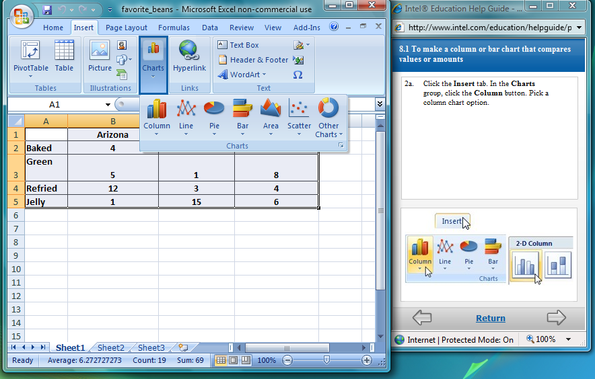
Slide 22
Slide notes:

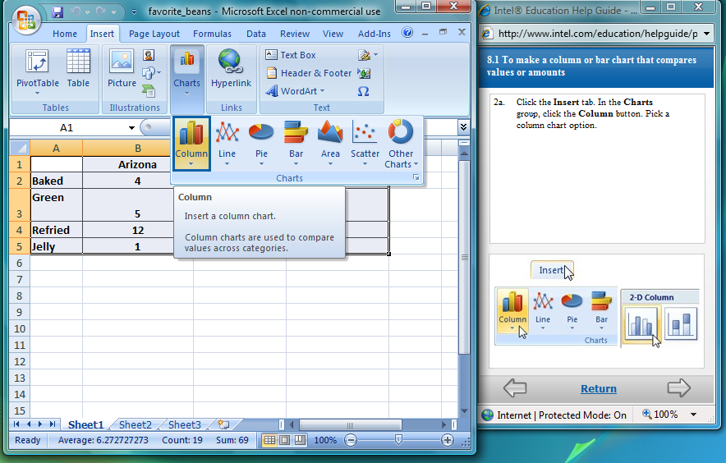
Slide 23
Slide notes: Students work at thier own pace getting the help that they need as they need it.

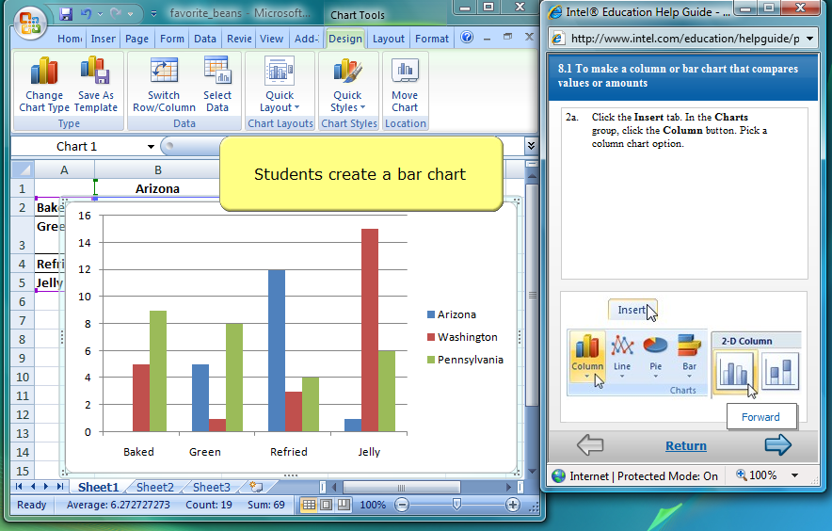
Slide 24
Slide notes:
Text Captions: Students create a bar chart

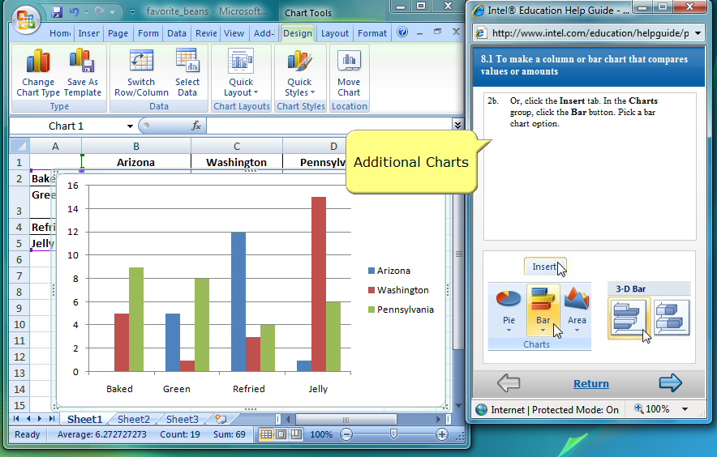
Slide 25
Slide notes: Students continue to explore different types of
charts.

Text Captions: Additional Charts

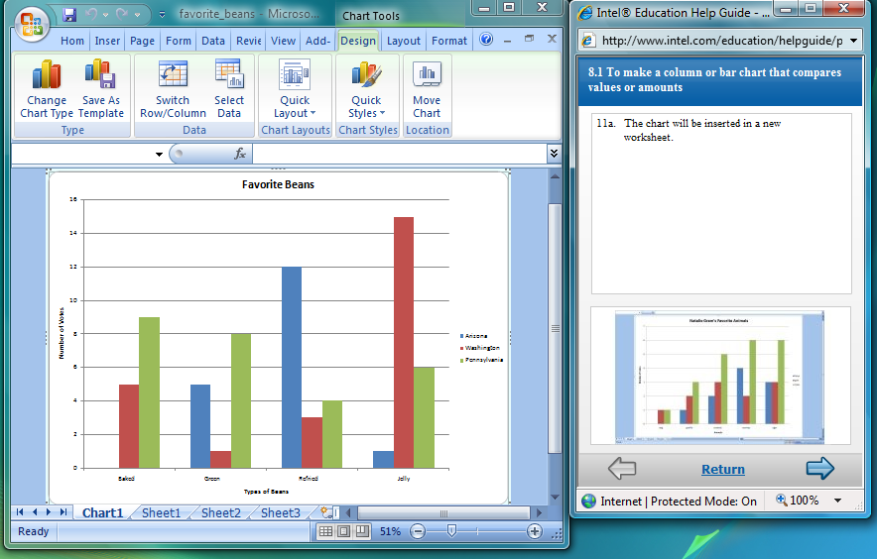
Slide 26
Slide notes: The final result is a complete chart with labels.

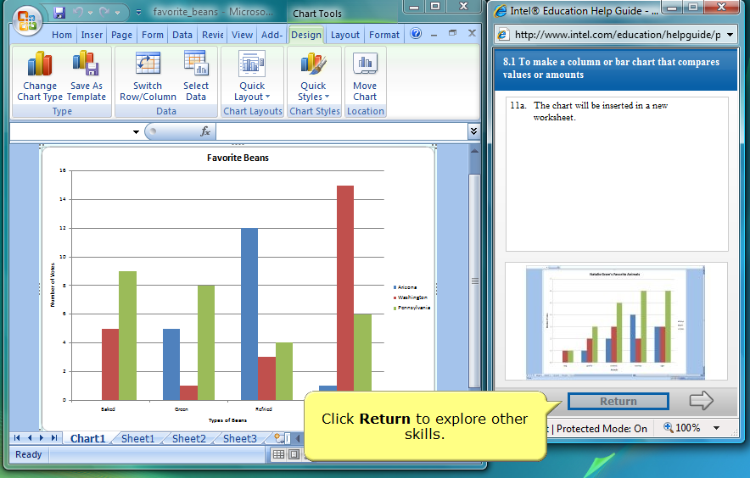
Slide 27
Slide notes:
Text Captions: Click Return to explore other skills.

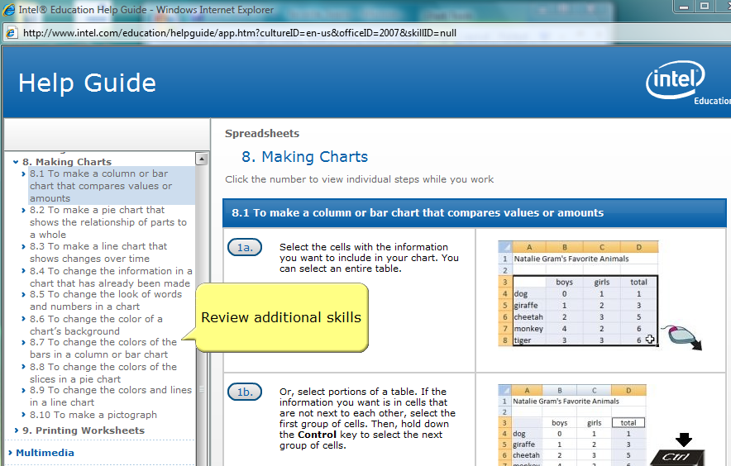
Slide 28
Slide notes: Students can now review additional skills such as changing the color of a chart's
background or find the Mulitmedia skill to learn how to add their chart to a
presentation.

Text Captions: Review additional skills

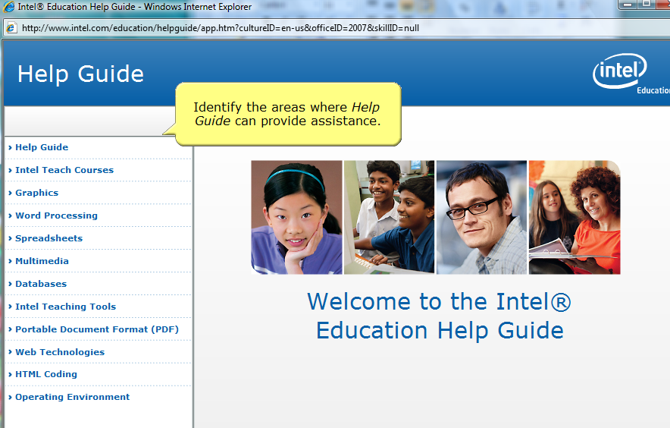
Slide 29
Slide notes: Help Guide can make every student an expert.

Text Captions: Identify the areas where Help Guide can provide assistance.

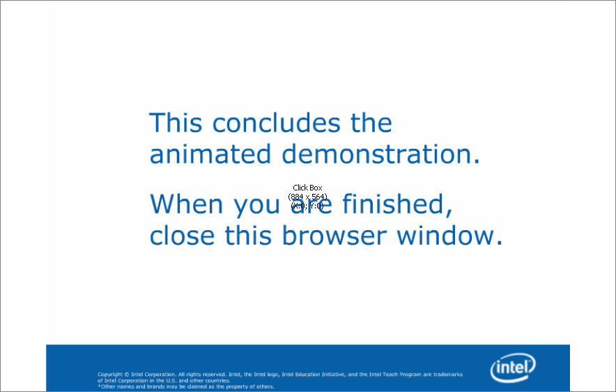
Slide 3
Slide notes:

