RoboHelp Documentation

RoboHelp is an Adobe software package that helps authors create CD, desktop, or web help based packages. Intel uses RoboHelp to create CD’s for projects like Essentials and Thinking with Technology. Below you will find documentation on creating a CD resource using Robohelp.

Systems and software requirements

- RoboHelp version 7.0 or higher.
- Intel® Pentium® 4 processor
- Microsoft® Windows Vista™, Windows® XP with IIS 5.0/6.0, Windows Server® 2003 with IIS 6.0, and Windows 2000/2000 Server with IIS 5.0
- 256MB of RAM
- 200MB of available hard-disk space
- CD burner and CD burning software.
- 1 Gig free Hard Drive space for projects you create and space for builds.

Getting started
You will need:

- Intel 3.0 Skins (as of July 2008)
- Graphics PSD file for creating buttons.
- 3 files that are used to change out the About CD pop-up (2 files to add and 1 that you modify)
- Launch page and graphics that are put in the root of the project to launch the application.
- CD instructions folder that are used on CD as a help file to show users how to navigate the project.

We recommend having the following files in addition to the above:
- A sample project that you can use as reference or use to edit to create a new project (including the CD instructions folder on how to navigate the project).

Beginning your project

Double click the RoboHelp icon to launch the application.

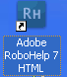

To Open an Existing Project,,,click on the link to your existing project and it will open, or click browse to open a different project.

To Create a New Project, click on Web Help and follow the steps below

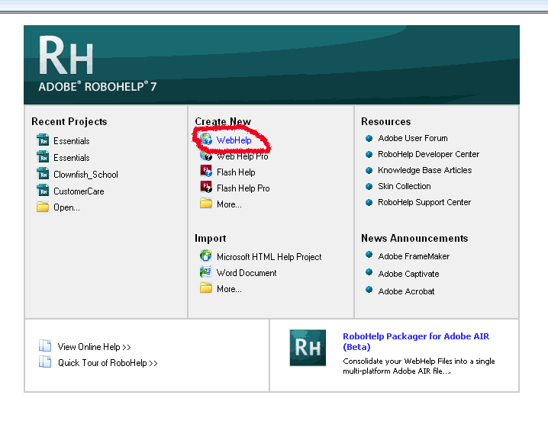

Set up your initial project parameters in the New Project Wizard dialog box:

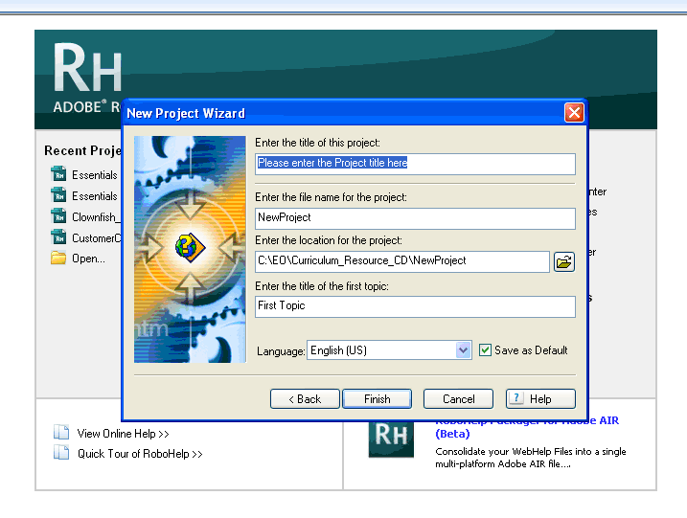
Fill in the following information as follows:
- “Enter the Project title here”
  - Enter the name of your project, such as “Intel Education Essentials Resource CD”. This name will display in the Browser Title bar when the project starts.
    - Note that other boxes will fill in automatically.
- “Enter the file name of the project”,
  - Enter the same file name with NO spaces between words. Use underscores instead: “Essentials_Resource_CD.”
- “Enter the location of the project”,
  - Browse to the target location where you want to store your work in progress.
  - Note that the location where you set up your project is not the same location that you will output your project to, so you can choose any location. For example: c:\test\Essentials_Resource_CD or c:\Temp.
- Enter the title for your first topic. A good starting title is “Welcome.”
- Click Finish.

You should now see a screen that looks like below:
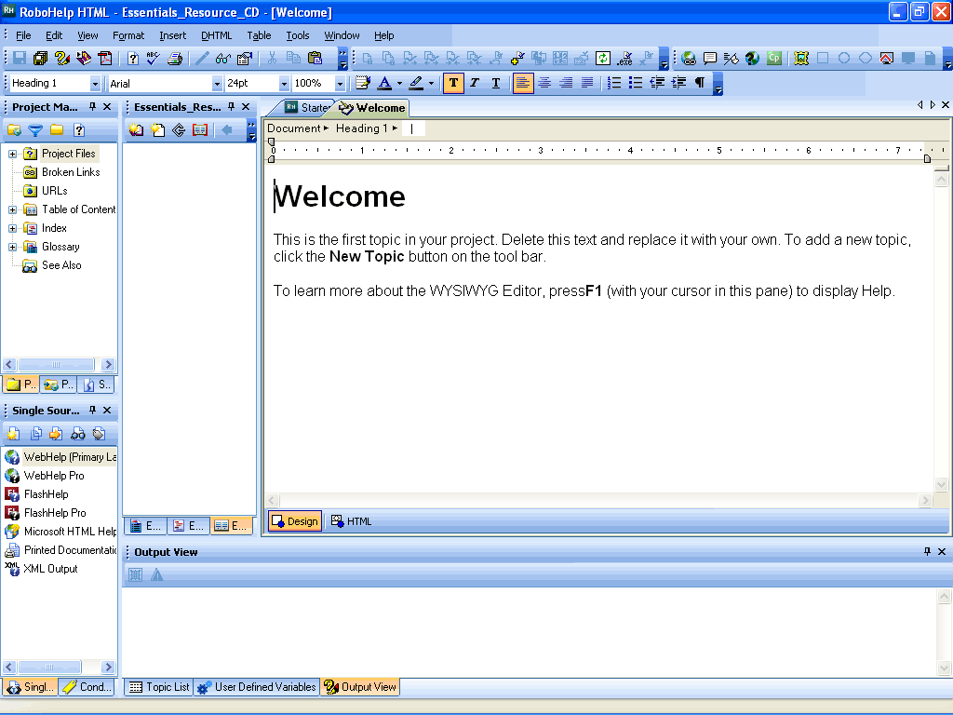

Adding Skins to your project

Intel uses a specific skin for the resource CD. To import the skin, click on the “Project Set-up” Tab, (center tab in the project manager window).

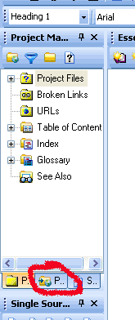

On the Project Set-up tab, you should see Skins listed. Right mouse click on the skins and select Import

.

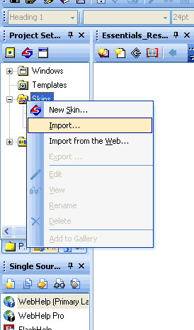

Browse to the RoboHelp Resource CD that came with these instructions (or other location) to find the Intel _30_skin. The skin will be in the folder:!SkinSubFolder!\ Intel_30_Skin\

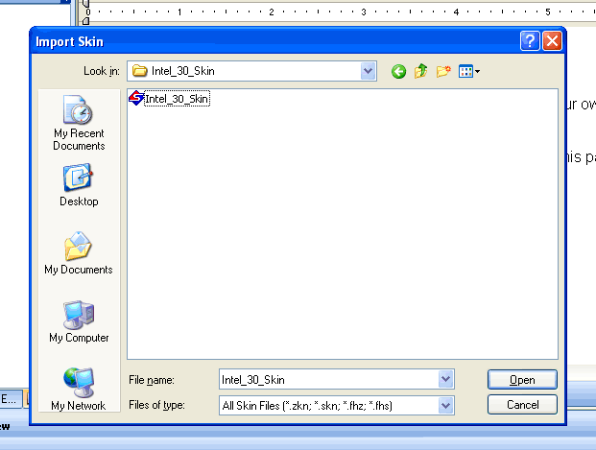
Select the Intel_30_skin and click Open.

The next screen allows you to modify the skin’s look and feel and behavior.
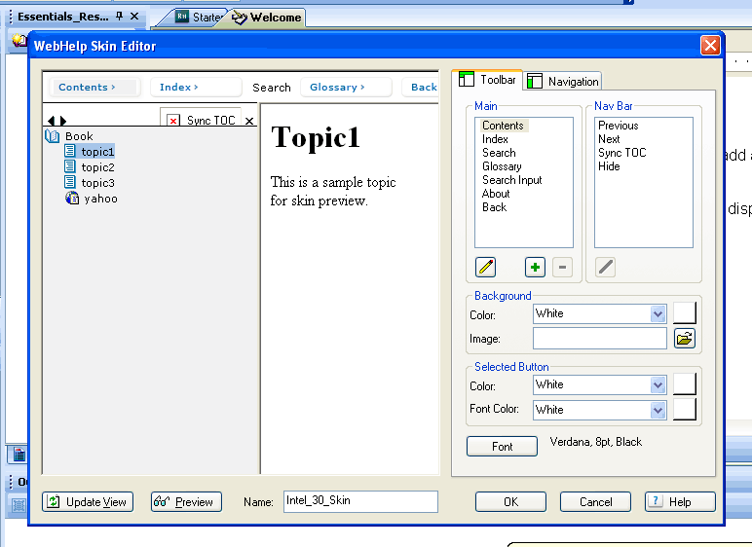

Note: you can come back to this screen later to make changes at any time. Right mouse clicking on the Intel_30_Skin and select edit.
Click OK.

When prompted for a file name for the new skin, accept the default.

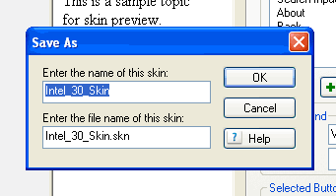

Setting up the Content Structure

Click on the project tab as shown below to return to the file structure of the project.
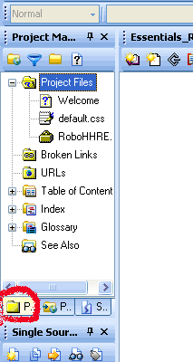

Now you should see “project folder” in your list. Click the + to expand the list.

Note: RoboHelp generates numerous files that can make file navigation confusing. We recommend you create folders under the project folder for all of your images, HTML, and resource files (docs, pdfs, xls, ppt, etc) for better navigation and organization.
To create Folders:
Right mouse click on the root Project Files folder, and select New.Folder

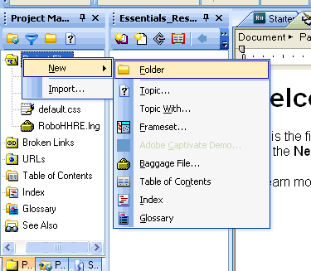

Now type in the name of your folder, (Example would be a folder called HTML)

Create another folder under HTML by right clicking on the HTML folder and selecting New. Give this folder the name images.

Your file structure should look like the following:

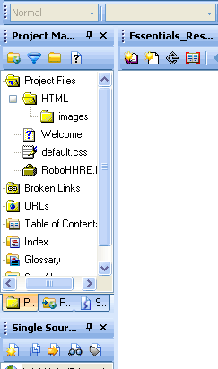

Continue creating all the folders you will need in the project.

Creating an Introductory Page

By default, when you set-up your project, an introductory page called Welcome.html (or whatever you named your first topic when you set-up the project) was created and appears in your project list. This will be the first page the user sees or an introductory page

Note: You can change this default later when you produce a compiled version (see the section building a project).

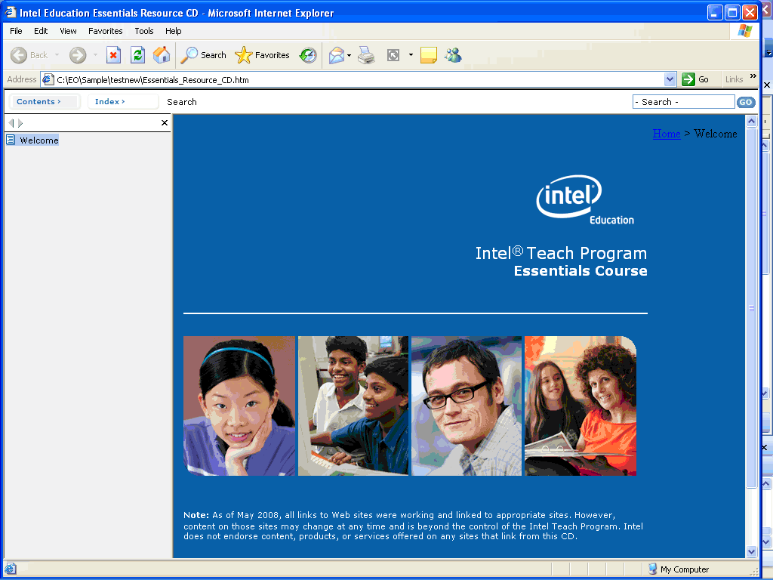

You can create the introductory page in several ways

- You can import an existing cover page from another project.
  - Difficulty: Easy
- You can paste the HTML into the editor for the welcome page and modify as needed.
  - Difficulty: Medium
- Create your own.
  - Difficulty: High

1. Importing a page into your project
Click on the folder in the project manager where you want the file to be imported to.

Right mouse click on that folder and select import.

Note: If a file is imported into your project, it will also bring over any images linked with that page.

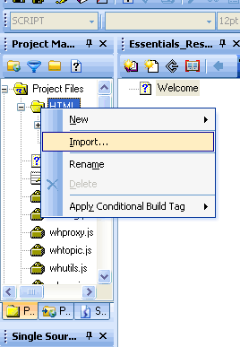

Select the file(s) that you wish to import and click open.

Note: A message may appea,r informing you that some files are outside of the project and will be included, or that some files already exist in your project and you will be given an option to have them included in the import. If you do not wish to include any additional file(s) with your import, uncheck the file(s) you do not need.
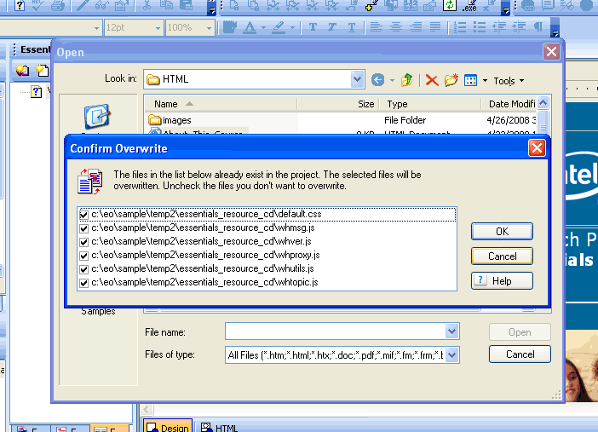

1. Copy code to your Welcome page.

Double click on your welcome page in the project file list under the project manager. Click on the HTML tab at the bottom of the display pane to switch to HTML mode. Delete all the old content out of the page and then paste the example content in its place.

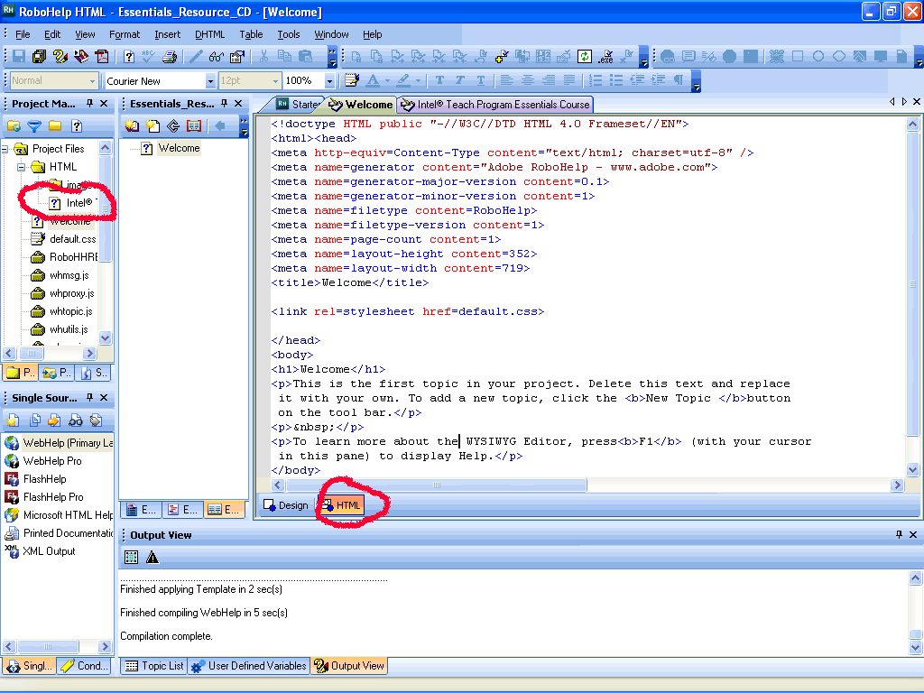

Fix any issues you may have with linking to graphics in you code,. Switch to design mode, by clicking the design tab, to view your page.

In the code, change the following section of code “Project Name”

Note: The “Title” section is what shows up in the browser title, and the page name in the project. If you change the title in HTML mode, it will automatically be changed in the project explorer.

3. Create your own HTML page.
HTML pages can be created inside of RoboHelp using the built in HTML editor or you can use an external HTML editor such as MS FrontPage or MS Visual Studio. If the HTML page was created in RoboHelp, no additional action is required. If you created an HTML page with another editor, then you will need to refer to the instructions above on “Importing a page into your project”.

Creating a Table of Contents

To create a TOC index that will appear in the left navigation of the project, use the following procedure:
- In the Resources pane (middle window), click the “New TOC Page” or “New TOC Book”.
- Create a Page Title (Page Title will show up in the left nav.)
- Select a page from the list under the existing project window
- Click OK.

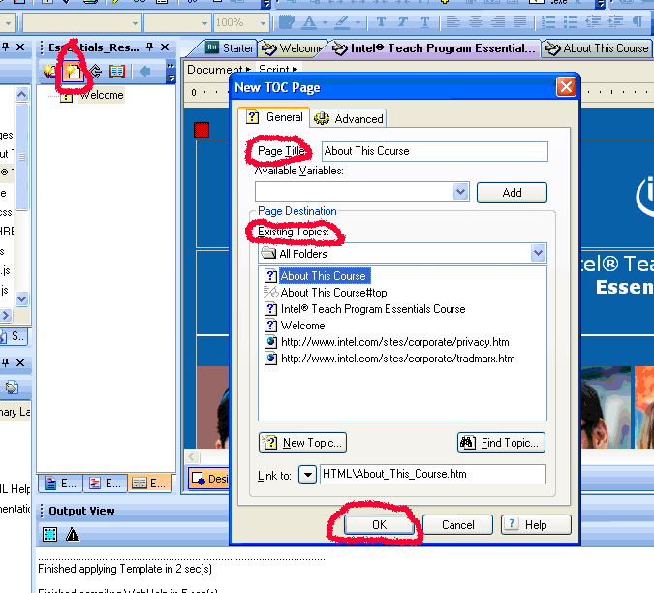

Linking files and resources

You can link any resource in the project to any other page, bookmark, outside link, or files (doc, xls, ppt, pdf, etc.)

Open the page, highlight the link, and click the globe icon. (located in the top tool bar with a link)

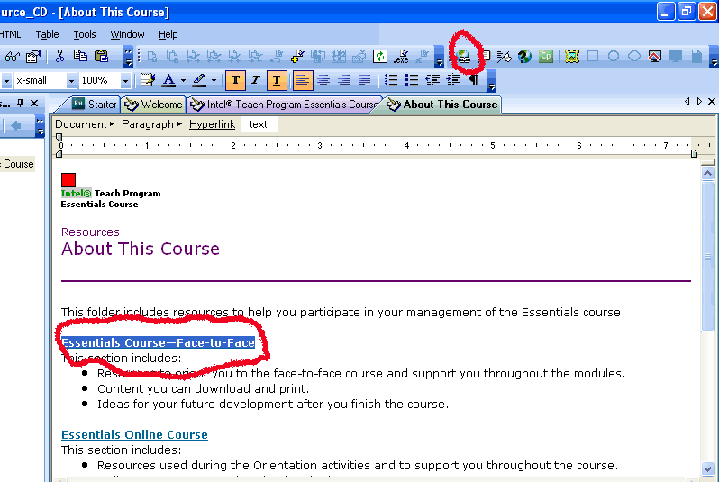

You can link to different types of resources. Select the type of resource from the drop down in the Link to box.

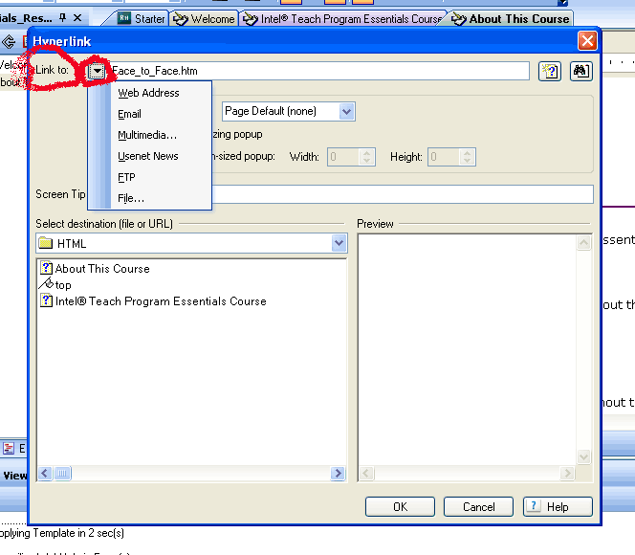

Linking to a Bookmark or File Within the Project
Select the page or bookmark from the list of available pages and bookmarks. See below for examples. The page will appear in the preview pane. Click OK.

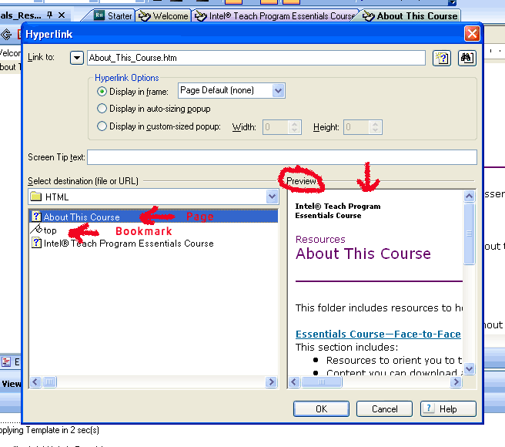

Linking to a, file (Word, Excel, PPT, etc)

- Follow the steps above for linking to a bookmark or page within the project
- Click on the drop down next to the Link to and select File.
- Browse to the file.
- Select the file, and click Open.
- In the Hyperlink Option (under the link to box) Select from the dropdown list Same Frame.
- Click OK..
- You will need to add the file that you just linked to your project as a Baggage File. See instructions below on adding a Baggage File.

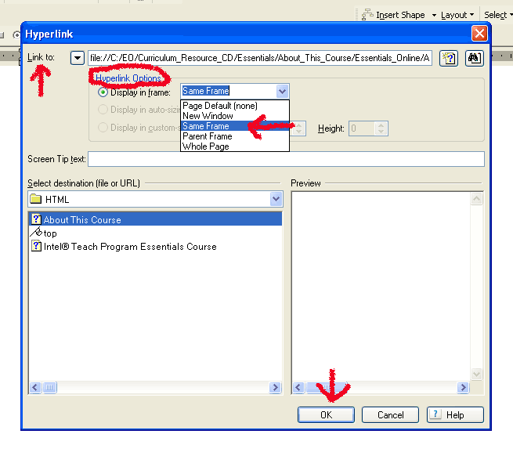

Adding a Baggage File

All files, images, or other resources that you include in your project must be created as a baggage file. To create a baggage file follow these steps:

- All your files should be placed in a separate directory called resources. You did a similar action above when you created the HTML folder in your project to house your HTML files.
- How do I get the files

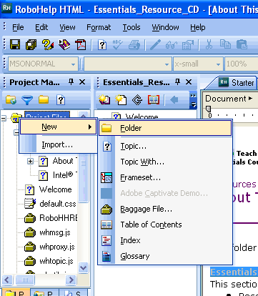

- Right Mouse Click on the folder to create the Baggage File.

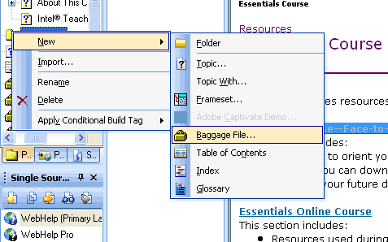

Note: You should now see your file in the window. If you do not see your file, you should go back and correct the location of your file or the directory structure and repeat this step.
- Click Open.
- The baggage file has now been created.

Building a Project (Outputting the project files)

First Time Build

If this is your very first build, you will need to set some options. These options will be saved and you should not have to change them again.

- Select File from the top application tool bar.
- From the list find and select Generate Primary Layout (Web Help).
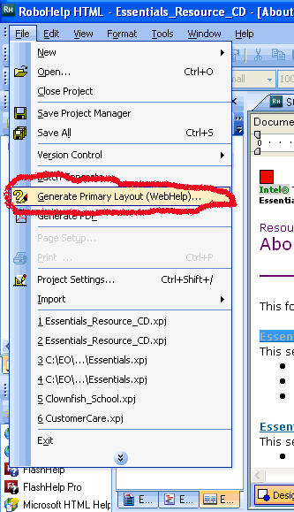

- From “Select Output Folder and Start Page” fill in box, Select a location and a launch page. See below for example.
Note: Select a new location. Do not select the same location as your project.
- From the Skin dropdown box, select the Intel_30_Skin.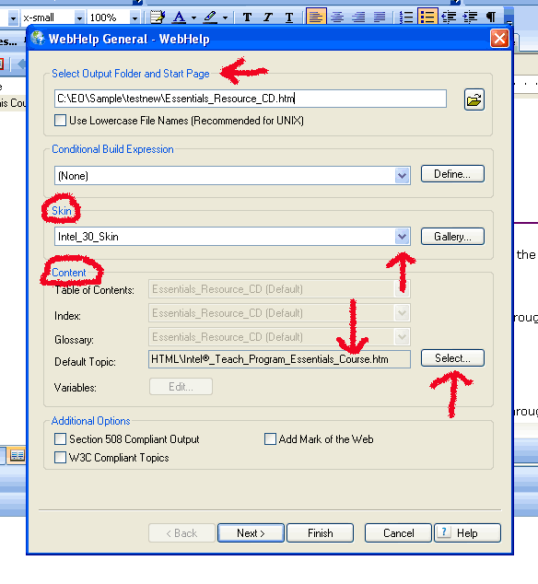
- Under Content, you will see an option called Default Topic. This is the default page that the user will see when the application opens. This will usually be set to your introductory or Welcome page. Click the Select Button.
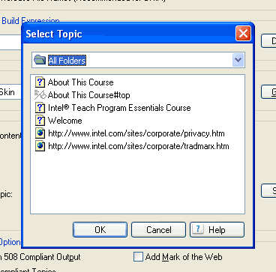
- Select your Default Topic and Click OK.
- Now at the bottom of the WebHelp General window, Click the Next Button.
- Under Toolbar Buttons, select the buttons that you wish to show up in the top navigation of your application. See below for an example. Your options may be different based on any additional buttons you have setup in your skin.
- Use the Up and Down Buttons listed to move the buttons to the left or right of your page on the top navigation in your final output.
- Use the Set as Default Button if you want to make a different button the default selection when your application starts.
- Under Navigation, uncheck both selections unless you need them.
- Under Additional Options Select the following:
  - Add About Box – Checked
  - Enable Highlight Search Results – Checked
  - Search Input Field Toolbar – Optional
  - Synchronize Table of Contents – Checked
- Select Next.
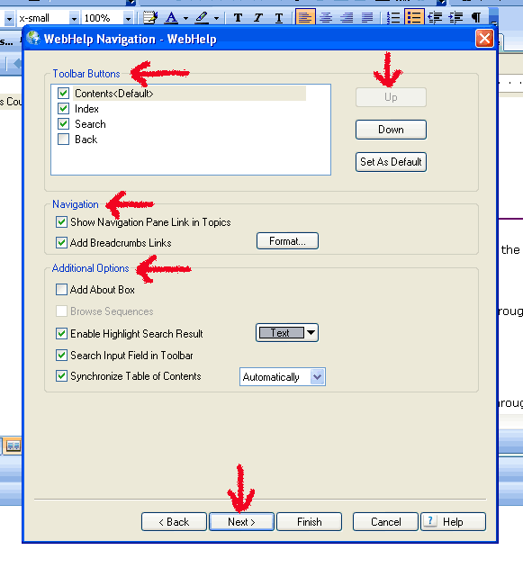
- Under Navigation Pane Preferred Format, select DHTML > Java Applet > Pure HTML located under the Java Applet.
- In the Optimize Speed For radio buttons, select Local PC or Intranet (Internal Network)
- Click Next
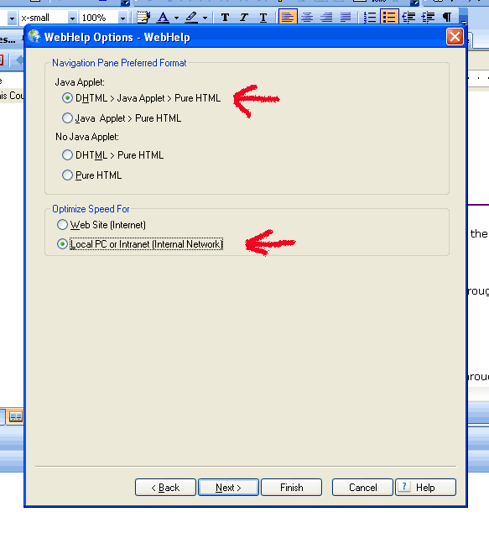
- In the WebHelp Publish window, do not select any options.
- Click Finish to run the Build.
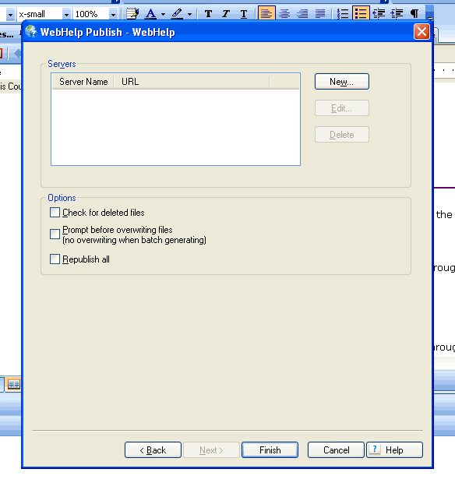

Run a Build

- Select File from the top application tool bar.
- From the list, select Generate Primary Layout (Web Help).
- Check your options to ensure they are still valid
- Select Finish.

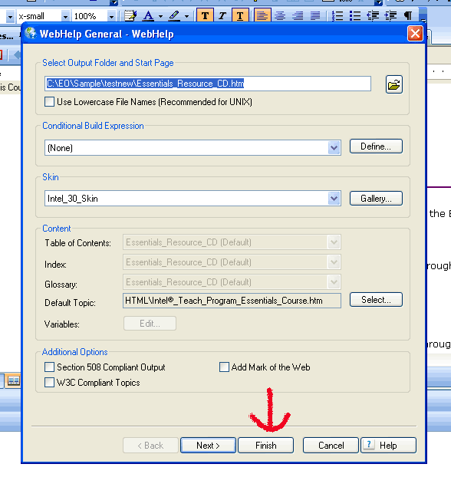

Finishing Your Project

After the project is built and tested, some additional files will need to be added to the final output to finish the CD. Locate and add the following files to the project.

Launch page: The launch page usually is named Start_Here.html or something that lets the user know to click on that file. Use a start here file from another project CD and modify for your own CD as needed.

About CD Button: If you have selected to add the About CD button to the top menu of your project, you will need to add two files This should be the last step you perform in the project. If you go in a change anything in the Robohelp files, you will need to complete this step again..
- Add the file whskin_banner.htm and the image intelEDU_rgb_68.gif to the root of your project folder not the root of your CD. For example, c:\Essentials\*.*
- Edit whskin_banner.htm file to match your version of CD.
- The intelEDU_rgb_68.gif file is the Intel Logo gif file seen when the about CD window opens.
- The whtbar.txt file is for reference only. This file shows you what code to change to adjust the size and options for the About CD window.

CD Instructions: Every CD will need to come with a copy of CD Instructions. These are simply a set of instructions that are used by the end user to guide them in the navigation of the project CD. An example of this can be found under CD_Instructions.

