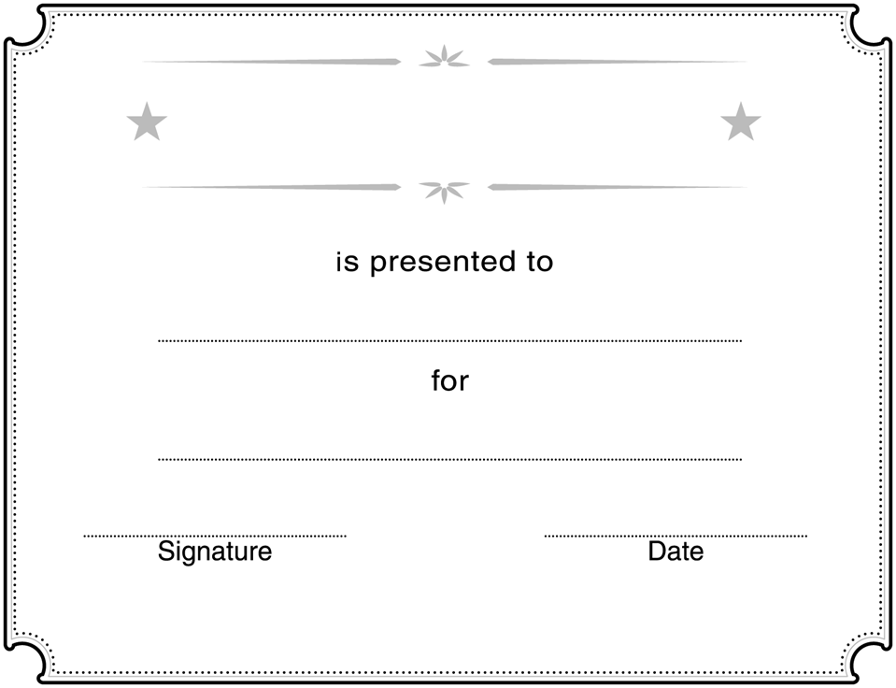
Insert NAME here

Course Completion
Completing the Intel® Teach Elements:
Educational Leadership in the 21st Century Course

Course content developed and provide free of charge by Intel Corporation. www.intel.com/teachers

