Leverage this content to support your Intel.com Education Site

The below script contains the content for the Corporate Elements Web page at www.intel.com/education/elements.

This script contains descriptions for the Project-Based Approaches, Assessment in 21st Century Classrooms, and Collaboration in Digital Classrooms. Depending on which course you have, you may need to remove and adapt some of the content within this script.

URL of page | www.intel.com/education/elements

Intel® Teach Elements
Free, just-in-time professional development that you can experience now, anytime, or anywhere. A new series of high interest, visually compelling courses provides deeper exploration of 21st century learning concepts using:
- Animated tutorials and audio dialogs to explain concepts
- Interactive knowledge checking exercises
- Offline activities to apply concepts
Learn more about the series (PDF) ›


Take Collaboration in the Digital Classroom Online
Develop activities to help prepare students to collaborate in the digital, global world.
Review the Syllabus (PDF) ›


Take Assessment in 21st Century Classrooms Online
Learn new assessment strategies to meet needs of 21st century students.
Review the Syllabus (PDF) ›


Take Project-Based Approaches Online
Explore ideas and try new project-based approaches for your classroom.
Review the Syllabus (PDF) ›
 | 
Order Elements Courses on CD  No high speed Internet connection? Take the course offline from a free CD. | Facilitate the Course  Integrate Elements in your professional development program with free course facilitation materials.
- Find more K-12 Resources

Share Your Feedback
Help us improve our Elements courses. When you finish a course, complete a survey:
- Collaboration Survey
- Assessment in 21st Century Classrooms Survey
- Project-Based Approaches Survey

More from Intel® Teach
If you enjoyed an Elements course, learn more about the Intel® Teach Program's other free professional development courses.
- Intel Teach Program

Ordering CDs
In the US, we have a distributor for our CDs. We have set up the following page so users can order and be shipped the Element CDs. Depending on how you are distributing your course, establishing a distributor and web page to order CDs may be an option.

URL of page | https://educate.intel.com/pblorder.htm

Intel® Teach Elements
Order CDs for offline, self-paced learning
The information you provide here will be used by Intel's fulfillment company to ship the CDs you request and by Intel® Education Customer Support if there are any issues with your order. Your information will not be used for any other purpose.

Top of Form

Name *
Address (no PO Boxes please) *
City *
State *
U.S. *
Non-US:
Zip *
Country *
We are not able to ship to all locations.
We will notify you if we are unable to provide CDs to your location.
Phone (required by shipping company)*
Email address (required for communication regarding your order)*

PLEASE CHOOSE:
- Order CDs for Intel® Teach Elements
Note: You will receive two available courses on a CD: Assessment in 21st Century Classrooms and Project-Based Approaches
Order up to 25 CDs. To request more than 25, please email Intel® Education Customer Support
Quantity *:

- PRE-Order CDs for three Intel® Teach Elements
Note: When the CDs are ready, you will receive Collaboration in the Digital Classroom, Assessment in 21st Century Classrooms and Project-Based Approaches
Order up to 25 CDs. To request more than 25, please email Intel® Education Customer Support
Quantity *:

Pre-order the 3-course CD (includes Collaboration in the Digital Classroom)

Please let us know which course(s) you plan to take or facilitate (PBA, Assessment, Collaboration, or all 3)*:
* Indicates required field
Intel cares about your personal privacy. Your information will only be used for the purposes for which it has been collected. Review Intel’s privacy policy here.
By submitting this order, I confirm that I have read and agree to the Terms of Use

Bottom of Form

Highlights :

On the Corporate Web site we add highlight to show case and drive traffic to the Elements section. Below are some examples of our highlights.

- Highlight on http://www.intel.com/about/corporateresponsibility/education/k12/index.htm

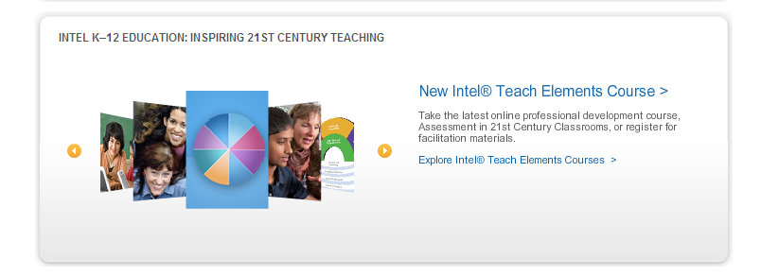

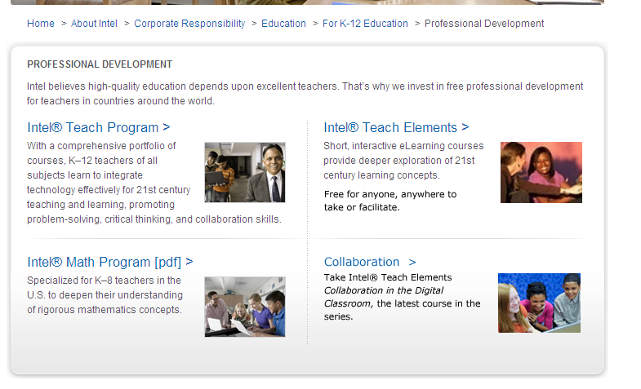

Facilitation :
If you are supporting facilitation of the Elements courses, content describing the benefits of facilitation and the delivery options for your Intel.com site is below.
Type of Page | Content page
Headline Title <H1> | Intel Teach Elements: Facilitation
Browser Page Title / HTML | Intel Teach Elements: Project-Based Approaches: Facilitation
URL of page | Intel.com/education/elements/facilitate.htm
Meta Description | Facilitate free, online teacher professional development on 21st century learning concepts: Project-Based Approaches from Intel Teach.
Meta Keywords | Free online learning, facilitate, train, Intel Teach, professional development, teachers, educators, online course, 21st century learning, project-based learning, project-based approaches, classroom ideas, projects, self-paced, teaching strategies

[BODY TEXT]
Are you looking for free course content that you can integrate into your online or face-to-face professional development program? Intel® Teach now provides free content to facilitate the Intel® Teach Elements: Project-Based Approaches course in face-to-face or online formats.

The facilitation materials promote a deeper experience for teachers as they work through the e-learning modules of the course. With small group discussions and sharing of ideas in action plans, a facilitated experience builds professional learning communities around project-based learning.
- The facilitation content is flexible with several optional activities. You can modify or add your own activities.
- The length of a facilitated course is flexible and determined by your program needs. While the total facilitation content covers 8 hours, there are sample schedules the facilitator may choose to follow or adapt.
- You are permitted to use this content and charge reasonable fees for delivering your course, with the understanding that teachers will receive continuing education credit, based on local requirements.
- Upon completion of a course, Intel asks that you report the number of teachers.

You have two options, determined by your course delivery format:
- Face-to-face: Participants use the Web or CD-based course to complete e-learning and action planning activities individually and then meet for facilitated discussions in a group setting. After you agree to the terms of use, Intel provides a print-ready guide that includes general facilitation strategies along with prompts for discussions, small group work, and sharing.
Click here to receive and use face-to-face facilitation materials for Intel® Teach Elements: Project-Based Approaches
- Online: You can integrate a facilitated course into your Learning Management System or host in your education portal. Participants complete e-learning and action planning activities online in your Learning Management System or education portal and then contribute to facilitated discussions and give feedback to others online. Your online course may be fully online, or a hybrid with some face-to-face components. Following a simple application and approval process, Intel will grant a two-year, renewable and royalty-free license for use of the content to education agencies that offer professional development to K-12 teachers. With a license agreement in place, Intel provides a location to download the e-learning course files and facilitation scripts. We also provide link to a sample online course as an example to support the adaptation of the course on your own platform. Intel will not provide technical support with this option: you are responsible for loading, hosting, and maintaining the course.
Apply here for your license to download the e-learning course files and facilitation scripts for Intel® Teach Elements: Project-Based Approaches.

Read the FAQ document for answers to common questions.

[Highlight Box—

<Title> For More Information </Title>
<Body>
Find answers to common questions. Read more about the Elements series and the Project-Based Approaches course.
Frequently Asked Questions (PDF) ›
Project-Based Approaches Syllabus (PDF) ›
Overview of Intel Teach Elements (PDF) ›

