Intel® Teach Elements “Welcome” video
Paul Otellini

Localization Option & Transcript

Localization tips

You should not dub the voice-over. It should remain Paul Otellini’s voice

Option 1: Keep video with Paul speaking in English
- Provide translation of the video (transcript below)
- Text will appear in small blocks in synch with Paul’s voice.

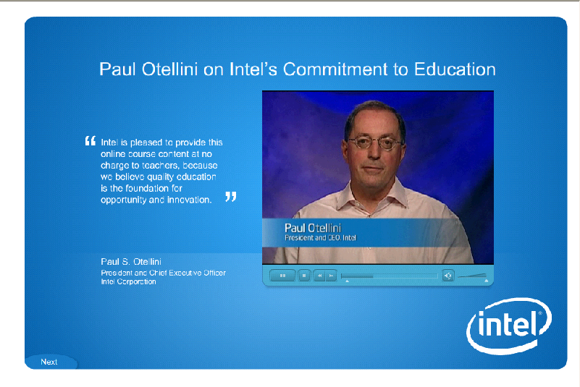
Translated text chunks will replace this quote here:

Remember, there is a “next” button that allows your viewers to skip past the video.

Option 2: No Video—image with quote in translated text
You may replace the video with a still image of Paul Otellini on the page if you do not feel the video is useful for your audience.
- Select an image from http://newsroom.intel.com/community/intel_newsroom/bios
- Translate the page title (Paul Otellini on Intel’s Commitment to Education)
- Place his name and title near the image (Paul Otellini, President and Chief Executive Officer, Intel Corporation)
- Translate the quote on the page and link (“Read more”) to a pdf containing the full translation of the transcript (remove the English and the timing columns, format it as you like).

English transcript—385 words | Timing | Translation
Paul Otellini on Intel’s Commitment to Education | Screen title
Paul Otellini, President and Chief Executive Officer, Intel Corporation | PSO title
Welcome to the Intel® Teach Elements series of courses. Intel is pleased to provide this online course content at no charge to teachers, because we believe quality education is the foundation for opportunity and innovation. | 00:00:00  to  00:00:15
An innovative, global economy needs young people capable of analyzing information, collaborating with others, and communicating their ideas using technology. | 00:00:16  to  00:00:25
At Intel, we work with teachers to build education programs that combine best practices with the power of technology. | 00:00:27  to  00:00:33
Since 1999, the Intel Teach Program has helped 6 million educators in more than 50 countries to make learning more compelling and relevant through the use of technology. | 00:00:35  to  00:00:45
You are joining a network of teachers in an innovative approach to better prepare students to compete in the global economy. | 00:00:46  to  00:00:53
I believe that mastering innovation is essential for the jobs of the future, and your participation in the Intel Teach Program will create wonderful opportunities for your students, well beyond the classroom. | 00:00:54  to  00:01:05
On behalf of Intel, I’d like to thank you for your participation and your dedication. | 00:01:07  to  00:01:13

