Design and Discovery: An engineering and design [summer, after-school, weekend] program

[Dates]

[Location]

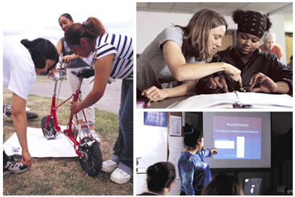

[Sample Program Description: Design and Discovery is a design and engineering initiative for students entering the 8th, 9th, or 10th grade. This program involves students in the exploration of design and engineering concepts during an interactive [length of program] program.

Through hands-on activities, field trips, and projects, students will learn to recognize and explore the designed world around us. They will meet scientists, engineers, product designers, and technology specialists. In addition, they will learn team-building skills and participate in related field trips. Students will develop a project that incorporates the study of design, engineering, and computer applications and will be supported by adult mentors.]

Design and Discovery [dates]

REQUIREMENTS

[Sample Requirements: To qualify for the Design and Discovery program, students should be entering the 8th, 9th, or 10th grade.]

To apply, complete the attached application and return to:
[Name of organization, address]

THE SITE
[Explain where the program will be held, the address, and the facilities available there.]

DETAILS
Dates:
Times:
Location:
Fee:
Capacity:
Deadline:

TIMELINE
Applications Due:
Pre-Program meeting for students and mentors:
Program Dates:

DESIGN AND DISCOVERY VOLUNTEERS

Adult volunteers are needed to help with the program and chaperone field trips. Volunteers must (include requirements.)

Design and Discovery [dates]

Name Age Date of Birth / /

Address
(Street) (City) (State) (Zip)
Phone( ) Cell( ) Email

Grade in Fall 2002 School (name & location)

Parent(s)/Guardian(s) Name

T-shirt Size? SM M LG XL XXL

In the event of emergency, please notify the following person (available during program hours):
Name Relationship to Participant
Phone( ) Cell Phone or Pager( )

INTERESTS
❑ Engineering  Medicine  Computer Science  Science
❑ Math  Education  Physics  Social Work
❑ Government  Law  Design  Other
Do you plan to attend college?  YES  NO  NOT SURE

Has anyone in your family attended college?  MOTHER  FATHER  SIBLING

ESSAY QUESTIONS
(attach an additional sheet if needed)
- What is your favorite subject in school and why?

- Why are you interested in this program?

Design and Discovery [dates]

STUDENT AGREEMENT
I have reviewed the Design and Discovery program description carefully. I understand that admission to this program in done by individual selection based upon interest and essay submission.

Applicant’s Signature Date

PHOTO RELEASE
I, being the Parent/Guardian of: hereby consent that (student’s name)__________________ name, image, and likeness, whether in video-tape, photograph, motion picture film and/or electronic images for which she/he poses, and/or audio recordings made of her/his voice will be the property of and may be used by [name of organization], its assigns or successors, for purposes of promotion and /or recruitment of other students, including television, free and clear of any claim whatsoever on my part.

Signature of parent/guardian Date

PARENT/GUARDIAN PERMISSION
As a legal guardian I give permission for the student named above to participate in all phases of the activities including off-site trips. I understand and agree to cooperate with all regulations. I will not allow her/him to attend if she/he is not in good physical condition. In an emergency, I give permission for the program authorities to take any emergency measure deemed appropriate. The parent/guardian will be notified as soon as possible.
THIS FORM CANNOT BE PROCESSED WITHOUT THE SIGNATURE OF A PARENT OR GUARDIAN.

Signature of parent/guardian Date

