Parts of a Circuit

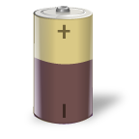
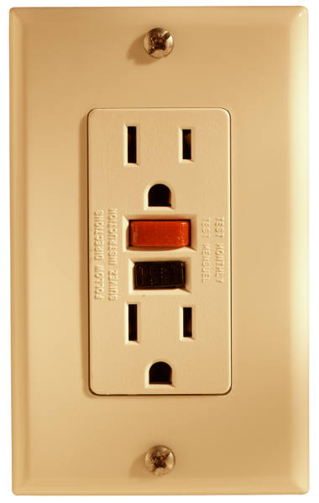
Energy Source
Where the power comes from.

For example, a household wall plug or a battery. Since different circuits have different power demands, the source must provide at least as much power as the circuit uses.

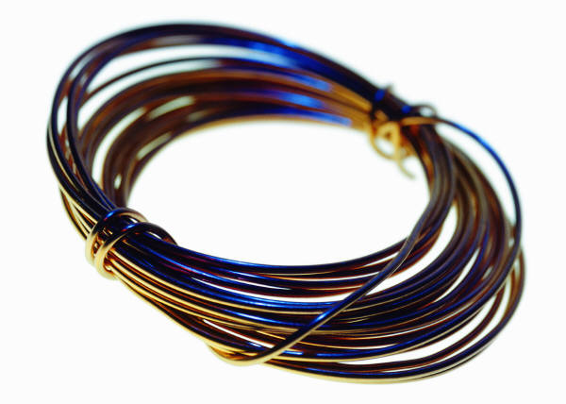
Transmission Wires
How the electric current is carried from one part of the circuit to another.

Typically, wire consists of a copper strand insulated with a thin plastic jacket. The insulation prevents wires from shorting out against each other and keeps higher voltages safely contained.


Load
The part that consumes the power.

This can be a light bulb, a motor, a doorbell, or anything that requires electricity to operate. All other parts of the circuit are relative to the power used by the load.

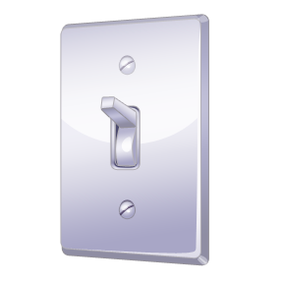
Switch (optional)
How to turn the electric current on and off.

A switch completes the circuit when it’s on and breaks the connection when it’s off. When the connection is broken, no current can flow through the circuit.

