Electricity Pre-Assessment
Using only the components found in your electricity toolbox, show how you could light up the light bulb. Below your drawing, write a few sentences to explain how your design works.
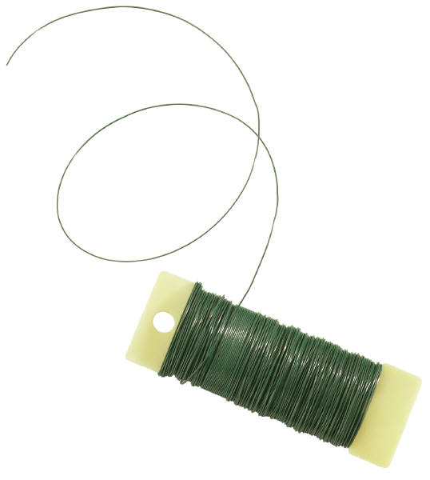
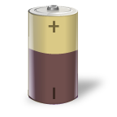

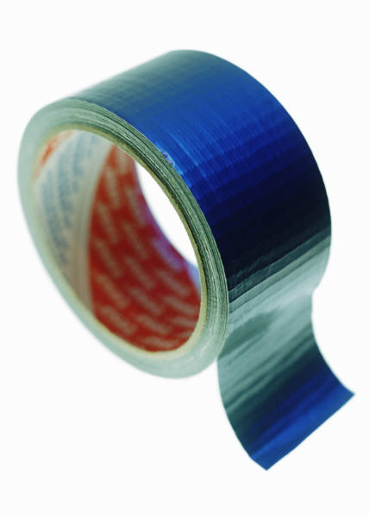
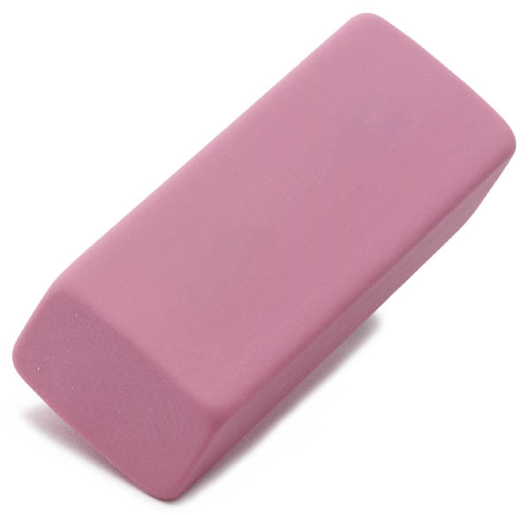
batteriesnewspaper
electric wireseraser
paper clipsduct tape


Show how you could light the bulb:

_________________________________________________________________________
_________________________________________________________________________
_________________________________________________________________________
_________________________________________________________________________
_________________________________________________________________________

