Shocking Truths about Electricity
Read each statement below and make a prediction about whether you think the statement is true or false. Under each statement, explain why you made that prediction. Hint: 5 of the statements are true and 5 are false. Mark the correct answer, given by your teacher, in the space provided.
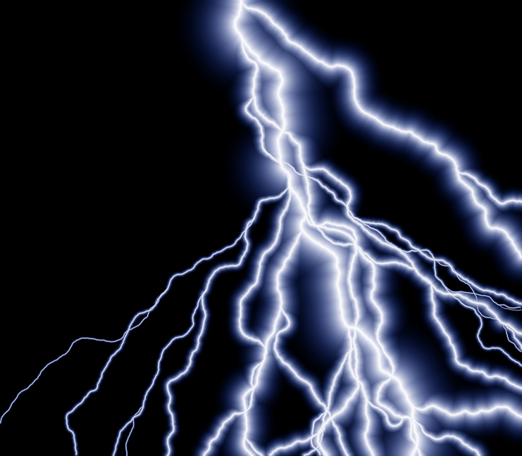  My Prediction | The Correct Answer | Statement  Explain your thinking about your prediction
True False |  | Electricity travels faster than the speed of light.
True False |  | Electricity can be made from animal manure.
True False |  | Hydropower is the most common way electricity is made in the United States.
True False |  | Frog legs helped create the first battery.
True False |  | One power plant can produce enough electricity for 180,000 homes.
True False |  | Benjamin Franklin was the first person to discover electricity.
True False |  | The power generated by walking on carpet is similar to that of a lightning strike.
True False |  | Electric current is measured by how fast it is traveling (miles/second).
True False |  | Electricity cannot travel through water.
True False |  | A spark of static electricity from walking on carpet measures about 3,000 volts.

Which statement surprised you the most? Why were you surprised?
_________________________________________________________________________
_________________________________________________________________________
How did this change your thinking?
_________________________________________________________________________
_________________________________________________________________________
For each statement that is false, make it true by recording the correct answer from your teacher.

