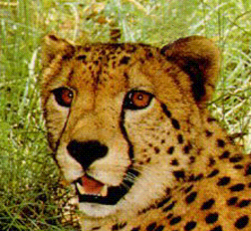
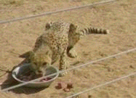
Length:
Weight:
Speed:
Family:
Mortality:
Life Span:
Food:
Range (previous):
Range (current):
Population:
Interesting fact
Interesting fact
Interesting fact

Want to spot a (your animal)? Tell where your animal can be found and what it might be doing during different times of the day. Tell what plants and animals share the habitat, and tell what your animal eats (and what eats it!) so the safari visitor knows what to look for when trying to spot this critter. Tell about your animal’s adaptive strategies (how it looks and how it behaves). Tell how males and females look or act differently. Help the visitor know what they’re seeing if the animal is hunting, resting, playing, hiding, fighting, or hanging out.
(My animal) Facts in Brief:
My Animal
This section is about animal conservation.
How is (your animal) doing? What is the health of this spe-cies? Is its habitat OK? Is its food web balanced? Are there more, less, or the same number of animals compared to long ago? Is your animal hunted? Is there anything that makes it unnaturally sick? Are there other animals crowding its niche? Are humans endanger-ing the animal? Is your animal threatening humans?
What are the best ways to help this species last for a long, long time? What can a person do to help?
Answer the question, What is the price of life? Make sure to support your opinion and ideas with facts from your research. Talk about whether your animal is worth protecting. Talk about what might happen to your ani-mal if something isn’t done to protect it. Give some ideas about what others might do to help protect the animal.

Title Tell about your great picture in a caption here.
Threatening or Threatened?
What Is the Price of Life?
Spotting a ________ on Safari

Think about producers, primary consumers, secondary consum-ers, and decomposers. Show what gets energy from what. Fill in the animal and plants from your food web in the boxes above.
Food Web
grass
antelope
cheetah
hyena
Describe how your animal survives in the wild. How does it catch its prey? How does it escape from predators? Does it have any special characteristics that help it survive in the wild? Are humans threatening the survival of your animal?
______________ Survival
Your name
Put a great picture here.
Put a great picture here.

Gives energy to

