Spreadsheet Instructions

Description: Use a spreadsheet to enter your data and create charts using the data from your soil porosity and absorption investigation as well as your great bean race later in the unit.

Step 1: Enter Your Data
- Open a worksheet in a spreadsheet application.
- In cell A1, type the title of your study (for example, type Soil Porosity and Absorption).
- To make your title go across several columns, highlight the cells you want your title to cover, select the Format menu, click Cells, and click the Alignment tab. In the Text control section, click Merge cells, and click OK.
- You can now center your title and change the font size and style. You can even change the background fill color, like the example below.
- In row 3, beginning in cell A3, type the types of soil used in the investigation (see the example).
- In cell B2, type Amount of water drained. Starting in cell B3, enter the amount of water drained (after subtracting the 250 ml) for each of the soil types.
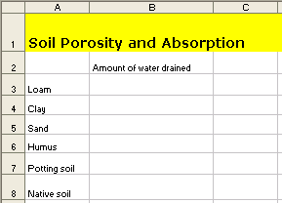

Step 2: Create Your Chart
- Highlight all of the cells.
- Choose Chart on the Insert menu.
- Choose the chart type that you think best represents your data, click the Next button, and then follow the directions for your type of chart.
- Add titles for your chart.
- Place your chart as an object on the original worksheet.
- Save the file.

