Name _____________________

What Do the Graphs of Linear

Functions Look Like?

Graph each of the following equations using a graphing calculator, and then sketch all four lines on the same axis.
Slope Intercept Form: y = mx+b

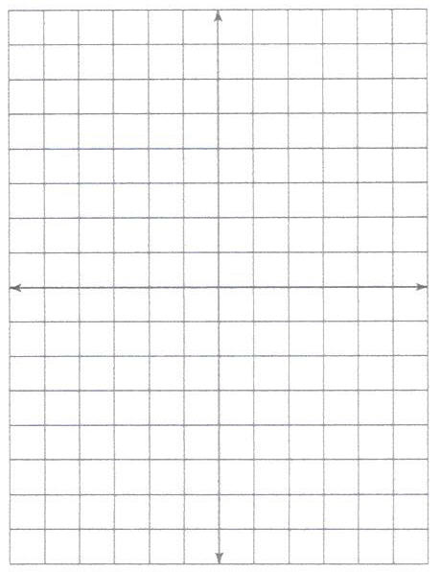

A.
y = 2x+6
y = 2x+3
y = 2x+5
y = 2x+1

- What stays the same when the lines are drawn?

- What is different?

- Explain what the graph of y = 2x-5 would look like.

- How does changing b, the y-intercept, affect
the graph of y = mx+b?

B.
y = x+3
y = 2x+3
y = 4x+3
y = 3x+3

- What stays the same when the lines are drawn?

- What is different?

- Explain what the graph of y = 5x+3 would look like.

- How does changing m, the slope, affect
the graph of y = mx+b?

C.
y = -2x+6
y = -2x+3
y = -2x+5
y = -2x+1

- What stays the same when the lines are drawn?

- What is different?

- Explain what the graph of y = -2x+2 would look like.

- Make a conjecture about how m, the coefficient of x, affects
the graph of y = mx+b.

D.

y = -x+4

y = -2x+4

y = -4x+4

y = -3x+4

- What stays the same when the lines are drawn?

- What is different?

- Explain what the graph of y = -5x+4 would look like.

- Make a conjecture about how adding 4 affects the graph of y = mx+b.

E.

How has using the graphing calculator assisted you in understanding what the graphs of linear functions look like?

F.

What conclusions can you make?

