Cinderella Wiki Checklist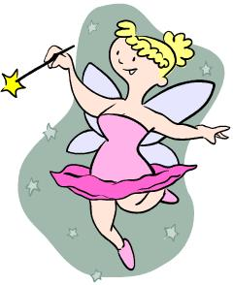

◻ | We thought about the pages we wanted to make and made a plan to keep us organized.
◻ | We changed our plan when we had good reasons to.
◻ | We shared the jobs in our group fairly.
◻ | We helped each other.
◻ | We made a home page that describes the purpose of our wiki.
◻ | We published our stories or blogs.
◻ | Our pages have titles.
◻ | We added graphics and Web elements to make our wiki attractive.
◻ | We created pages for our readers to add stories.
◻ | We created links so people can move around our wiki easily.
◻ | We carefully proofread all of our text.

