Earthquake Poll Spreadsheet Worksheet

Description
Use a spreadsheet to enter your group’s combined poll data and create charts from your earthquake survey homework assignment last night. Use the spreadsheet and charts to represent your results to share with your classmates. The following steps can support you as you create your spreadsheet from scratch.

Step 1
Look over your data survey results and decide which questions/answers can be counted or measured. Choose these questions to enter into your spreadsheet, since they will provide the opportunity to graphically represent them.

Step 2
Open a worksheet in spreadsheet software. In cell A1, type the title of your study (for example, type Earthquake Poll Data). To make your title go across several columns, highlight the cells you want it to cover, select the Format menu, choose Cells, and then click the Alignment tab. In the Text control section, select Merge cells. You can now center your title and change the font size and style if you wish. You may even wish to change the background fill color.

In row 3, beginning in cell A3, type the questions that you studied and measured or counted (see the following example). Enter your data (what you counted) in column B or columns B and C.

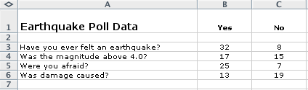

Step 3
Highlight all of the cells that you want to represent graphically. Choose Chart on the Insert menu. Choose the chart type that you think best represents your data, click the Next button, and then follow the specific directions for your type of chart. Add titles for the chart and its axes if appropriate. Click the Gridlines tab and experiment with gridline options if it applies to your type of chart. Choose gridlines that make understanding your data easier. Click the Legend tab and choose a location for the legend, and then click Next. Place the chart as an object on the original worksheet, so that you can see the worksheet entries as you examine the chart or place it in a separate sheet of your worksheet and label it (see the following example, which represents the spreadsheet data shown in the previous sample).

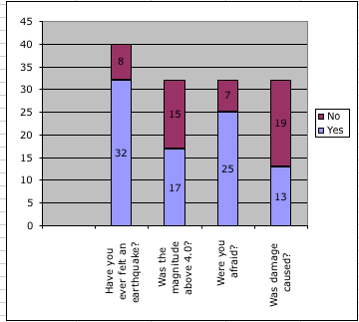

Explore several options of charts to see which one best represents your data! Or choose several different types of questions from the survey to represent with different charts.

Step 4
Homework Assignment:

Choose one or more questions from your group’s combined poll that you did NOT use in today’s spreadsheet and create a spreadsheet (be sure to write down the questions and total count or measures).

Choose at least two different kinds of charts or graphs to represent your data. Write an explanation of the pros and cons of each graph in terms of how it represents your data. Decide which of the graphs best represents your data and explain why you think so.

