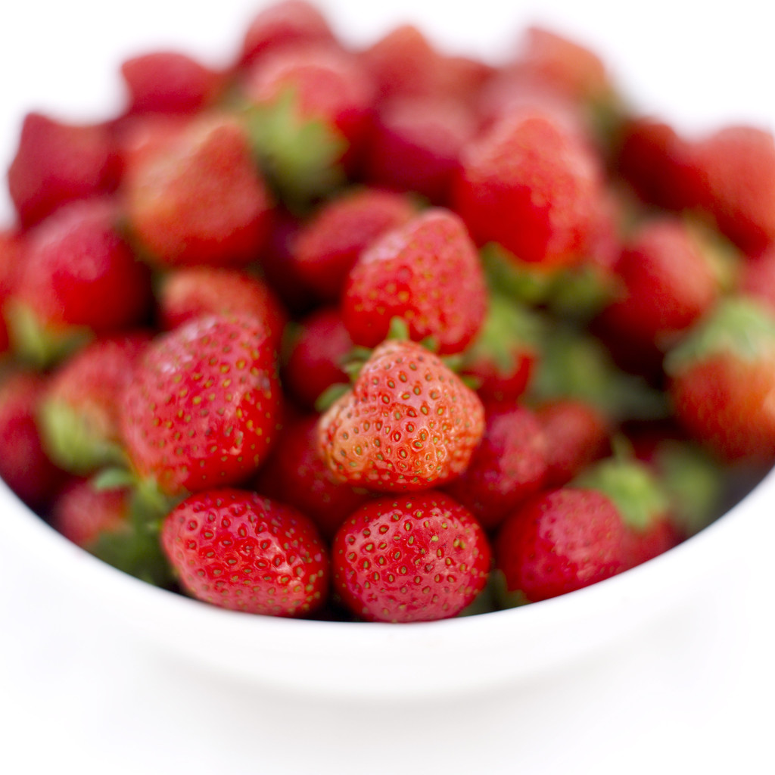
Healthy Foods Survey

How many of each of the food groups have you eaten today? Ask at least 5 people and tally their answers in the table.

Tally Marks
Fruits 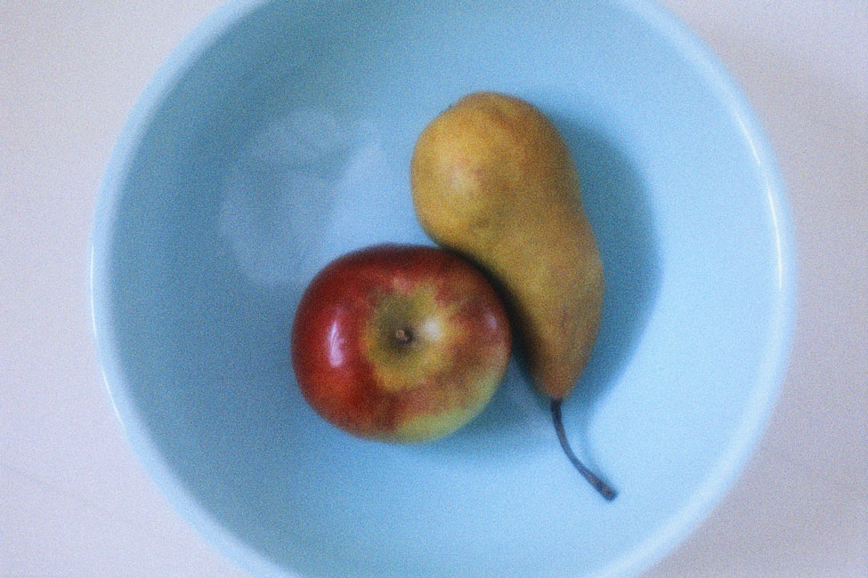
Vegetables 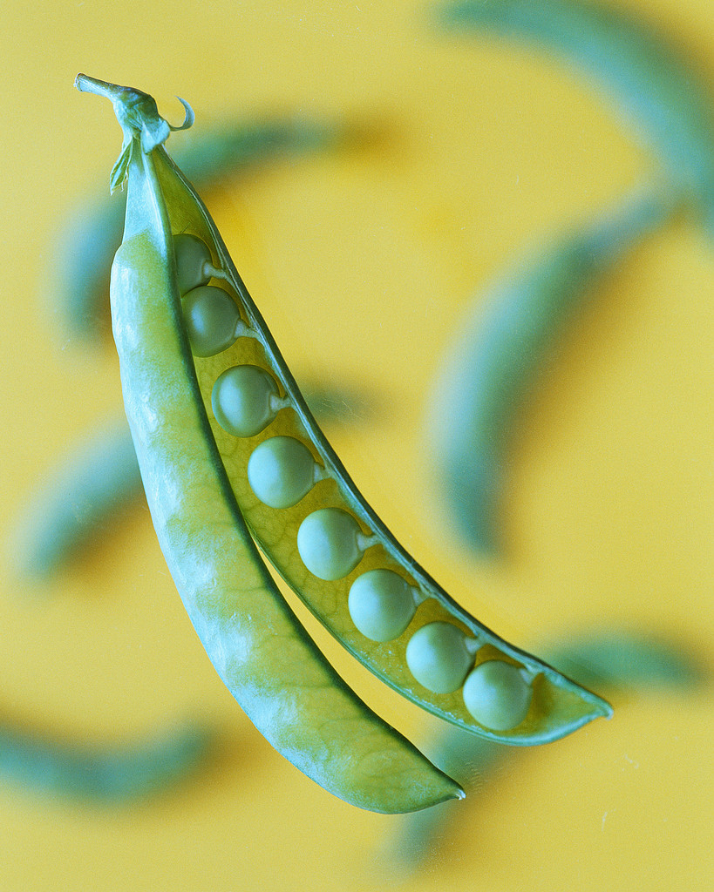
Dairy 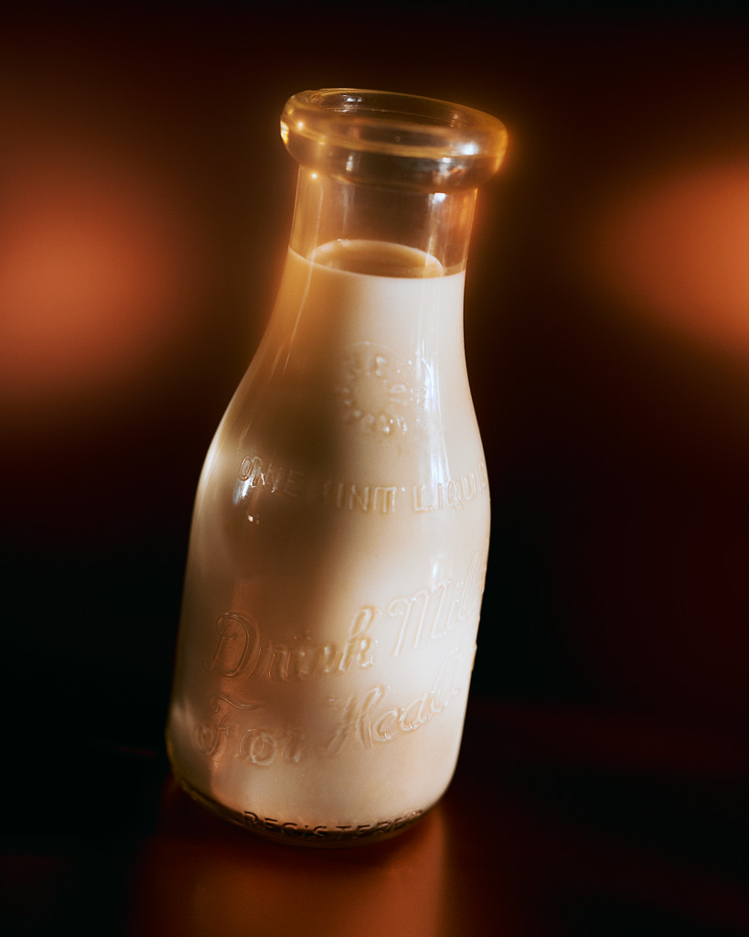
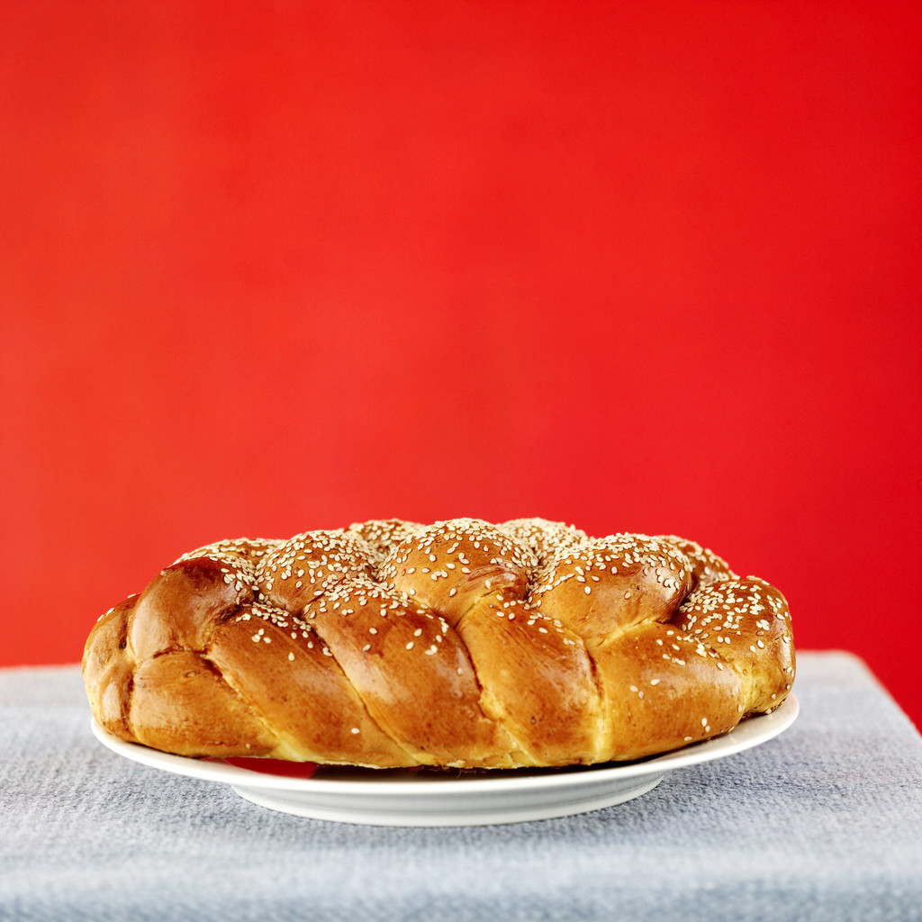
Breads and Grains
Meat 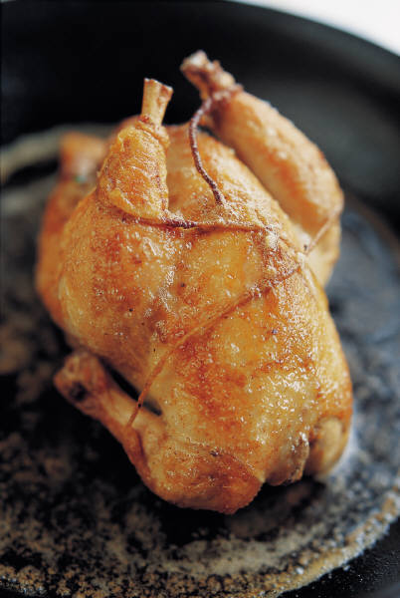

Fats and Sweets

* After you collect all of the data, create a graph to show what you have learned.*

