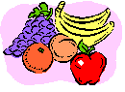
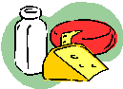

Fats and Sweets
Breads and Grains
Vegetables
Fruits
Name______________
Use tally marks to show what foods are in your lunch.
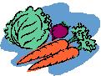
Dairy
Meat

