Nutrition Learning Log
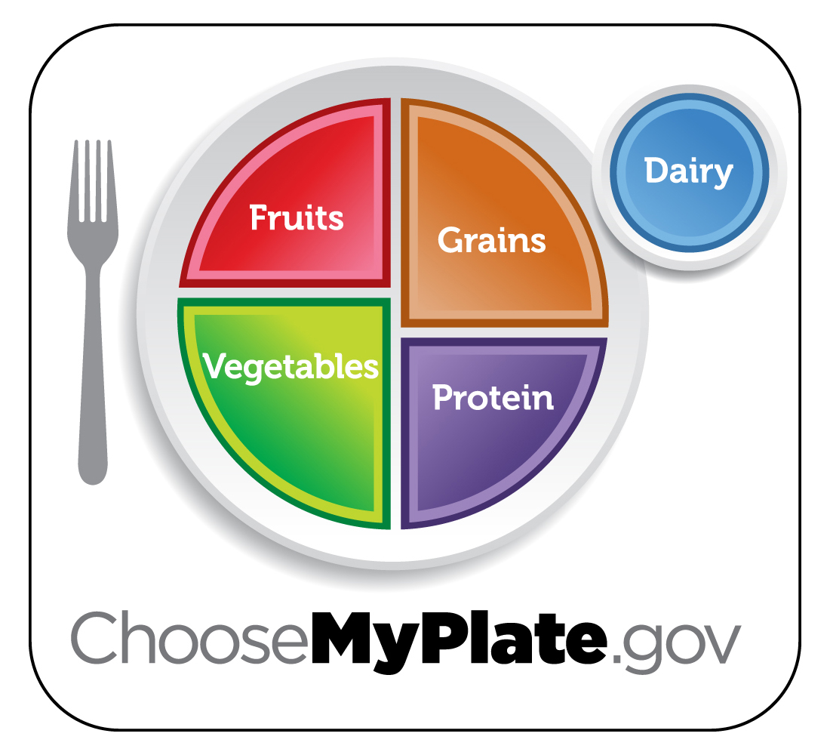
Date:

Name:

Prompt for today:

My response:

