Food Diary
Date: Name:

Write down the foods you eat today. Color in your food eaten in the appropriate spaces on the My Plate graphic. Write down the foods you eat that belong in the “Others” category. Count composite foods in each category. For example, a ham and Swiss cheese sandwich with mayonnaise, lettuce, and tomato would count as: 1 meat serving, 1 dairy serving, 2 bread servings, 1 vegetable serving, and 1 “Others” serving.
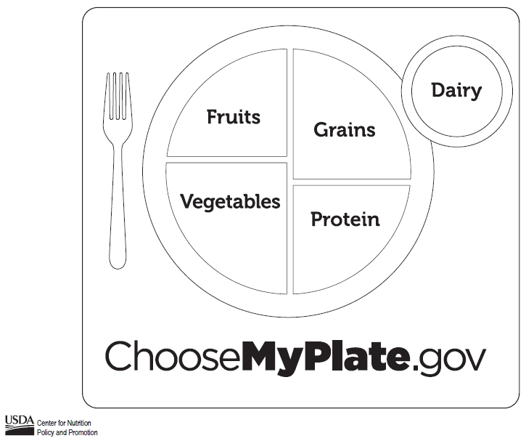
Breakfast:
Lunch:
Dinner:
Snacks:
Others:

Answer these questions:
- Did you get all the proper servings from each food group?
- Is your plate completely colored in?
- How many servings of “Others” foods did you have?

Chart from Nutrition Explorations, www.nutritionexplorations.org*

