Gadget Research
(Teacher note: Save this page as a key. Then, it can be used as an assignment sheet by deleting the sample responses.)
Name: Date: _______________
Simple Machine
LEVER | INCLINED PLANE | WHEEL AND AXLE
A lever is an arm that turns against a point (fulcrum). There are three classes of levers. You can tell what kind, depending on the position of the fulcrum. | A straight, slanted surface allows a load to be moved over a longer distance, so less force is required. | A wheel is fixed to a shaft or axle, and they move together. Sometimes, the wheel has a crank or handle.
Example Picture or Diagram
Seesaw | 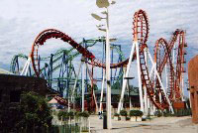  Roller Coaster | 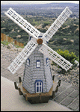  Windmill
Citation
Edheads: Activate Your Mind  http://www.edheads.org/activities/simple-machines/ | Mikids: Simple Machines  http://mikids.com/Smachines.htm

Simple Machine
WEDGE | SCREW | PULLEY
A wedge turns an inclined plane down and uses it to push things apart. A wedge is basically two inclined planes set back-to-back. | A screw works by moving a load across a spiraling inclined plane. The screw on a piano stool lets the seat go up or down. Often a lever, like a screwdriver, works to give force to the screw. | In a pulley, a cord moves up or down easily over a wheel. If you attach something to the cord, it can be moved up or down. With a pulley, you trade force for distance, making work easier.
Example Picture or Diagram
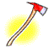  Axe | 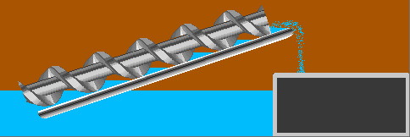  Archimedes’ Water Screw | Flagpole
Citation
The Franklin Institute: Online Simple Machines  http://sln.fi.edu/qa97/spotlight3/spotlight3.html | Edheads: Activate your Mind  http://edheads.org/activities/simple-machines | Franklin Institute Online: Simple Machines  http://sln.fi.edu/qa97/spotlight3/spotlight3.html

