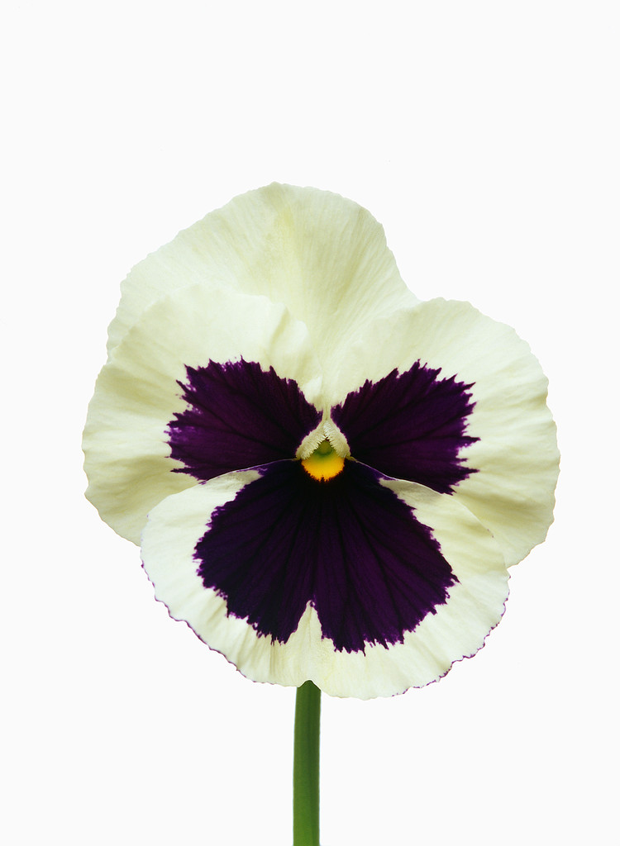
Flower Fortunes
Your knowledge of Punnett Squares could really pay off if you can successfully create a designer flower!
Part One
You are a famous horticulturist who happens to be quite knowledgeable about Gregor Mendel’s experiments with dominant and recessive traits. Although Mendel studied pea plants, you are quite sure that the same genetic principles could be applied to flowers.
You’ve received a large custom order for a new flower creation - a white flower with purple spots. You’ve decided to cross a pure homozygous dominant white flower (WW) and a pure recessive purple flower (ww), hoping to produce a white flower with purple spots. Use the Punnett Square below to show the types of offspring you would expect.
 | White (W) | White (W)
Purple (w)
Purple (w)

- What fraction of the offspring is homozygous white flowers (WW)? ______
What percent? _____%
- What fraction of the offspring is homozygous purple flowers (ww)? ______
What percent? _____%
- What fraction of the offspring are heterozygous (Ww)? _______
What percent? _____%
- What will your offspring flowers look like? Explain how you know.
___________________________________________________________________
__________________________________________________________________
- Was your idea successful? Why or why not?
___________________________________________________________________
___________________________________________________________________
Although your first idea was unsuccessful, you decide to try something else. You review Gregor Mendel’s work with peas and decide to cross two white hybrid (Ww) offspring flowers. Set up and complete your Punnett Square below:

- If these parent flowers produced 100 offspring, predict how many offspring would be purple flowers? ______________________________________________________
- Explain how two white flowers could produce a purple flower.
___________________________________________________________________
___________________________________________________________________
___________________________________________________________________
- What would the offspring look like from a cross between a heterozygous (Ww) white flower and a homozygous (ww) purple flower? Show the possible outcomes on the Punnett square below:

- Was your idea successful? Why or why not?
___________________________________________________________________
___________________________________________________________________
___________________________________________________________________
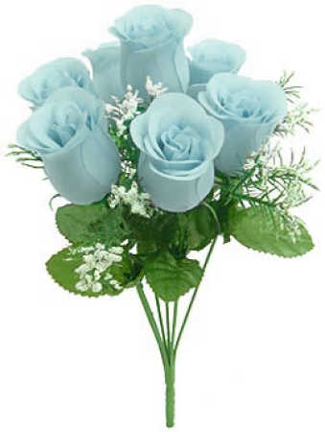
Part Two
Unfortunately your attempt to create a white flower with purple spots was unsuccessful. But don’t worry- you’ve received another large custom order that could really pay off! Your next client is requesting light blue roses. Fortunately, you have just learned of a variety of dark blue roses that is controlled by a dominant (B) gene. You know that white roses have a white color gene (W) that is equally strong, or co-dominant. A (BW) plant produces light blue flower petals.
Create a Punnett Square to show how you would create light blue roses.
Record the fraction and percentage values of each offspring type:
Dark Blue Roses (BB) _______ = _______%
White Roses (WW) _______ = _______%
Light Blue Roses (BW) _______ = _______%

Congratulations, you did it! Now what would happen if you cross two light blue (BW) roses? Create a Punnett Square that shows this cross and answer the questions below.
Record the fraction and percentage values of each offspring type:
Dark Blue Roses (BB) _______ = _______%
White Roses (WW) _______ = _______%
Light Blue Roses (BW) _______ = _______%

If 100 roses were produced using a cross between two light blue (BW) roses, predict how many would be:
__________ dark blue __________ white ___________ light blue
What would be the most effective way of producing light blue roses? Explain your thinking.
_________________________________________________________________________
_________________________________________________________________________

