Single-Gene Traits in Humans
For each single-gene trait, determine whether your phenotype is dominant (uppercase letter) or recessive (lowercase letter). Record your phenotype and your genotype. Remember, a dominant phenotype can be represented by a homozygous genotype (AA) or heterozygous genotype (Aa). Use a shorthand symbol (A_) to represent these two possibilities.
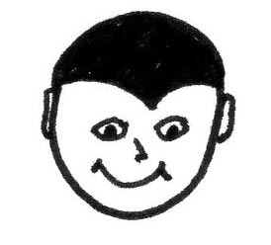 | Widow’s Peak (W) |  | 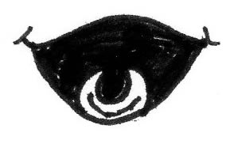 | Tongue Roller (T)
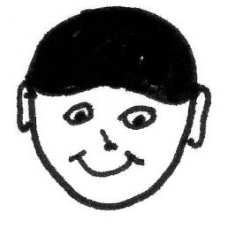 | No Widow’s Peak (w) |  | 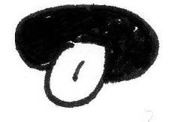 | Non-Tongue Roller (t)
My phenotype:  My genotype: |  |  | My phenotype:  My genotype:

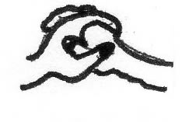 | Crossed Hands: Left Thumb on Top (C) |  | 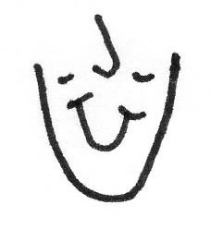  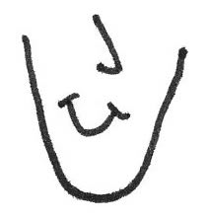 | Dimples (D)
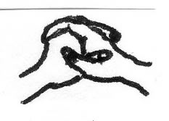 | Crossed Hands: Right Thumb on Top (c) |  |  | No Dimples (d)
My phenotype:  My genotype: |  |  | My phenotype:  My genotype:

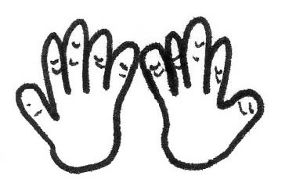 | Bent Pinkies (P) |  | 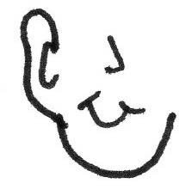  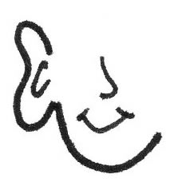 | Free Ear Lobes (E)
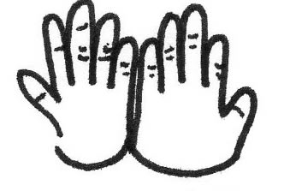 | Straight Pinkies (p) |  |  | Attached Ear Lobes (e)
My phenotype:  My genotype: |  |  | My phenotype:  My genotype:

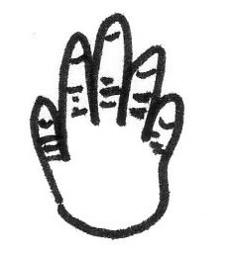 | Hair on Fingers (H) |  | 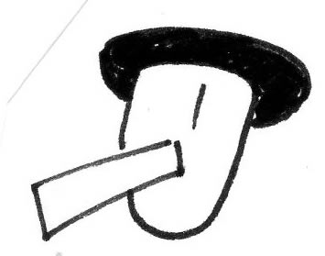 | PTC Taster (B)
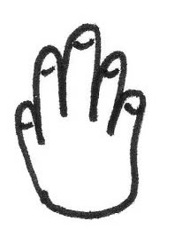 | No Hair on Fingers (h) |  |  | PTC Non-Taster (b)
My phenotype:  My genotype: |  |  | My phenotype:  My genotype:

