What Do These Graphs Tell You?

Analyze the following graphs and share your interpretations.

Global Warming
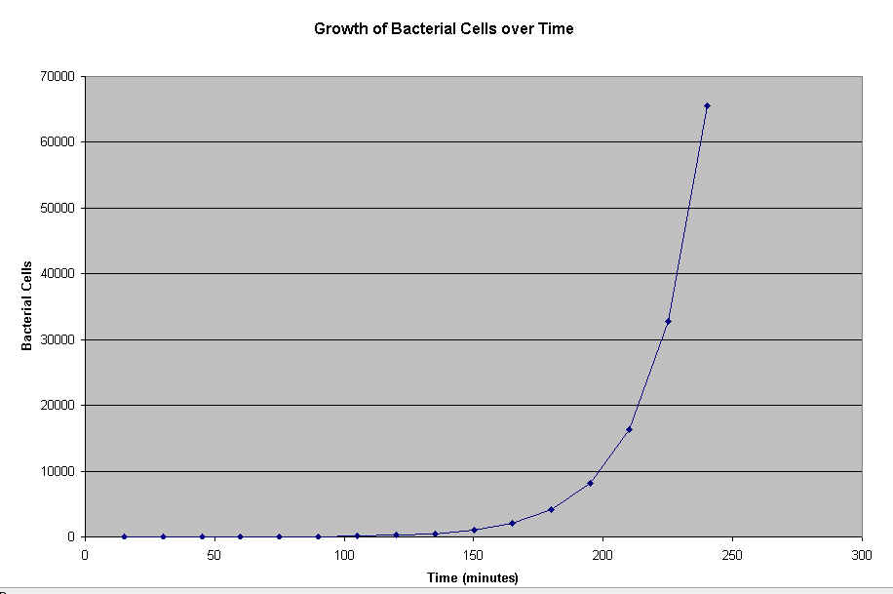
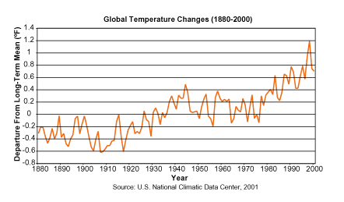

Bacterial Cell Growth

Create a situation that describes the motion depicted in the following velocity–time graphs.

Graph A
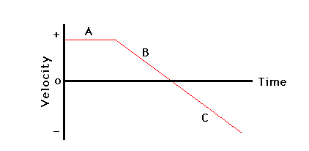

Graph B
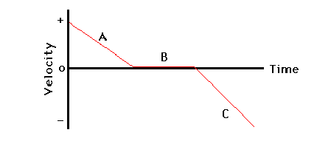

Graph C
