STOP GLOBAL WARMING
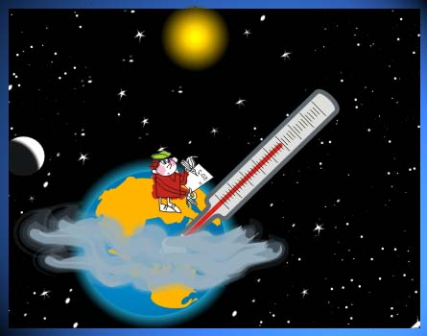

Climate change is a reality. Today, our world is hotter than it has been in two thousand years. This follows increasing droughts, floods, and extreme weather.

What can you do to help save us?

Don't drive unless you have to.
Walk more
Cycle more
Skate more
Turn off lights when you leave a room.
Use alternate sources of energy

Demand better mass transit.
Use buses, trains, and trams
Share cars
Share what you have; buy less stuff.

REUSE BEFORE YOU RECYCLE

