The Soufriere Bay
Despite the efforts of the Soufriere Marine Management Authority (SMMA) overfishing is still a major problem for the Soufriere coral reef.
We are proposing that the reef should allow presently overfished resources to recover. This would increase fisheries production in the longer-term. In order to do this, limitations should be placed on the size, amount, and types of fish that can be caught near the reef and in the surrounding

area. We are proposing that St. Lucia require special fishing licenses to local fisheries.
Once the overfished resources recover, restrictions on fishing can be lifted.

Our Proposal
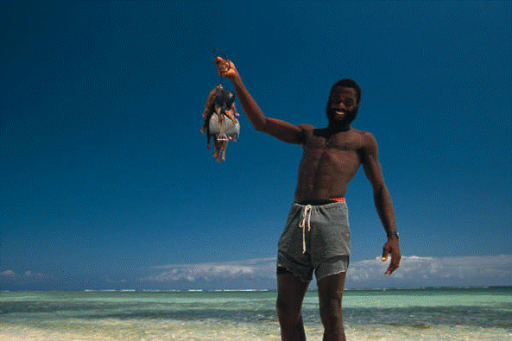
Presented By
Pat Johnson, Terry lorance, and Kelly Martin

Protecting Soufriere Bay

United Nations
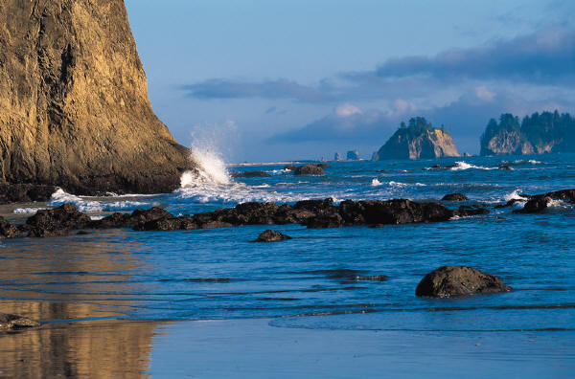
The Soufriere Bay
The Soufriere Bay
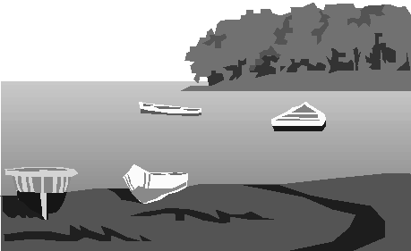
Presented By
Pat Johnson, Terry lorance, and Kelly Martin
Efforts to help preserve the coral reef in Soufriere Bay will require the cooperation of everyone.

Prepared for the Delegates of the United Nations
Resources

The Ocean Adventure www.theoceanadventure.com

Soufriere Marine Management Association www.smma.org.lc

International Coral Reef Initiative www.icriforum.org/secretariat/lucia.html

The Soufriere Bay

The Soufriere Bay Ecosystem

Background of
Environmental Problems
Soufriere experienced increasing population pressures during the 1980s. These threatened the health of St. Lucia’s fringing reefs primarily due to pollution and overfishing. Overfishing works in a step-by-step fashion to cause imbalances. First, fishing selectively takes larger, predatory fish off the reef causing population explosions of smaller herbivorous fish. When the larger fish become scarce, the herbivorous fish are then targeted by fishermen. Without the herbivores, seaweeds can overgrow the corals and smother them. Destructive fishing practices include the use of cyanide to stun fish for capture for the marine aquarium and live fish trades and blast fishing to kill fish for food. These fishing methods are not usually species-specific. Many organisms are killed in the process and habitats that took thousands of years to build are destroyed.

Causes of
Environmental Problems
The main environmental problems in the late 1980s and early 1990s were mostly caused by humans. The water quality was getting worse. Fishery resources were disappearing, general environment quality on or near beaches was worsening, and pollution generated by waste disposal was increasing. There were many conflicts between commercial dive operators, fishermen, the local community, and hoteliers over the use and protection of the reef.

Soufriere Bay is located along the southwestern shore of St. Lucia in the Caribbean Sea and is home to a fringing reef. It is unique because it is formed around a submerged volcanic crater and contains active gas vents.
Like most fringing reefs, the coral reef in Soufriere Bay has a very delicate ecosystem. Its location in the Caribbean Sea provides warm temperatures. The waves bring in food, nutrients, and oxygen, and prevent sediment from falling on the reef. The shallow warm water provides calcium needed for the reef to grow.

The sun is the source of energy for the coral reef ecosystem. Plant plankton, algae, and other plants convert light energy into chemical energy through photosynthesis. As animals eat the plants, energy is passed on. These plants also give food and oxygen to the animals that live on the reef. Seagrasses are especially important because they provide shelter for many reef animals.
Many different types of animals can be found in Soufriere Bay including sea urchins, sponges, sea stars, worms, fish, sharks, rays, lobster, shrimp, octopus, and snails. These animals use the reef as a stopping point as they travel the sea, or live as residents in the reef. The corals themselves are the most abundant animal on the reef. They are tiny organisms called polyps. Polyps attach themselves to the hard reef and live there forever. The animals of the reef live in symbiosis; they live and work as a team.

Previous Efforts
In response, government agencies and community groups formed the Soufriere Marine Management Area (SMMA), a marine reserve, in 1994. Since the reserve was created, fish populations within the management area have tripled.
With the creation of the Soufriere Marine Management Authority (SMMA) these result have been achieved:
- Reduction of conflicts among users
- An increase in fish biomass within marine reserves
- An increase in fish biodiversity (increased number of fish species observed per count in annual censuses)
- A self-financing management area
- A management team, which involves continued participation of all stakeholders (Board of Directors and a Technical Advisory Committee)

Research on Marine and Coastal Resources
Soufriere Marine Management Association (SMMA) has been fairly successful with their efforts to put an end to overfishing in Soufriere’s reef and to eliminate human pollution in the bay. Despite their success, SMMA realized in 2002 that reef fish populations are still under serious threat and that there is an urgent need to reestablish the declining population of red snapper in the reef. This is where our proposal comes in.

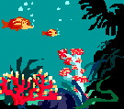
Many different types of animals
can be found in Soufriere.

Previous Efforts
In response, government agencies and community groups formed the Soufriere Marine Management Area (SMMA), a marine reserve, in 1994. Since the reserve was created, fish populations within the management area have tripled.
With the creation of the Soufriere Marine Management Authority (SMMA) these result have been achieved:
Reduction of conflicts among users
An increase in fish biomass within marine reserves
An increase in fish biodiversity (increased number of fish species observed per count in annual censuses)
A self-financing management area
A management team, which involves continued participation of all stakeholders (Board of Directors and a Technical Advisory Committee)

Research on Marine and Coastal Resources
Soufriere Marine Management Association (SMMA) has been fairly successful with their efforts to put an end to overfishing in Soufriere’s reef and to eliminate human pollution in the bay. Despite their success, SMMA realized in 2002 that reef fish populations are still under serious threat and that there is an urgent need to reestablish the declining population of red snapper in the reef. This is where our proposal comes in.

Previous Efforts
In response, government agencies and community groups formed the Soufriere Marine Management Area (SMMA), a marine reserve, in 1994. Since the reserve was created, fish populations within the management area have tripled.
With the creation of the Soufriere Marine Management Authority (SMMA) these result have been achieved:
Reduction of conflicts among users
An increase in fish biomass within marine reserves
An increase in fish biodiversity (increased number of fish species observed per count in annual censuses)
A self-financing management area
A management team, which involves continued participation of all stakeholders (Board of Directors and a Technical Advisory Committee)

Research on Marine and Coastal Resources
Soufriere Marine Management Association (SMMA) has been fairly successful with their efforts to put an end to overfishing in Soufriere’s reef and to eliminate human pollution in the bay. Despite their success, SMMA realized in 2002 that reef fish populations are still under serious threat and that there is an urgent need to reestablish the declining population of red snapper in the reef. This is where our proposal comes in.

Previous Efforts
In response, government agencies and community groups formed the Soufriere Marine Management Area (SMMA), a marine reserve, in 1994. Since the reserve was created, fish populations within the management area have tripled.
With the creation of the Soufriere Marine Management Authority (SMMA) these result have been achieved:
Reduction of conflicts among users
An increase in fish biomass within marine reserves
An increase in fish biodiversity (increased number of fish species observed per count in annual censuses)
A self-financing management area
A management team, which involves continued participation of all stakeholders (Board of Directors and a Technical Advisory Committee)

Research on Marine and Coastal Resources
Soufriere Marine Management Association (SMMA) has been fairly successful with their efforts to put an end to overfishing in Soufriere’s reef and to eliminate human pollution in the bay. Despite their success, SMMA realized in 2002 that reef fish populations are still under serious threat and that there is an urgent need to reestablish the declining population of red snapper in the reef. This is where our proposal comes in.

Previous Efforts
In response, government agencies and community groups formed the Soufriere Marine Management Area (SMMA), a marine reserve, in 1994. Since the reserve was created, fish populations within the management area have tripled.
With the creation of the Soufriere Marine Management Authority (SMMA) these result have been achieved:
Reduction of conflicts among users
An increase in fish biomass within marine reserves
An increase in fish biodiversity (increased number of fish species observed per count in annual censuses)
A self-financing management area
A management team, which involves continued participation of all stakeholders (Board of Directors and a Technical Advisory Committee)

Research on Marine and Coastal Resources
Soufriere Marine Management Association (SMMA) has been fairly successful with their efforts to put an end to overfishing in Soufriere’s reef and to eliminate human pollution in the bay. Despite their success, SMMA realized in 2002 that reef fish populations are still under serious threat and that there is an urgent need to reestablish the declining population of red snapper in the reef. This is where our proposal comes in.

