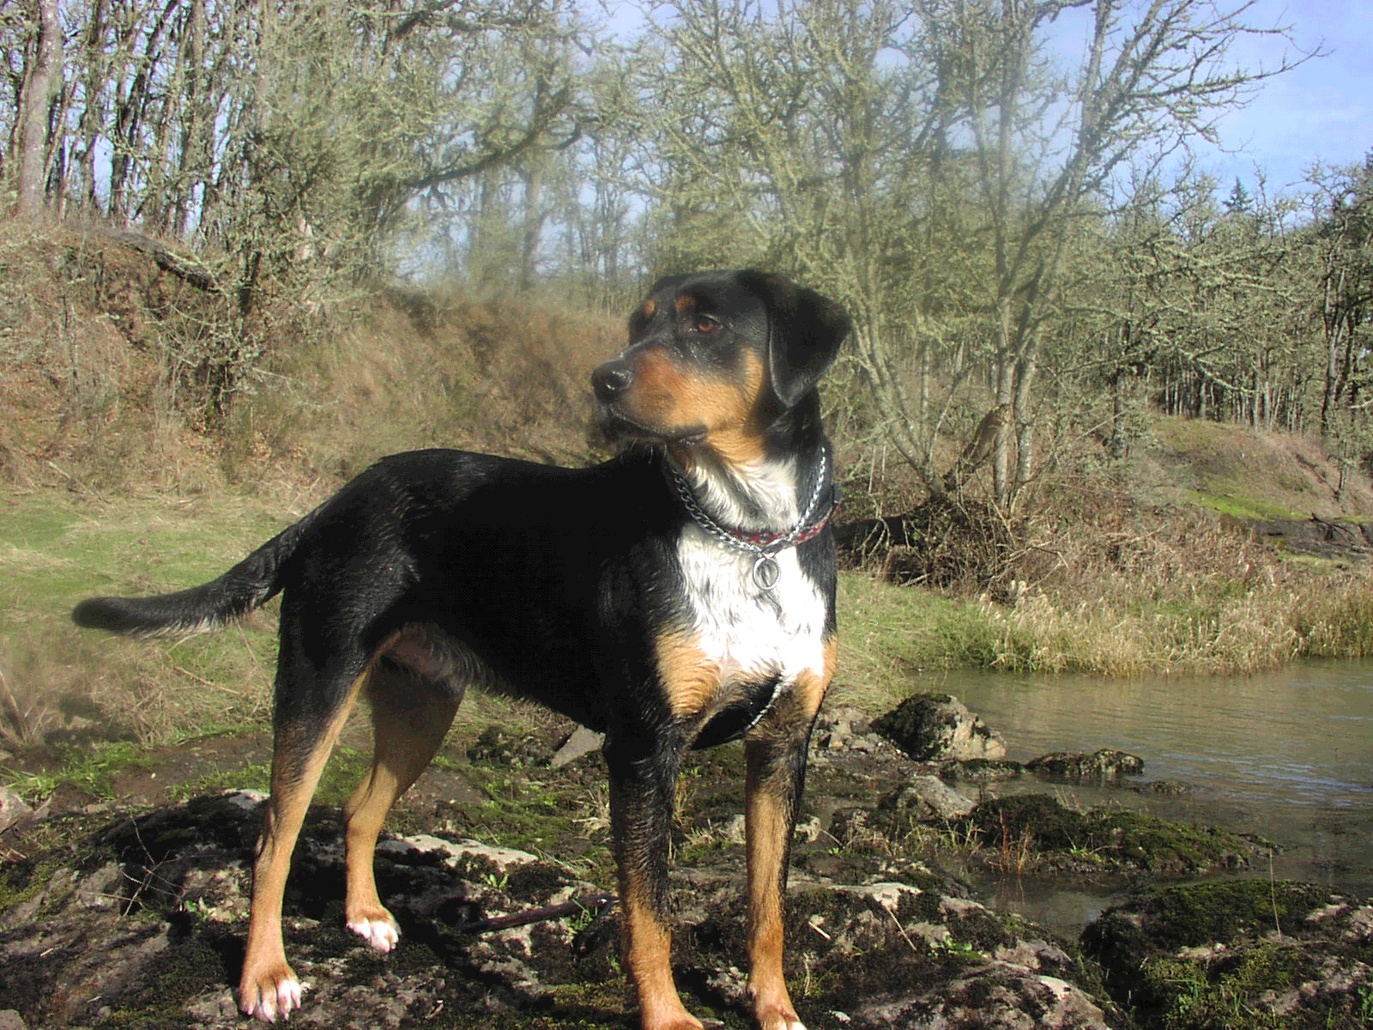
Lost Dog
Hank is a two-year-old male, weighs 80 pounds, has short black and tan fur, with a white chest and throat. Is wearing collar with tags. He was last seen along Mill Creek, January 8, 2002.
Please See Jane in Room 9
REWARD

