Spreadsheet Help Page

I. Entering data into a spreadsheet.

Open a worksheet in spreadsheet software. In cell A1, type the data column title (such as Time(s) below). In cells B1 and C1, enter the column titles Passenger Train and Freight Train respectively.

In column A beginning in cell A2, type the times. Beginning in cell B2, enter the passenger train information. In cells C2 and below, enter the data for the freight train.

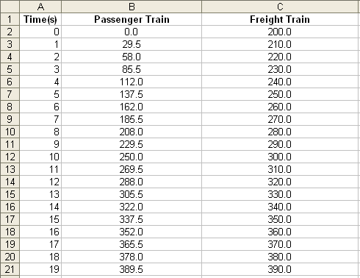

II. Choosing and creating graphs to represent your data.

Highlight all of the cells that you want to use to create a graph or chart. Choose Chart on the Insert menu. Choose the chart type that you think best represents your data, and then click the Next button. Follow the specific directions for your type of chart. Add titles for the chart and its axes if appropriate. Click the Gridlines tab and experiment with gridline options if it applies to your type of chart. Choose gridlines that make understanding your data easier. Click the Legend tab and choose a location for the legend, and then click Next. Place the chart or graph as an object on the original worksheet so that you can see the worksheet entries as you examine the object, or place the chart or graph in a separate sheet of your worksheet and label it. Explore several options of charts to see which one best represents your data!

