Spreadsheet Instructions

Description: Using your traffic studies and family surveys, create spreadsheets to enter your data and then make charts to analyze your data. Create one spreadsheet per group for your traffic study and individual spreadsheets for you family surveys.

Step 1
Open a worksheet in spreadsheet software. In cell A1, type the title of your study (for example, enter Street Safety). To make your title go across several columns, highlight the cells you want it to cover, click the Format menu, choose Cells, and click the Alignment tab. In the Text control section, select the Merge cells check box. You can now center your title and change the font size and style. You may even want to change the cell’s background fill color.

In row 3 beginning in cell A3, type the areas that you studied and measured or counted (for example, street corners, pedestrians using crosswalks, and pedestrians not using crosswalks). In column A, beginning in cell A4, list the places that you gathered your data, such as street corners. Enter your data (what you counted) in columns B and C.

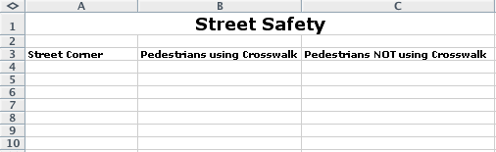

Step 2
To create a chart or graph:
- Highlight the data cells without highlighting the title.
- Choose Chart on the Insert menu.
- Choose the chart type that you think best represents your data, and then click Next.
- Follow the directions for your type of chart, such as:
- Add titles for the chart and its axes if appropriate.
- Click the Gridlines tab and experiment with gridline options if gridlines apply to your type of chart. Choose gridlines that make understanding your data easier.
- Click the Legend tab and choose a location for the legend.
- Click Next.
- Place the chart or graph as an object on the original worksheet, so that you can see the worksheet entries as you examine the object, or place the chart or graph in a separate sheet of your worksheet and label it.

Explore several options of charts to see which one best represents your data!

Step 3
Now create a spreadsheet (including charts) using your family survey data.

