MAKING A MILLION

1. How long is 1 million days? __________

1 million hours? __________

1 million minutes? __________

1 million seconds? __________

How did you arrive at your answers?

2. Name something that happened 1 million days ago ___________________________

1 million hours ago _____________________________________________

1 million minutes ago _____________________________________________

1 million seconds ago _____________________________________________

3. How many square millimeters are in the grid below? __________ Write this using both standard notation and powers of 10 notation.
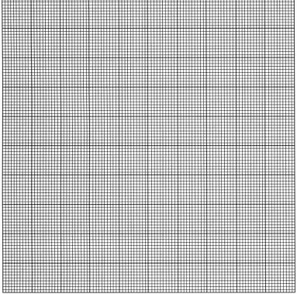

4. How many grids would we need to have 1 million square millimeters? _________.
Write this using both standard notation and powers of 10 notation.

