Seasoning the School Year
Duniway Elementary School
How does the world change during the year?

How Parents Can Help

We will need an immense amount of adult support to make some of these activities work. Parent helpers will be needed to take dictation for observation journals and class books. We’ll need volunteers to drive us on our trips to the Rhododendron Garden and to help keep us safe once we’re there. If you know how to make a slideshow presentation or use desktop publishing software, your help will be invaluable in making our slideshows and newsletters. You are welcome to help as often as weekly or just with trips. Please let us know which.

Duniway Elementary School

Duniway Elementary
7700 SE Reed College Pl.
Portland, OR 97202

Phone: 503-916-6343
Voice mail: 503-916-3625
Fax: 503-916-2623
Email: pubinfo@pps.k12.or.us
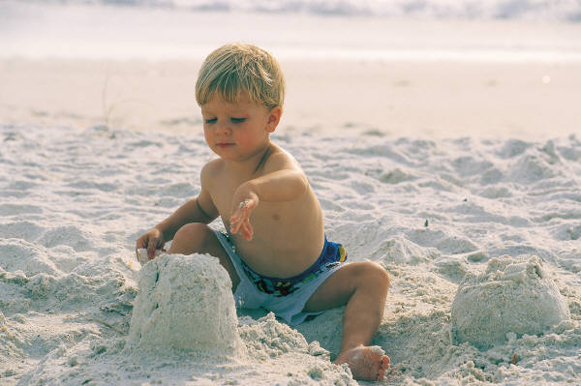
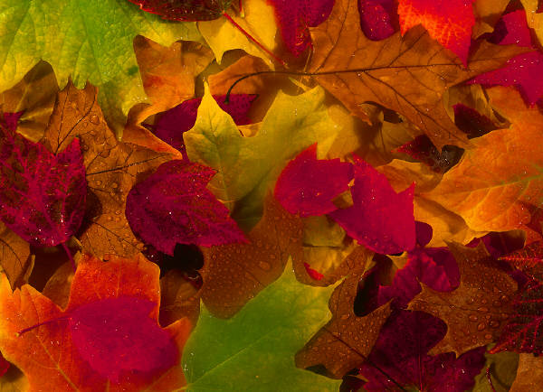
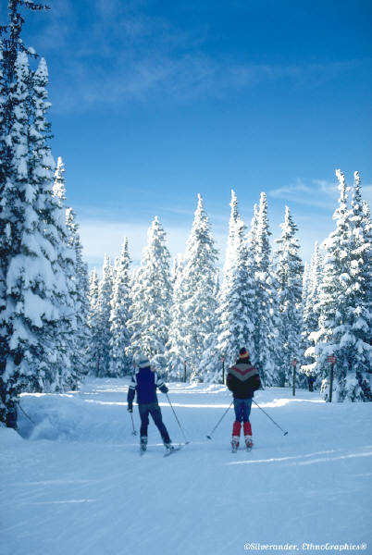
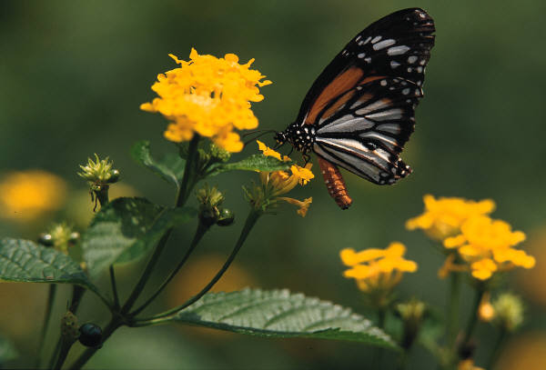

How do our lives change with the seasons?
What's it like right now in other parts of the world?
During this school year, your kindergartners will be learning about the seasons of the year and changes that occur in the weather and to trees as part of our science curriculum. This brochure will tell you about some of the activities we will be doing as part of this unit.
Summer
Since we still have a
couple of weeks of
summer left at the
beginning of the year, we will go outside and choose “our” tree. We will take a picture of all of us standing next to it. We will begin our observation journal by drawing a picture of what our tree looks like. We will make summer banners and a class book. We will also make a short slideshow presentation on the computer to tell what we know about summer. The children will dictate the words and choose the pictures, and so forth.

Duniway Elementary
7700 SE Reed College Pl.
Portland, OR 97202

Phone: 503-916-6343
Voice mail: 503-916-3625
Fax: 503-916-2623
Email: pubinfo@pps.k12.or.us
We will begin a daily weather graph to compare our local season/climate to that of other places in the world.
Fall
In the fall, we will
revisit our tree.
We will continue our
observation journals and our seasonal class book series, banners, slideshow presentations, and weather graph. We will add a seasonal newsletter with the children dictating the content, choosing the graphics, and deciding the format. As well, we will begin taking seasonal visits to the Crystal Springs Rhododendron Garden to look at the plants and animals and see what changes over time.
also hoping for some cold and/or snowy days so that we can throw in some activities and projects incorporating those themes.
Spring
In the spring, we
will repeat all of
our usual seasonal
activities and each student will get to make their own slideshow presentation. Toward the end of May, we will start comparing and contrasting the seasons of the year and the changes we’ve observed. We will create an Our Favorite Seasons class book to present to a local National Arbor Day Foundation representative during our end-of-the-year Season Festival celebration.
Winter

In the winter we again repeat all of these same activities—comparing our weather, visiting our tree, writing our class book, creating slideshow presentations, and taking our trip to Crystal Springs, and so forth. We are

