The Seasons of Kindergarten
September 12, 2006
Volume 2005, Issue 4
Duniway Elementary School
Wow! Finally, spring is here!
Here are some things we know about SPRING:
The days are getting longer.
It’s getting warmer.
Trees are starting to get new leaves.
The birds are back.
There are Swifts in our chimney so the heat is turned off.
Lots of flowers are blooming.
Some days are nice, but it still rains a lot!
We planted seeds and are watching them grow.

It Is Spring!

Announcements:
Are you missing a coat? I have four that aren’t mine. (It’s these warmer days.) They’re hanging on the wall by the outside door. If you’re missing one, please check the wall.

Coming
Attractions:
5/1May Day
5/10Talk About Trees Presentation
5/22Music Program 9:55 AM
5/28Holiday
NO SCHOOL
5/29Talk About Trees
Papermaking
6/6Field Trip to
Crystal Springs
Rhododendron
Garden
6/13Last Day of
School!!!

Spring Things
We made spring banners this week. One side is watercolors and there are spring flowers on the other.
We made our “Spring” book. Each of us made a page.
We painted BIG spring flowers. They are out in the hall.
We took pictures of us outdoors and made our own slideshows! They are cool!
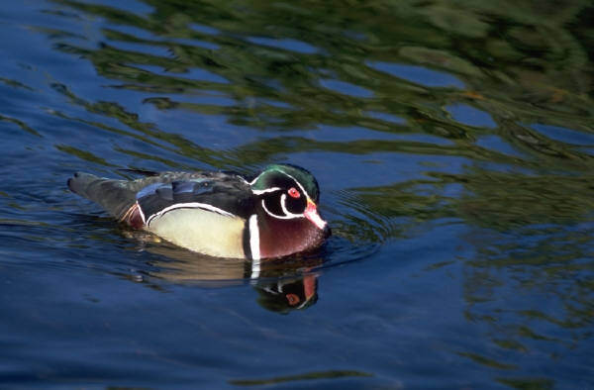
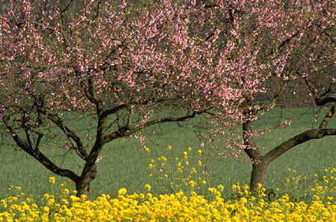
Page 2
The Four Seasons are:

Summer
Fall
Winter
Spring
Our Class Tree in the Spring
How does the world change during the year?
What is your favorite season?
SUMMER: It’s HOT! The days are long and you can stay up late.
FALL: It’s cooler. The days are getting shorter and school has started so you go to bed earlier now.
WINTER: It’s COLD! It might snow. It’s dark more hours in the day!
SPRING: It’s getting warmer. The daylight time is longer.

There are four seasons each year. The weather is different in each. Trees change.

We will be going to the Crystal Springs Rhododendron Garden for our seasonal visit on Wednesday, June
6. Mark your calendars!
We’ll get to feed the ducks! (There might even be baby ducklings to see!)
Can you come to help?
More information and
permission slips will come home with the June News.
it. Our teacher takes our picture. We write about the season.
Now that it is spring, our tree has lots of blossoms!
We picked out a tree for our class on the first day of school.
Every season we go out and stand next to
How Do Our Lives Change With the Seasons?
Field Trip to Crystal Springs
Rhododendron Garden
Our Class Tree

