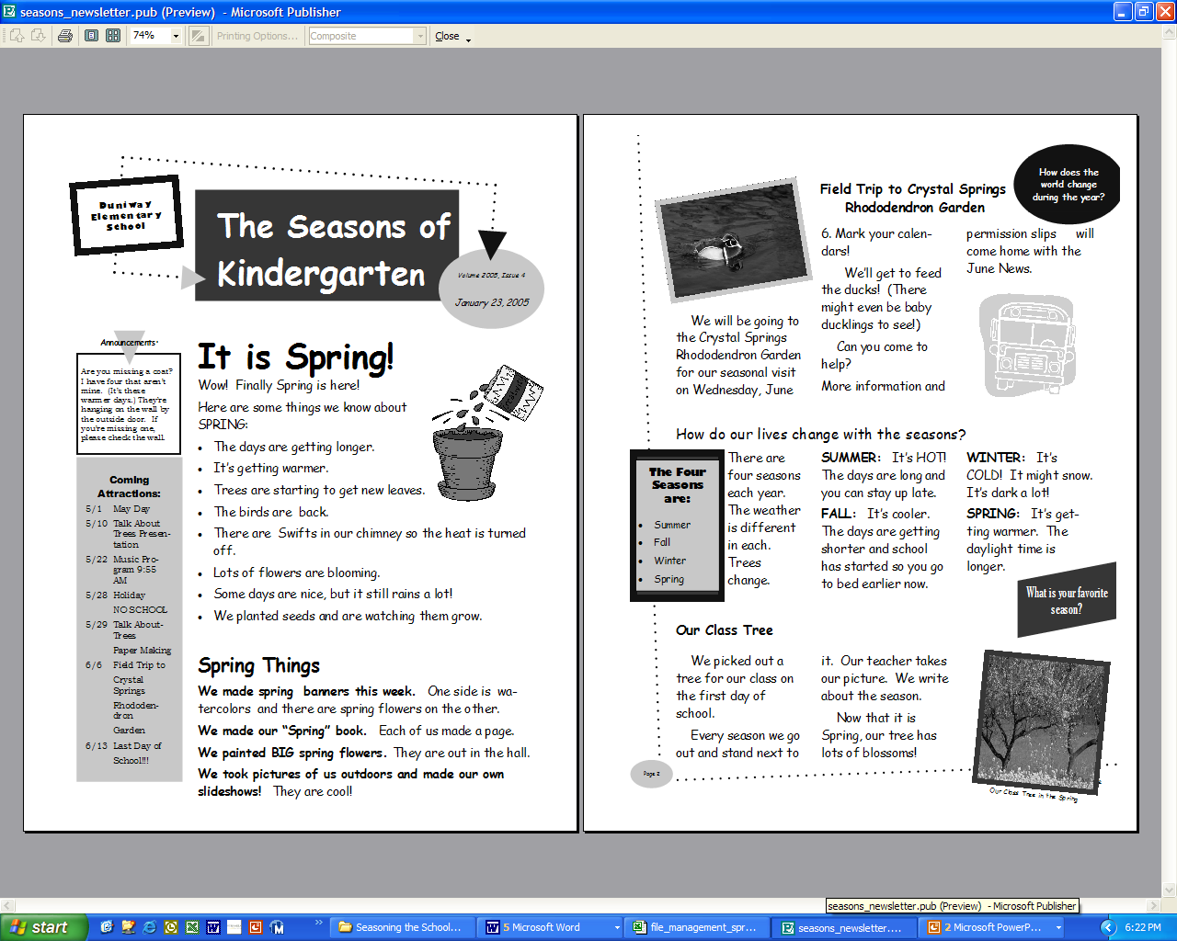
Seasons Newsletter Assessment Tool
Essential Question
How does the world change during the year?

Unit Questions
How do our lives change with the seasons?
What is the weather like right now in other parts of the world?
How can surveys help us collect and interpret information?

Sample Content Questions
How can we tell the seasons are changing?
What are the four seasons?
How do we represent data in different ways?

Use this table throughout the course of the unit. Keep a record of student participation as the children contribute to each season’s newsletter.
Name | Summer  Can identify an attribute of summer | Fall  Can identify an attribute of fall | Winter  Can identify an attribute of winter | Spring  Can identify an attribute of spring | Identified an element of change | Made a comparison between seasons | Made a comparison between two locations
<name
<name
<name
<name
<name
<name
<name
<name
<name
<name
<name
<name
<name
<name
<name
<name
<name
<name
<name
<name

