<Click Slideshow Checklist

Name:
Check one:  no  yes | Title Slide  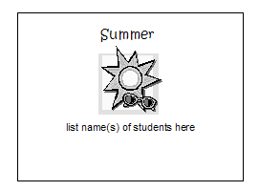  € Title  € Everyone’s name | .  Check one:  no  yes | Slide 3  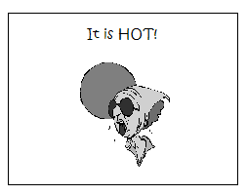  € Title  € Words about the season  € Picture
.  Check one:  no  yes | Slide 1  € Title  € Words about the season  € Picture | Check one:  no  yes | Slide 4  € Title  € Words about the season  € Picture
.  Check one:  no  yes | Slide 2  € Title  € Words about the season  € Picture

