Monthly Weather Bar Graph
11
10
9
8
7
6
5
4
3
2
1
Days |  |  |  | 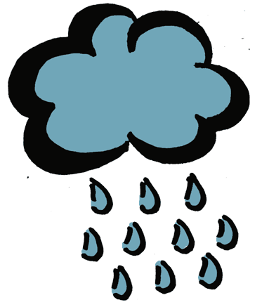 | 
  Sunny
  Partly Cloudy
  Cloudy
  Rainy
  Snowy

