Inside this issue:
What will our quality
of life be like in the
future?
lems. A few of those problems are:
- Air pollution
- Food shortages
- Traffic gridlock
- Water shortages
- Habitat destruction
Will the population increase like it has in the past? Can we count on past trends to continue? Can the past predict the future? There are many variables but we do know things must change if we want any quality of life!!
Thomas Robert Malthus was an English economist who had a hypothesis. His hypothesis stated that “unchecked population growth always exceeds the growth of means of subsistence.” He also said that, "The population of the world will multiply geometrically, while the food supply will multiply arithmetically." What he meant by that is food would increase in a 1, 2, 3 progression while population would increase in a 2, 4, 6 progression.
California currently produces a larger number of agricultural products than any other state in the U.S. More than 200 different crops are produced here—from lettuce, tomatoes, and strawberries to almonds, avocados, and oranges. But what will happen to the agricultural land if in 20 years our population has doubled? Houses and cities
December 2004
Volume 1, Issue 1
Tracking the Trends
Does the past predict the future?

California—exploding beyond it’s limits by Group 2

California, the land of dreams, the Golden State. What could be better than the ocean, palm trees, and warm weather? A line from a popular Beach Boys song says, “If ev’rybody had an ocean, across the U.S.A., Then ev’rybody’d be surfin’, like Californ-I-A.” Images of surfers, convertibles, and fun. These images have beckoned millions of people to this land of opportunity.
California is a big state. The first federal census conducted in California in 1860 counted 308,000 residents. California’s population exceeded 36 million persons on January 1st, 2004. Now let’s think about that.
That is more than twice the population of Australia, or The Netherlands. Bigger than Venezuela or Peru, and slightly larger than Canada.
And it doesn’t seem to be slowing down. According to our predictions, in six more years, the population will be over 65 million—more than double the population from 1990. And by 2050, the population will be about what the population of the United States is currently.
This state is not big enough to handle all of this growth. Having a growing population like this leads to many prob-

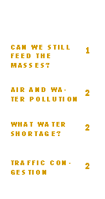
Continued on page 2

Can we still feed the masses? By Matt
will have to expand out to lands that are currently farms. Developers convert at least 50,000 acres of California's farmland to home sites and other urban amenities every year, a phenomenon with no end in sight. Farming will decrease and not only will we not be able to feed others, but we may not be able to feed ourselves. The California

Special points of interest:
California is the most populous state in the United States.
70% of Californians consume all or some of their water from bottled sources every year.
30% of the state lives in Los Angeles County.
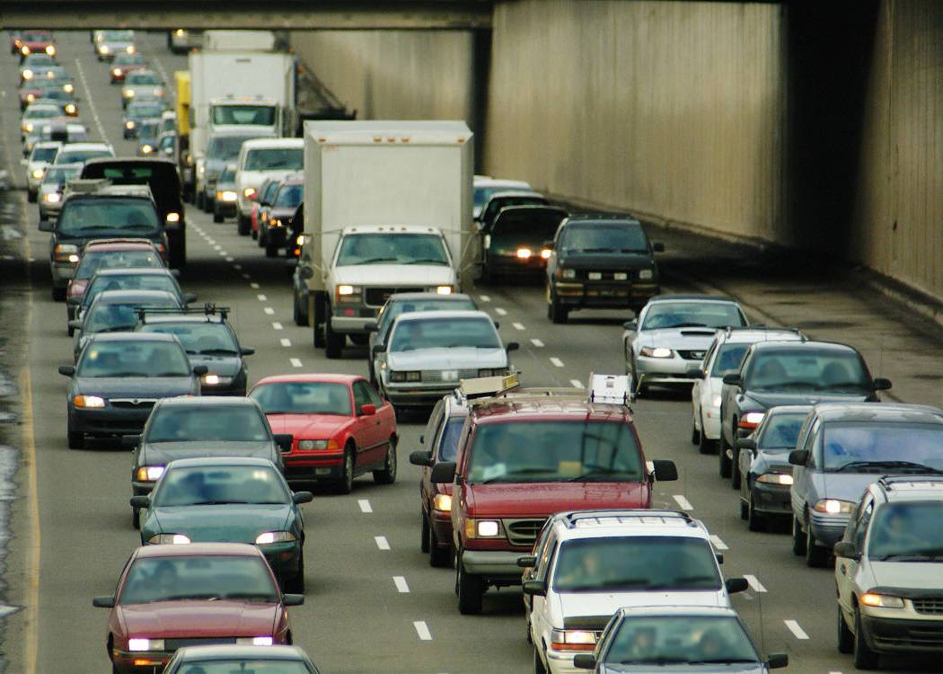
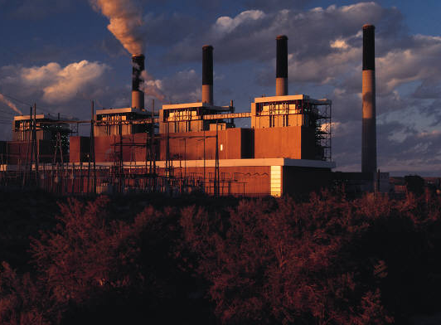
The San Joaquin River is on the list of the 10 most endangered rivers in the United States.
Are there limitations to linear regressions? Yes! There are too many variables that may affect a trend that a linear regression doesn’t take into consideration.
Air pollution is an issue in sunny California. Air pollution is worse in cities where most people live and work. Pollution comes from businesses, factories, power plants, cars, agricultural operations, paint, and fires. Many parts of California have almost perfect conditions for the development of photochemical smog. These conditions include lots of cars and sunshine—and Los Angeles is just the spot as it is known by many as the Smog Capital of the U.S. Air pollution has an effect on global warming. Air temperatures rise, and this can effect climate worldwide.
We must think about what climate changes have we seen so far? How will this affect agriculture, water resources, ecosystems, and human health? The good news is that looking at pollution trends, air pollution has actually improved. Taking a look at the chart on the right, we can see that ozone particulates have actually decreased over the last 9 years! Strict regulations have put constraints on vehicles and businesses in order to address the air pollution problem. Looking at the chart, we can also see that starting in 1995 until 1999, the trend was downward. Then it went up for a year, down for 2, and back up last year.
Due to the up and down nature, we cannot predict what the future trend will be. More
Traffic jams are a daily expectation in many California cities. This is a huge issue as a gridlocked infrastructure leads to less productivity, fewer jobs, higher costs of doing business, and more air pollution. If the state cannot keep up with the incoming transportation issues with a growing population, then everything will grind to a halt! As it is, the average urban motorist loses about 62 hours a year due to traffic congestion.

That is up from 16
hours a year in
1982. If there is a
linear regression, we
may lose 108 hours
per year! There may
be many solutions,
ranging from toll roads
to more HOV lanes. We can’t track the trends on traffic as we don’t know what kind of public transportation may be introduced over the years. But we know that without anything being done about traffic, our quality of life will increase!

Air Pollution by Trevor

Feeding the masses continued

Is there a Water shortage? By Gina
all the water come from? Californians should learn from the past. In 1976-77, there were such severe water shortages in the state that the quality of life for many made a drastic change. No more watering lawns, washing cars, or filling up swimming pools. People actually put bricks in toilets to save water. From 1987 through 1992, California faced another water shortage. Ration-
ing was imposed again. Unfortunately Californians have since returned to their wasteful ways—with no looking towards the future—we need to stop that trend!!
You can’t track the trends for water shortages—that is because you cannot predict the weather year after year—a variable. Some years are wet—others are dry—and the water supply fluctuates significantly between wet and dry years. Of course, another issue is that existing water resources are being ruined by pollution. This will impact our quality of life in the future.
Water consumption is growing at a very high rate right now in the state of California. It has gone from 200 gallons per person per day in 1992 to 229 gallons per person per day in 2001. If we track that trend in a linear fashion, we find that in 9 years, the water consumption may be 258 gallons per person per day. And in 18 years, it will be 287 gallons per person per day. This is an issue as California is already facing major water shortage issues. Where will
Page 2
Tracking the Trends
Does the past predict the future?
Traffic congestion by Anne
people means more cars—will this increase ozone parts per million (ppm) or will automakers produce cleaner burning cars? Or will more people buy electric cars? That is for the future to tell!
Smog Trend
Southern California—Ozone (ppm)
1995 154
1996 151
1997 141
1998 114
1999 118
2000 123
2001 121
2002 118
2003 133

ourselves. The California dream will no longer exist. Will this affect peoples choices to move out to California? It must if we want a quality of life like one that currently exists. This not only will feed the masses but provide many other benefits such as cooler temperatures and an intact ecosystem. It is important that we track the trends to stop the problems before they get out of hand.

