Adding a Trendline to Your Chart

Choosing the Best Trendline for Your Data
After you have entered your data into spreadsheet software and chosen a chart to represent your data (see the California Population example below), you can add a trendline to your chart.

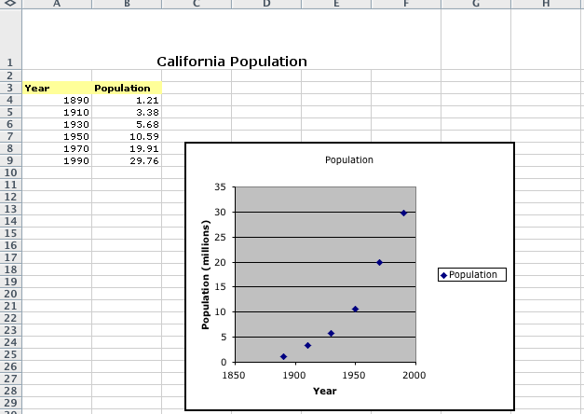

When you add a trendline to a chart, you can choose any of the six trend/regression types—linear, logarithmic, polynomial, power, exponential, and moving average.
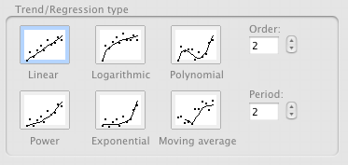

The type of data you have determines the type of trendline you should use. You will want to choose a trendline that is reliable. A trendline is most reliable when its R-squared value is at or near 1. When you fit a trendline to your data, spreadsheet software automatically calculates its R-squared value. If you want, you can display this value on your chart.

Six Choices of Trend/Regression Types
Following are brief descriptions of each type of trend/regression types available in spreadsheet software.

Linear
A linear trendline is a best-fit straight line that is used with simple linear data sets. Your data is linear if the pattern in its data points resembles a line. A linear trendline usually shows that something is increasing or decreasing at a steady rate.
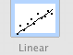

Logarithmic
A logarithmic trendline is a best-fit curved line that is most useful when the rate of change in the data increases or decreases quickly and then levels out. A logarithmic trendline can use negative and/or positive values.

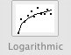

Polynomial
A polynomial trendline is a curved line that is used when data fluctuates. It is useful, for example, for analyzing gains and losses over a large data set. The order of the polynomial can be determined by the number of fluctuations in the data or by how many bends (hills and valleys) appear in the curve. An Order 2 polynomial trendline generally has only one hill or valley. Order 3 generally has one or two hills or valleys. Order 4 generally has up to three.

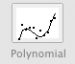

Power
A power trendline is a curved line that is best used with data sets that compare measurements that increase at a specific rate—for example, the acceleration of a race car at 1-second intervals. You cannot create a power trendline if your data contains zero or negative values.

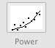

Exponential
An exponential trendline is a curved line that is most useful when the data values rise or fall at increasingly higher rates. You cannot create an exponential trendline if your data contains zero or negative values.
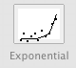

Moving Average
A moving average trendline smoothes out the fluctuations in data to show a pattern or trend more clearly. A moving average uses a specific number of data points (set by the Period option), averages them, and uses the average value as a point in the line. If Period is set to 2, for example, then the average of the first two data points is used as the first point in the moving average trendline. The average of the second and third data points is used as the second point in the trendline, and so on.

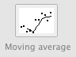

Directions for Adding a Trendline to a Data Series
- Click the data series (chart) to which you want to add a trendline or moving average.
- On the Chart menu, click Add Trendline.
- On the Type tab, click the type of regression trendline or moving average you want.
- If you select Polynomial, enter the order box the highest power for the independent variable.
- If you select Moving Average, enter in the Period box the number of periods to be used to calculate the moving average.
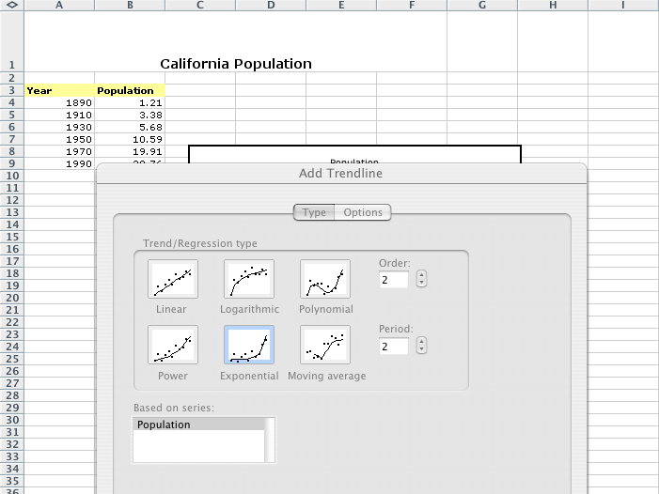

Notes
- The Based on series box lists all the data series in the chart that support trendlines. To add a trendline to another series, click the name in the box, and then select the options you want.
- If you add a moving average to an xy (scatter) chart, the moving average is based on the order of the x values plotted in the chart. To get the result you want, you might need to sort the x values before adding a moving average.

