How to do exponential regression

on a TI-83 graphing calculator

The table at right gives the year and population (in millions) of California. |  | Year | Yrs Since 1890  X | CA Pop  Y
 |  | 1890 | 0 | 1.21
- Create a scatter plot using this data. |  | 1910 | 20 | 2.38
- Find the equation for the curve of best fit |  | 1930 | 40 | 5.68
 | for the data. | 1950 | 60 | 10.59
 |  | 1970 | 80 | 19.97
 |  | 1990 | 100 | 29.76

STEP 1
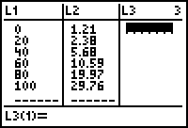
To enter data, press STAT, 1:Edit and then enter data into columns L₁ and L₂. Press ENTER to move down. Use right and left arrow buttons to move to other column.

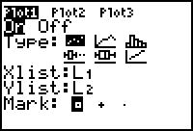
Press 2nd, STAT PLOT, ENTER to create scatter plot.
Then move cursor to ON and press ENTER to activate scatter plot
and make sure the rest of the screen looks like this:

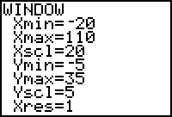
To set the scale of the x-axis and y-axis, press WINDOW. Change the settings to look like this:

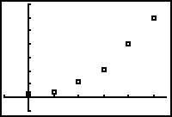
To see your scatter plot, press GRAPH.

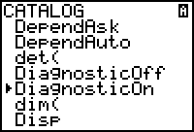
STEP 2

Turn the diagnostics on in order to see the correlation
coefficient (the measure of how close the equation is to
the actual data). The closer to 1 it is, the better the match.

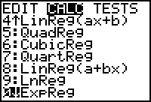
To find the curve of best fit, you will need to do exponential regression. Press STAT, then right arrow to highlight CALC, and then press 0:ExpReg .

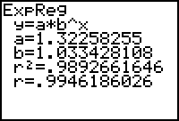
Press ENTER twice and the exponential regression program will be run. This is what your screen should look like. This means that the equation of the line of best fit is approximately y = 1.323 · 1.033^{x}
The correlation coefficient is r, which is 0.994 in this case. That means that the equation is a 99.4% match to the data.

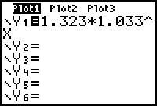
To graph this line on your scatter plot, press Y= and enter 1.323*1.033^X

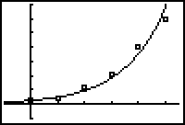
Then, press GRAPH to see the curve of best fit through the coordinate points.

Additional Example

These are the closing prices for the NASDAQ Stock Index at the end of February.

Year | Years Since 1992 (X) | Stock Index Price  (Y)
1992 |  | 633
1993 |  | 671
1994 |  | 793
1995 |  | 794
1996 |  | 1100
1997 |  | 1309
1998 |  | 1771
1999 |  | 2288
2000 |  | 4696

- If x = the number of years since 1992, complete the blank column above.

- Calculate the equation and correlation coefficient using the x and y columns.

Equation y = _______________________ r = _________

- Using your equation, answer the following questions:

  - The NASDAQ Stock Index will hit 10,000 in the year _________ .

  - In the year 2017, the NASDAQ Stock Index will be ___________ .

  - The NASDAQ Stock Index rises ________ percent per year.

