Tulip Project  Tulip Blooms Prediction | Names:  Date:

 | Official Site | Latitude, Longitude | Garden Schools
A | Sterling, Alaska | 60.56° N, 151.80° W | Sterling Elementary
B | Boston, Massachusetts | 42.36° N, 71.05° W | Joyce Middle School
C | Hood River, Oregon | 45.57° N, 121.65° W | Westside Elementary
D | Kingwood, Texas | 29.75° N, 95.36° W | Hidden Hollow Elementary
E | Dainville, France | 50.0° N, 2.0° E | Home School
F | Toronto, Ontario | 43.50° N, 79.59° W | Yorkview School
G | Murfreesboro, Tennessee | 35.50° N, 86.23° W | McFadden Elementary
H | Newport-on-Tay, Scotland | 56.40° N, 3.00° W | Wormit Primary
I | Palo Alto, California | 37.44° N, 122.14° W | Barron Park Elementary
J | Pequot Lakes, Minnesota | 46.67° N, 94.24° W | Pequot Lakes School
K | Salt Lake City, Utah | 40.77° N, 111.92° W | Eastwood Elementary
L | Utsjoki, Finland | 69.90° N, 26.00° E | Utsjoen Saamelaislukio
M | Bowie, Maryland | 38.59° N, 76.45° W | Rockledge Elementary

1. Locate the 13 official Journey North Tulip Gardens on the map below.
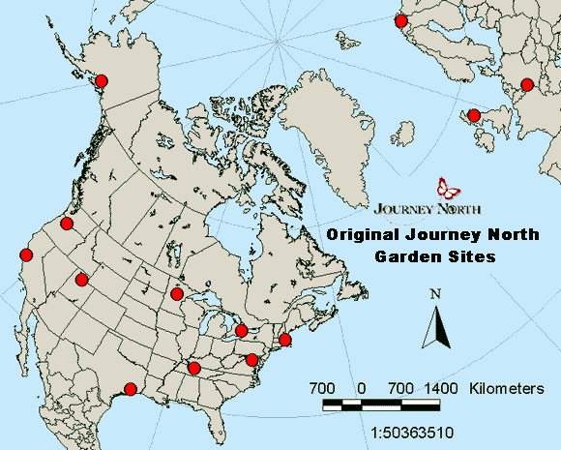
Used by permission from The Journey North

