Journey North  Tulip Bulb Sketches | Name:
Whole Bulb Sketch Date ___________________________
Sketch your whole tulip bulb on a sheet of white drawing paper. Color your sketch as realistically as you can with crayons or colored pencils. Label the parts of your tulip bulb that you can see from the outside.

Half Bulb Sketch Date ___________________________
Sketch your tulip bulb cross-section on a sheet of white drawing paper. Color your sketch as realistically as you can with crayons or colored pencils. Label the all the parts of your tulip bulb.

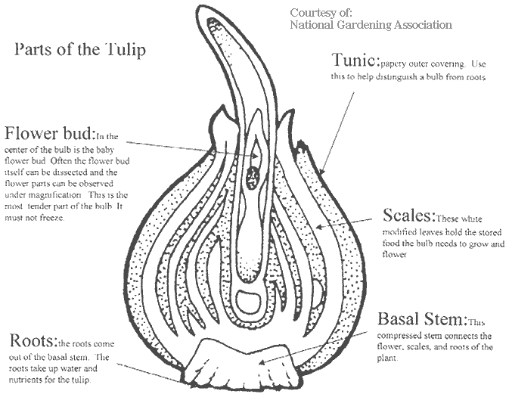
Used with Permission from The National Gardening Association

