Assessment Timeline
Click on any descriptive text, then type your own. Complete the Assessment Summary section if it helps you draft your Assessment Timeline.

Assessment Plan
Assessment Timeline
Before project work begins |  | Students work on projects and complete tasks |  | After project work is completed
- 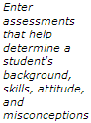 |  | - 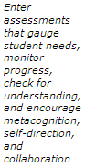 |  | - 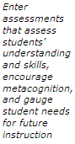

Assessment Summary
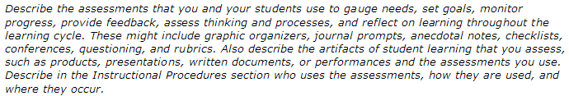

Programs of the Intel® Education Initiative are funded by the Intel Foundation and Intel Corporation.
Copyright © 2007, Intel Corporation. All rights reserved. Intel, the Intel logo, Intel Education Initiative, and Intel Teach Program are trademarks of Intel Corporation in the U.S. and other countries. *Other names and brands may be claimed as the property of others.

