Post Announcements Directions
Announcements appear on the Home tab. Click Previous announcements to view a record of past announcements. The most recent announcement appears on the Home tab.
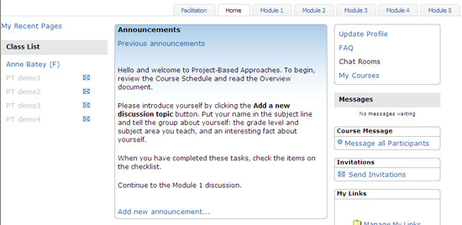
Announcements serve as an efficient way to regularly communicate with course participants as a group. Before posting announcements, first compose them in a word processing application that has a spell check feature to ensure that your announcements are error free. This method also allows you to save announcements for reference and future use. Announcements are primarily used to welcome participants to new modules, provide course schedule reminders, and help keep participants on track.
- To create an announcement, click the Facilitation tab, and then choose Post Announcement.
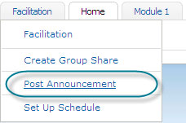
- Click Add new announcement.

- Type your announcement, and then click Post to forum.
Note: For optimal results, format all text in course communication using Verdana font, size 10.
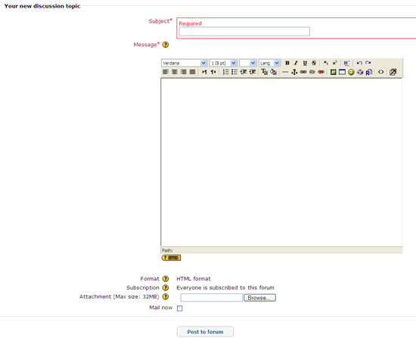
- To attach a document, click Browse, locate the file you want to upload, and then click OK.
Note: You may only upload one file per announcement. If multiple files are needed, compress the files into a single file before uploading.
- If you want to e-mail the new announcement immediately to all course participants, select Mail now. If you do not select Mail now, the announcement will automatically be e-mailed to all participants within 36 hours if they have not entered their course.
Note: You have one hour to modify a posted announcement. After one hour, it cannot be edited. To change it, you must delete the announcement and create a new one.
- When you are finished, click Post to forum.

