Set Up Schedule Directions
The course schedule informs participants when key events and activities occur in the course as well as when specific discussion postings are due. The course schedule appears on the Home tab, under Announcements. If a participant enters the course environment on a day when an activity is due, the activity is emphasized in bold. A sample of a schedule from a participant view is shown below.
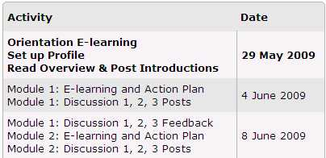

Prior to setting up the course schedule, review the sample course schedules. The recommended schedule is included in the course. Participants post to the discussion board twice a week, one of those posts is feedback for their peers. With this schedule, a facilitated course takes about three weeks. Choose a schedule and then determine any potential changes you need to make to the schedule, such as noting holidays or school closures. Change the schedule dates.

The Set Up Schedule feature pre-populates the required course activities and allows you to customize dates and activities for your course.
To make changes to the pre-populated course schedule:
- Click the Set Up Schedule link on the Facilitation tab.
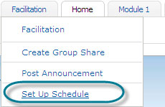
- Click the Edit button.
- Select your time zone and click Set Time zone to update to your time zone.
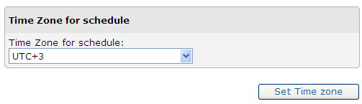
- To change an activity name or delete an activity:
- Click the edit icon in the activity’s Edit column to modify the name of the activity or to delete the activity.
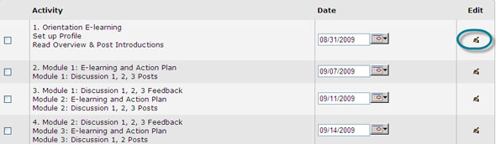
- When you finish modifying an activity name or deleting an activity, click Submit at the bottom of the page to save the changes.
- To change the schedule’s dates, use the Suggest Dates feature to automatically assign dates for each activity based on the start date you choose for the course.
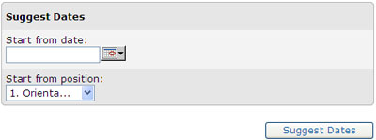
- Use the calendar on the right to select a start date for the beginning of your course.
- Click Suggest Dates. The dates for each activity on the left will automatically populate based on the timing of the recommended course schedule CSV spreadsheet.
- After dates are submitted, verify that the dates appear for the correct activities and in the correct order.
- Determine any potential schedule changes. If you need to change the date of a specific activity (such as adjusting for an upcoming holiday), click the calendar and choose the new date on which you would like the activity to start. Choose the activity name from the drop-down menu and then click Suggest Dates. All other dates following the activity will be adjusted to maintain the proper timing of the recommended schedule.
Note: You can also change the date of just one activity by clicking the calendar in the schedule next to the activity.
- When you are ready and the dates have been verified, click Submit. The course schedule will be updated.
- Use the Add button below the schedule to add a new activity or to upload a new schedule. To add an individual activity:
- Click Add at the bottom of the Set Up Schedule page.
- Provide a title for the activity.
- Determine a start date. Use the calendar feature for assistance in selecting dates.
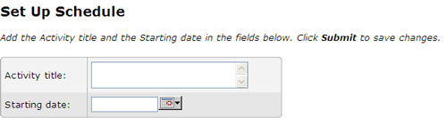
Click Submit to add the activity. The new date will appear on the
To customize dates and timing for all activities:
- Modify one of the sample course schedules or create your own spreadsheet.
Note: You must use the same column headings used in the sample spreadsheet if you create your own file.
- After you have modified or created your own spreadsheet, double-check the spreadsheet by copying the contents into Notepad (or another plain text editor) to make sure you do not have extra formatting.
- Save the spreadsheet as a CSV file.
- Click Select all at the bottom of the Set Up Schedule page.
- Click the Delete selected button.
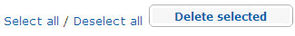
- Click Add at the bottom of the page.
- Use the Browse button to search for your CSV file.
- Select the file.
- Click Submit at the bottom of the page to save your changes. The new dates will appear on the course schedule.

