Clearing Browser Cache
For Macintosh Operating System

Firefox Browser
- Open Firefox
- Go to Tools > Clear Recent History
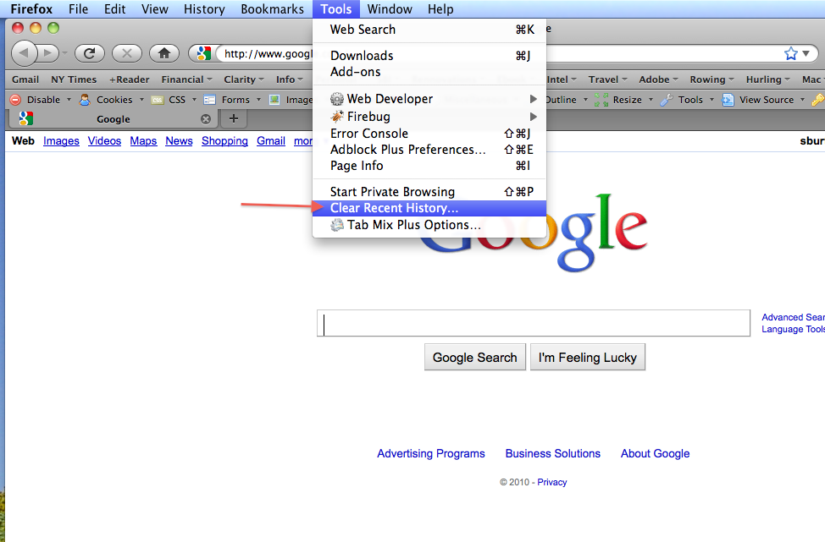
- Select your time range (i.e., ‘Today’) and check ‘Cache’
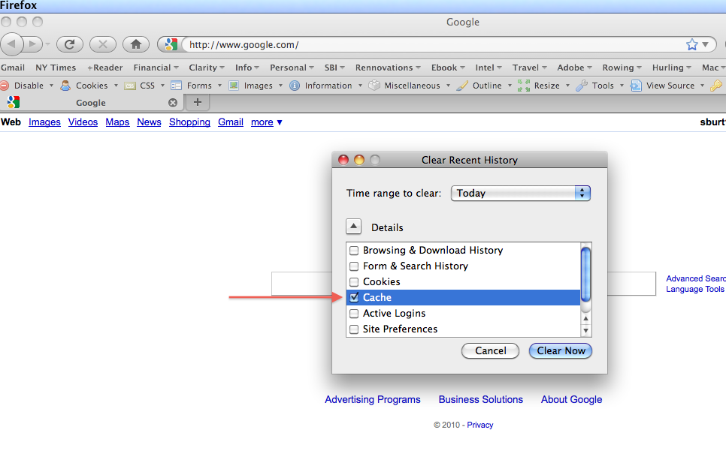
- Select Clear Now

Safari Browser

- Open Safari
- Click Safari > Empty Cache…
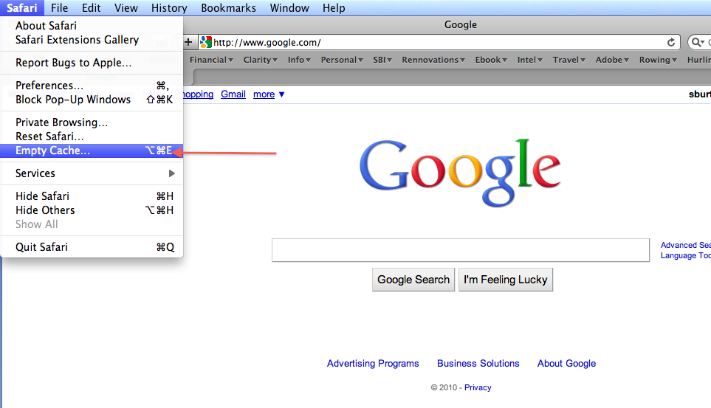
- Confirm you wish to Empty the cache
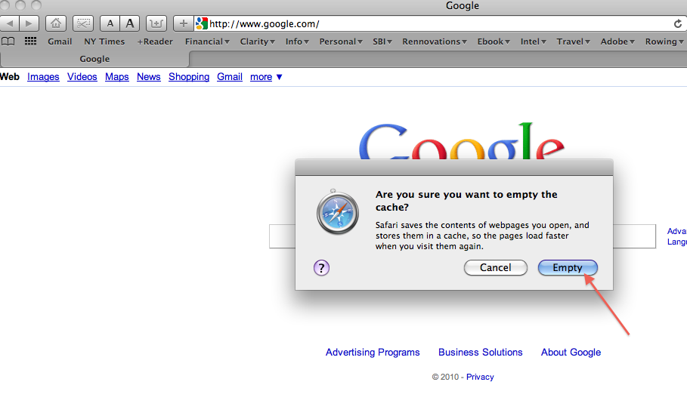
Chrome Browser

- Open Chrome
- Choose Chrome > Clear Browsing Data…
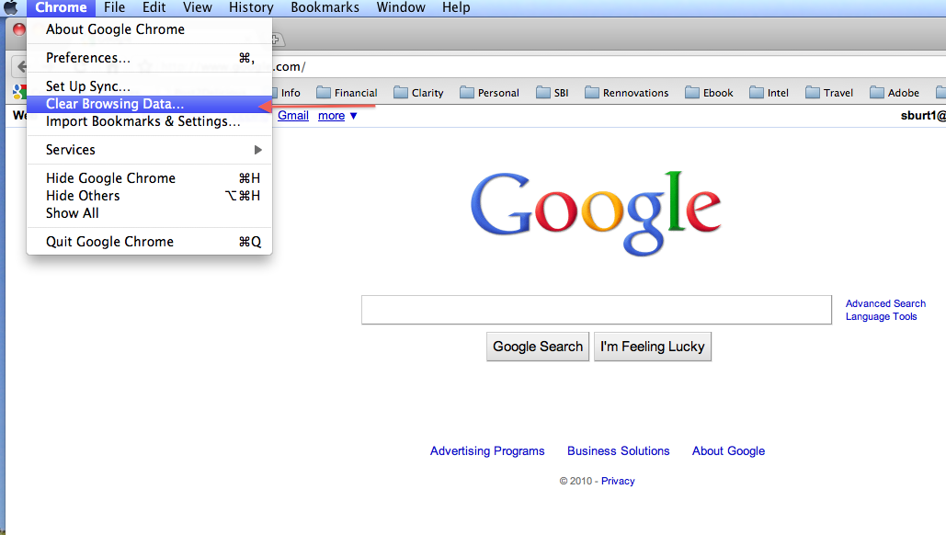
- Select the Duration (i.e., ‘Last Day’) and make sure ‘Empty the Cache’ is checked
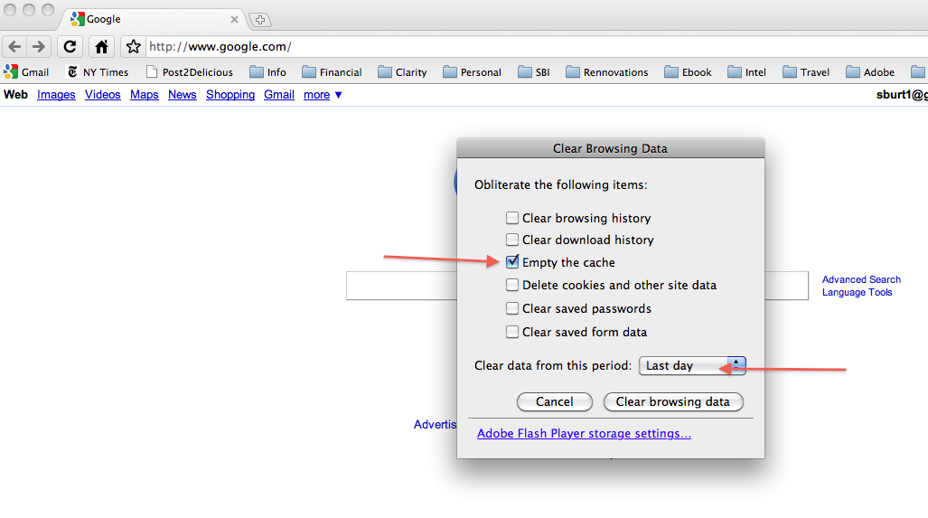
- Select “Clear Browsing Data”
- NOTE: From the Chrome Clear Browsing Data panel you can also select the link to adjust your Adobe Flash Player settings. This will take you to the URL http://www.macromedia.com/support/documentation/en/flashplayer/help/settings_manager07.html. From there you can use the Website Storage Settings panel to remove any stored Flash Objects (i.e., Flash cookies).

