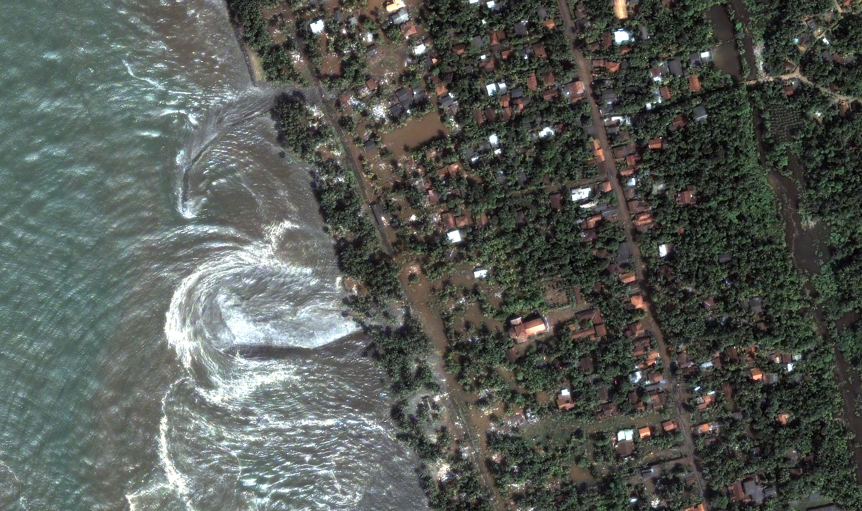
http://earthobservatory.nasa.gov/NaturalHazards/shownh.php3?img_id=12643
Image provided by DigitalGlobe

“What was seconds earlier, a gentle rolling ocean, turned into a man-eating monster!”
Tsunami Relief
1234 Maple Rd.
Chicago, IL 60603
Phone (312) 555 0125
Fax (425) 555 0145
http://www.tsunamirelief.net

Sri LankA Experience
December 26, 2004 started out like any other day in paradise. It was about 10:28 A.M. and we were lying on the sun-drenched beach soaking up the golden rays of the sun, when we heard ear-piercing screams. My friend and I jumped up and we couldn’t believe what we saw! What was seconds earlier, a gentle rolling ocean, turned into a man-eating monster.

Can You Help Me On My Next Journey?
The ad on the Internet travel site said, “You will experience golden beaches with glistening sand caressed by the gentle roll of the Indian Ocean,” so I decided I needed a break from work and I would spend Christmas 2004 in Sri Lanka at the exquisite Palms Hotel. Little did I know I would become involved in what has become the deadliest disaster in modern history. My friend and I survived, but many did not. I questioned why I survived and others didn’t. I then realized that my next journey would be to return to Sri Lanka and help those who were still suffering.
We need your help!

Tsunami Relief

Sri Lanka

Tsunami Relief
1234 Maple Rd.
Chicago, IL 60603
Phone (312) 555 0125
Fax (425) 555 0145
http://www.tsunamirelief.net

http://www.sxc.hu/photo/311255
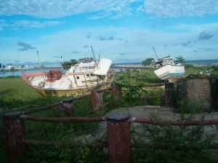

How Can You Help?

Tsunami Relief
Donations
The Tsunami Relief Agency and I invite you to help in any way that you can. After surviving the tsunami I realized that there is nothing more important than helping others in need. Approximately 229,000 people were killed, 30,000 in Sri Lanka alone and many people were left homeless with nowhere to go.
Tsunami Relief will accept donations of any amount. All the money will be sent directly to Sri Lanka to help those in need. There is much work to be done and your money will help make the lives of so many people better. Remember, all money will go directly to those in need to help supply them with fresh water, food and a place to stay.
Volunteering Opportunities
It is the mission of the Tsunami relief agency to serve all those in need. If you are unable to donate money you can still help. We are looking for volunteers to journey with me to Sri Lanka to help with cleanup and rebuilding, With your help many people will be able to return to their homes and have clean water and fresh food to eat, You could help Sri Lanka return to the land of golden beaches and gently rolling oceans
I believe President Bush was right when he said, “Americans have a history of rising to meet great humanitarian challenges and of providing hope to suffering peoples.” Let’s continue this tradition. To volunteer please call 312-555-0125.
It is not cars or money that defines who we are, but what we do to help others.

experiencing tsunami
The tsunami that hit Sri Lanka registered 9.2 on the Richter scale. It was the deadliest disaster in Modern History. When the tsunami hit we ran as fast as our sun-burned bodies could carry us. We tried to stay ahead of the water, but it became impossible. The water dragged us until we grabbed onto a pole. Suddenly the pole gave way and we were slammed into a tree. My friend and I were still together. We were able to climb a tree and look over the devastation that lay before us. The killer waves left a path of death and destruction that was hard to imagine.

We clung to the tree for dear life. It took about two hours for the water to subside. We climbed down carefully and knew immediately that we needed to help. We ran into a Doctor who quickly set up a makeshift hospital in our devastated hotel lobby. We did what we could. Everything was destroyed for miles and there was no place for anyone to stay. Later, the Red Cross came and set up temporary headquarters a few miles from our hotel and we were able to help deliver fresh food and water for those who needed it. Helping others kept us busy so we were not able to dwell on our small problems.

On our way home we realized how lucky we were to be alive. There were many wonderful people who helped us. Now, I would like to return the favor, but I will need your help!

I will never be the same after this experience and I am hoping that the opportunity for you to help will also be life changing. Please journey with me to Sri Lanka, so together, we can make a difference!

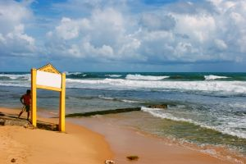
Http://www.sxc.hu/photo/866398

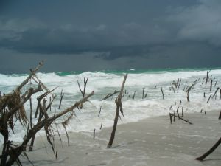
http://www.sxc.hu/photo/853417

“Americans have a history of rising to meet great humanitarian challenges and of providing hope to suffering peoples.” President Bush

